Chemical composition, Antioxidant, antibacterial and anti-inflammatory activities of essential oils extracted from Eucalyptus camaldulensis and Eucalyptus maidenii
Hajer Limam, PhD student, LPAM (CBBC), FST, Tunisia

Abstract (300 word limit)
Statement of the Problem: In recent years, investigations and researches on secondary metabolites of aromatic medicinal plants increase extensively for medical applications, as a source of medicinal agents, and in many other manufacturers like cosmetics and food industry. Eucalyptus is a genus known by its richness in essential oil with biological properties. The aim of this study is to demonstrate the antioxidant, antibacterial and anti-inflammatory capacities of Tunisian Eucalyptus essential oils, and determine their chemical profiles. Methodology & Theoretical Orientation: The essential oils were extracted by hydro distillation (Clevenger) and identified by gas chromatography-mass spectrometry (GC/MS).their antioxidant activity was evaluated by two tests; The scavenging ability of the free radical DPPH and the iron reducing power. Their antibacterial activity was determined using two methods; the diffusion method on disk-agar and the method of determination of the minimum concentration of inhibition (MIC) and the minimal bactericidal concentration (MBC). Both negative and positive bacterial strains were used. The anti-inflammatory activity was evaluated by a colorimetric method using the GRIESS reagent by evaluating the level nitric oxide (NO) released by RAW 264.7 murine macrophage cells stimulated with lipopolysaccharide (LPS). Findings: E. maidenii was the richest species in essential oil with a high percentage of 6.16 ± 1.55%, while E. camaldulensis shown a yield of 0.77 % ± 0.22. Whereas the essential oil of E. camaldulensis showed an interesting biological activities, especially for the anti-inflammatory and antibacterial proprieties. The last one showed an important capacity against infectious bacterial species. The main one was against Serratia marcescens (Gram Negative -) as showed the results of two methods; with inhibition zone 25.33 ± 2.84 mm of diameter and minimum inhibitory concentration MIC of 0.93 mg/mL. The biological activity can’t due only to the presence of the 1,8-cineole compound, since the main chemical class of essential oil extracted from E. camaldulensis was Oxygenated Sesquiterpenes with Spathulenol as the most representative compound (32.89 % ± 2.9). Conclusion & Significance: In the light of these results, the essential oils extracted from Eucalyptus leaves can use in different applications as pharmaceutical and food industries as natural additives.

Image
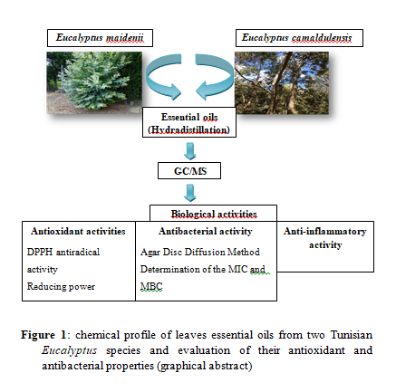
Recent Publications (minimum 5)
- Rezig L, Sadaa A M, Trabelsi N, Tammar S, Limam H, Bettaeib Rebey I, Smaoui A, Sghaier G, Del Re G, Ksouri R, Msaada K (2019) Chemical Composition, Antioxidant And Antimicrobial Activities Of Aloysia Triphylla. Essential Oils And Methanolic Extract. Italian Journal of Food Science 31(3). DOI https://doi.org/10.14674/IJFS-1373
- Limam H, Ben Jemaa M, Tammar S, Ksibi N, Khammassi S, Jallouli S, Del Re G, Msaada, K (2020) Variation in chemical profile of leaves essential oils from thirteen Tunisian Eucalyptus species and evaluation of their antioxidant and antibacterial properties. Industrial Crops and Products 158: 15-112964. DOI: 10.1016/j.indcrop.2020.112964
- Limam H, Ezzine Y, Tammar S, Ksibi N, Selmi S, Del Re G, Ksouri R, Msaada K (2021) Phenolic composition and antioxidant activities of thirteen Eucalyptus species cultivated in North East of Tunisia. Plant Biosystems 155, 587-597. DOI: 10.1080/11263504.2020.1762791
- Tammar S, Salem N, Aidi Wannes W, Limam H, Bourgou S, Fares N, Dakhlaoui S, Hammami M, Khammassi S, Del Re G, Hessini K, Msaada K (2021) Chemometric Profiling and Bioactivity of Verbena (Aloysia citrodora) Methanolic Extract from Four Localities in Tunisia. Foods 10(12). DOI: 10.3390/foods10122912
- Aidi Wannes W, Dakhlaoui S, Limam H, Tammar S, Msaada K (2021) Chemical profile, allelopathic, antibacterial and antioxidant potential of the essential oil from Aleppo pine (Pinus halepensis Miller) needles. Archives of Phytopathology and Plant Protection 54, 2483-2499. DOI: 10.1080/03235408.2021.1991125

 Biography (150 word limit)
Hajer Limam is a PhD student enrolled at the Faculty of Sciences of Tunis (FST) and she will defend her thesis on March 2022. She works in the laboratory of Aromatic and Medicinal Plants (LPAM), Biotechnology Center of Borj-Cedria (CBBC). Her research and thesis subject are focused the evaluation of chemical and biological properties of secondary metabolites extracted from leaves of 13 different species of Tunisian Eucalyptus.
Email: hajerlimam39@gmail.com
hajerlimam@protonmail.com

