Association of dietary and lifestyle inflammation score with general and central obesity in adults
Elaheh Asgari, MSc, Department of Community Nutrition, School of Nutritional Sciences and Dietetics, Tehran University of Medical Sciences (TUMS)
Abstract
Statement of the Problem: Obesity and its complications have become the main public health challenges in most countries around the world. It is recently hypothesized that there might be a bidirectional link between adiposity and low-grade systemic inflammation. Focusing on the dietary and lifestyle inflammation score (DLIS) may show a better picture of the association of human lifestyle as a whole and obesity than that of a single component such as diet or smoking. Therefore, we aimed to investigate the association of the DLIS with the likelihood of general and abdominal adiposity in Iranian adults. Methodology & Theoretical Orientation: In this cross-sectional study, 834 adults aged 18 to 59 years (69% female, mean age: 44.7 ± 10.7 years) were included. Using a 168-item semi-quantitative food frequency questionnaire, dietary intakes were collected. The DLIS was calculated by data from 18 components of the diet, and two components of the lifestyle including physical activity and cigarette smoking. The odds ratio (OR) and 95% CI of the general and abdominal adiposity across quartiles of the DLIS was calculated by logistic regression analysis after controlling for age, sex, marital-status, occupation, education-status, and energy-intake. Findings: The DLIS ranged between -3.00 and 2.32 (man ± SD: -0.31 ± 0.99). The ORs of central obesity, as assessed by waist-to-hip ratio (≥0.8 for women and ≥1 for men) across quartiles of the DLIS were as follows: 1.91 (95%CI: 1.21, 3.02), 1.62 (95%CI: 1.03, 2.56), and 1.25 (95%CI: 0.79, 1.97) for the second, third, and fourth quartiles, respectively. The results for weight-to-height ratio (>0.5) were 2.26 (95%CI: 1.24, 4.11), 1.08 (95%CI: 0.63, 1.86), and 1.38 (95%CI: 0.79, 2.39) for the second, third, and fourth quartiles, respectively. Conclusion & Significance: The present study showed having a diet and lifestyle with more pro-inflammatory properties may be associated with abdominal adiposity.

Image
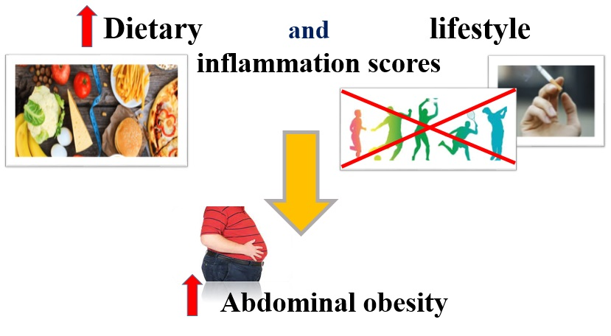

Recent Publications
1. Byrd, D.A., et al., Development and validation of novel dietary and lifestyle inflammation scores. The Journal of Nutrition, 2019. 149(12): p. 2206-2218.
2. Ruiz-Canela, M., et al., Dietary inflammatory index and anthropometric measures of obesity in a population sample at high cardiovascular risk from the PREDIMED (PREvencion con DIeta MEDiterranea) trial. British journal of nutrition, 2015. 113(6): p. 984-995.
3. Mirmajidi, S., et al., Inflammatory potential of diet: association with chemerin, omentin, lipopolysaccharide-binding protein, and insulin resistance in the apparently healthy obese. Journal of the American College of Nutrition, 2019. 38(4): p. 302-310.
4. Shivappa, N., et al., A population-based dietary inflammatory index predicts levels of C-reactive protein in the Seasonal Variation of Blood Cholesterol Study (SEASONS). Public health nutrition, 2014. 17(8): p. 1825-1833.
5. Kim, Y., et al., Associations of smoking with overall obesity, and central obesity: a cross-sectional study from the Korea National Health and Nutrition Examination Survey (2010-2013). Epidemiology and health, 2016. 38.
6. Ertek, S. and A. Cicero, Impact of physical activity on inflammation: effects on cardiovascular disease risk and other inflammatory conditions. Archives of medical science: AMS, 2012. 8(5): p. 794.

 Biography
Elaheh Asgari is a graduate student at the School of Nutritional Sciences and Dietetics School at Tehran University of Medical Sciences (TUMS). She completed her undergraduate studies in Nutritional Sciences at Shahid Beheshti University of Medical Sciences. Elaheh has 14 years of work experience as a nutritionist in various clinics and hospitals. Her research involves obesity, inflammation, diet, nitrition.
Email: e.asgari1398@gmail.com

Presenting author details
Full name: Elaheh Asgari
Contact number: +989122718347
Linked In account: elaheh-asgari-047423224
Session name/ number:
Category: (Poster presentation)

