Title:
A DESCRIPTIVE STUDY OF SUBSTANCE-RELATED DISORDERS AMONG THE IN-PATIENT POPULATION AT MAKATI MEDICAL CENTER FROM JANUARY 2015 – DECEMBER 2017

Renee Celeste C. Obra, M.D., Makati Medical Center, Philippines

- Abstract (300-word limits)
- Statement of the Problem
What is the clinical profile of patients with substance-related disorders admitted and referred to the Section of Psychiatry in Makati Medical Center from January 2015 to December 2017?

- Methodology & Theoretical Orientation
This was a descriptive study using retrospective review of medical charts of all in-patients with substance-related disorders in Makati Medical Center from January 2015 to December 2017. The necessary data were summarized. The total population was 179 (79 in 2015, 61 in 2016, 39 in 2017).

- Findings
Male subjects, aged 18 to 59 years old, single, and employed comprised the population’s majority. Most were discharged stable. Figure 1 shows the top 5 types of abused substances: alcohol, tobacco, stimulants, cannabis, and sedatives. Alcohol was the most frequently abused substance across all age groups, civil statuses, employment statuses, and clinical outcomes.

- Conclusion & Significance
Based on the Philippine National Survey on the Nature and Extent of Drug Abuse in 2015, as of July 2016, 4,791 persons were killed on the War on Drugs, and 3,001 were victims of extrajudicial killings. More than 8,000 barrios in the Philippines had illicit drug problems. The country had about 1.8 million problem drug users with only 42 facilities accredited by the government. This study aimed to raise awareness and aid programs to tailor fit the needs of the afflicted.
Treatment programs could be developed to focus on these top substances of abuse and the clinical profile of the population seeking treatment in Makati Medical Center.

- Image (Optional)
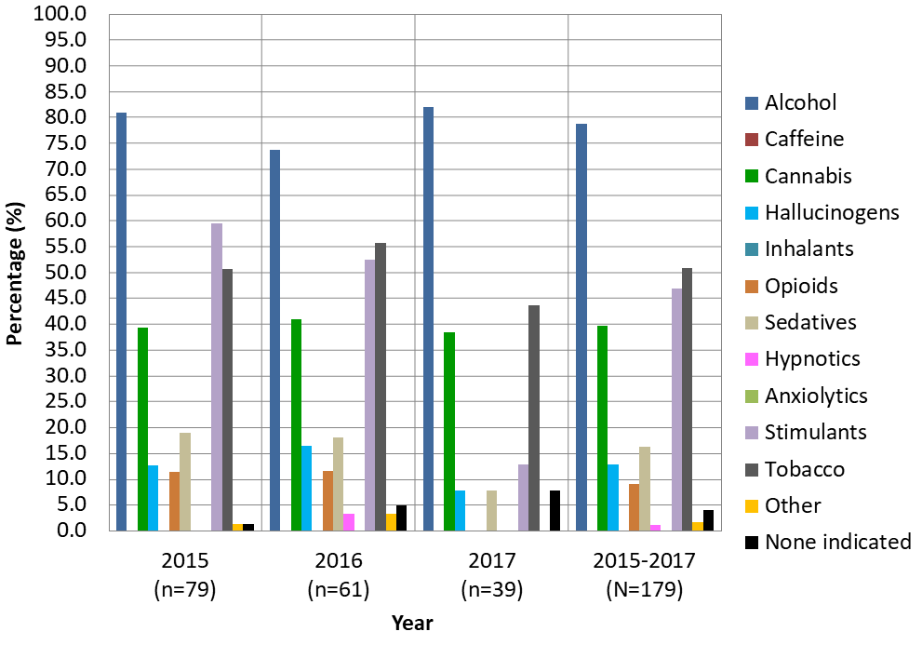
Figure 1. Percentage of types of substances abused per year.

- Biography with Author image (150-word limits)
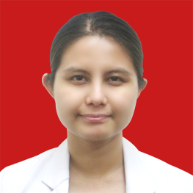
Dr. Renee Celeste C. Obra had her premed course in Psychology at the University of the Philippines Cebu College. During this time, she had her on-the-job training in drug rehabilitation at the Anmed Health Behavioral Health Center – Anmed Wellspring in Williamston, South Carolina, USA. Dr. Obra graduated with a medical degree in the Cebu Doctors’ University College of Medicine. She had her residency in Psychiatry at Makati Medical Center and will be doing her fellowship in Addiction Psychiatry.
- Presenting author details
- Full name: Renee Celeste C. Obra, M.D.
- Email: reneeobra@gmail.com
- Contact number: +63(917)7775571
- Research Interest: Addiction psychiatry
- Current designation: Incoming Addiction Fellow
- Twitter account: none
- Facebook account: Renee Celeste
- LinkedIn account: none
- Category: Poster presentation

Notes/Comments:

