The impact of parents and peers smoking on the behavior
of university students towards smoking
Name: Hussein Mohammed Resen.
University of Sharjah, College of Medicine, P. O. Box 27272 Sharjah, UAE

Abstract (300 word limit)

Introduction: Smoking prevalence has increased in both sexes, especially among young adults, various factors have led to this catastrophe, examples include TV, social media and its availability in the market. An interesting factor that we thought was worth studying, is the impact of smoking parents and peers, we noticed that a lot of students start smoking because of parents or peers impact, and we believed that if our results was true, it would direct future research to study and analyze this factor in order to prevent it.

The aim of this project is to study whether parents and peers smoking habits have any impact on the students of University of Sharjah’s behavior toward smoking.

Methods: a cross-sectional observational study with non-probability convenient type of sampling, the sample included in the study are university students aged 18 to 23. The information was collected using a Self-administered questionnaire, the questionnaire contained 23 questions and it was developed by us.

Results: A total of 400 University of Sharjah students (50% males & 50% females) within an age range from 18 to 23 years old were included in the study, 15.8% of the smoking students had smoking parents, and 17.1% of them had smoking peers. 22.2% of the smoking male students had smoking parents, meanwhile, 10% of the smoking female students had smoking parents. 21.7% of the smoking male students had smoking parents, while 7.8% of the smoking female students had smoking peers.

Conclusions: Peers had a stronger impact than parents, parents and peers had more impact on males rather than females, interestingly almost 80% of the smoking students didn’t have smoking parents or peers, which leaves the question of why did they start unanswered, action should be taken on a societal level to prohibit smoking for the aim of creating a non-smoking generation.
Image
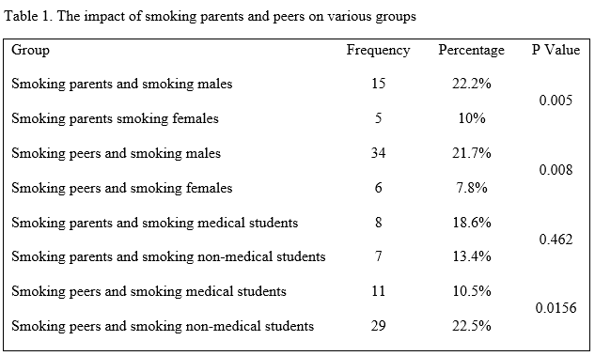
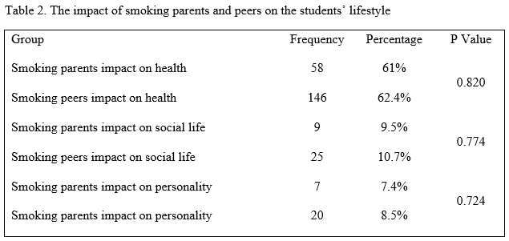
Recent Publications (minimum 5)
None.
Student.


Biography (150 word limit)
Mr. Hussein Mohammed Resen, has completed his high school at the age of 18 years from Al-Rashid Al-Salih school in Dubai, I am now a third year medical student in the college of medicine in the university of Sharjah since 2013, expected to graduate in 2019, I attended various workshops, conferences and courses, has been an active member in different medical associations, and I also have experience in volunteer work. Did and oral presentation at the psychiatry and psychosomatic medicine conference done in 05-06/12/2016 in Dubai, UAE.
Email: husmoh1995@gmai.com

Notes/Comments

