Assessing Obesity, Physical activity, Diet and Body image among students at Princess Nourah bint Abdulrahman University
Dr. Eman Soliman Soliman [1], Leena Hussain [2], Amnah Alsaffar[3], Fatimah Alhuzaimi[4], Ghadah Aljoufi[5], Marwah Alturki[6], Lamya Almusharaf [7], Najd Alrumaihi[8], Lena Alzahrani[9], Anamil Khyiami[10].
Affiliation: Princess Nourah bint Abdulrahman University, College of Medicine.

Image

Abstract (300 word limit)
Introduction: In recent years, the prevalence of obesity in Saudi Arabia has increased due to a number of modern lifestyle factors, which depict lack of awareness in certain regards. Social awareness in regards to the implications and negative effects of obesity, physical activity, diet, and body image perception on morbidity and mortality levels. The prevalence of obesity in Saudi Arabia calculated in a previous study was higher among women (33.5% vs 24.1%), which can be contributed to lifestyle and psychosocial factors. This study hypothesized the positive correlation between; obesity, physical activity, diet, and body image perception. Once an understanding of the correlation between these factors has been formed, an interventional process can be taken to reduce the negative impact on the community’s well being.
Methods: The study was conducted at Princess Nourah University over a period of ten months. 486 students were interviewed with survey instruments in the form of validated questionnaires. The Inclusion criteria were students who were willing to participate.
Results and conclusion: First, the results highlight the prevalence of overweight students (20.2%) with a low rate of obesity (6.4%) Second, there was a direct proportion between an unhealthy lifestyle and high body mass index. Finally, the correlation between BMI and Body image shows that body image has a positive relationship with the BMI scores. As the majority of students who had higher BMI scores has also had greater rates of negative body image. This study establishes a positive correlateion between obesity, physical activity, diet, and body image.

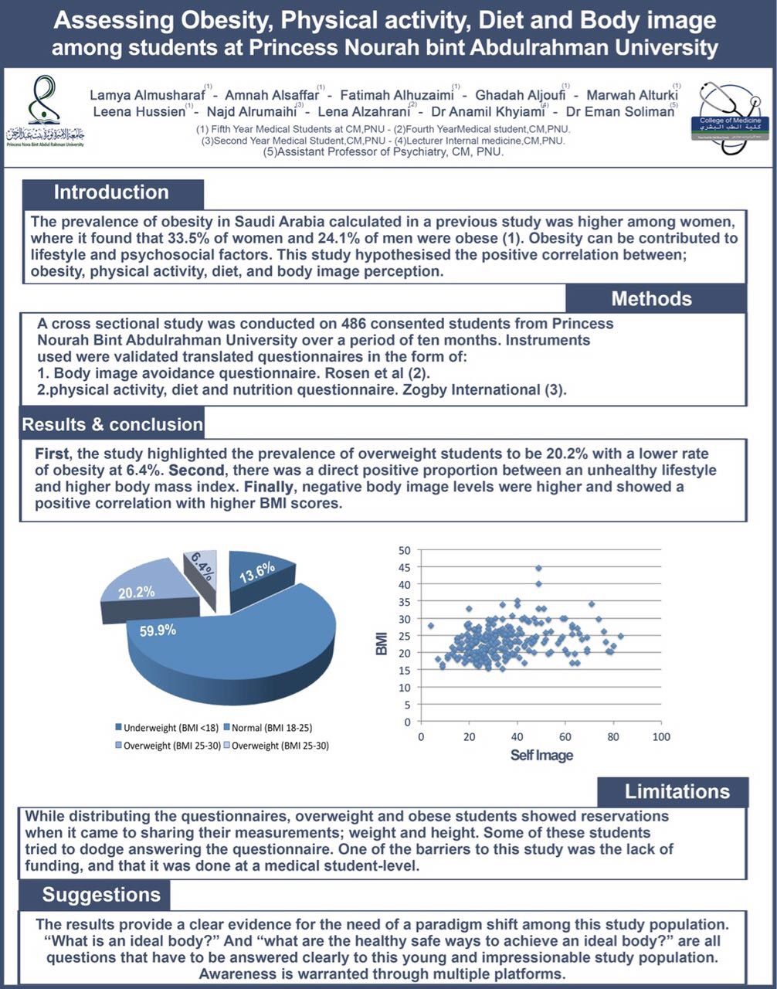

Recent Publications (minimum 5)
None.

 Biography
Leena Walid Hussain a medical Intern from Saudi Arabia , PNU . Interested in the psychiatry field. Conducted this paper to asses the affect of life style and psychiatric affects among young ladies.
Email: Leena_hussain.pnu@hotmail.com

Notes/Comments:

