Adult Attention Deficit Hyperactivity Disorder
A disorder within debate
Workshop on Assessment, Diagnosis, Use of
Diagnostic tools & Management of Adult ADHD
Dr Réhab Khalifa
August 2017

Introduction
ADHD is a neurobiological condition characterised by core symptoms and persistent patterns of inattention and/or hyperactivity and impulsiveness.1

ADHD is a persisting disorder. Of the young people with a sustained diagnosis most will go on to have significant difficulties in adulthood, which may include continuing ADHD, personality disorders, emotional and social difficulties, substance misuse, unemployment and involvement in crime.2

ADHD is a disorder that changes its presentation in different age groups.3

- In children: Academic/social dysfunction, Disruptive behaviour &Skill deficiencies
- In Adolescents: Academic failure, Alcohol & substance abuse, Low self-esteem& Parental conflict
- In Adults: Psychological dysfunction/disability, Psychiatric comorbidities, Significant job impairment, relationship difficulties, offending behaviour & low self esteem.

Aim of the workshop
The identification of ADHD in adults is still uncommon. There are still few specialist or general mental health services for adults with ADHD, 4 however; services are being developed in many areas across the world.
There is also a pool of adult patients in whom the diagnosis of ADHD has been unidentified and where ineffective treatments have been put in place for alternative diagnoses, which may account for the high rates of contact, reported with mental health services for adults with ADHD and in turn, associated cost implications.4
Transition from childhood into adulthood remains a major concern in young people with mental health problems, particularly those with ADHD who are vulnerable, and require continuing care into adulthood.4

Prevalence
In the 2007 WHO-WMH survey initiative the estimated worldwide prevalence of adult ADHD was 3.4% in the general adult population.6
Additional data to consider when estimating the potential prevalence and following on the potential patients are:
- Release of DSM V which potentially lowers the threshold for adult diagnosis
- Increasing recognition & awareness of adult ADHD
- Availability of existing pharmacological and psychological interventions.
Adults with ADHD generally have a high rate of comorbid conditions that add not only to the impairment associated with ADHD but also the disorder’s economic burden.7
Approximately 75% of adults with ADHD have at least one comorbid condition.8
Common co-existing conditions in adults include personality disorders, bipolar disorder, obsessive-compulsive disorder and substance misuse. ADHD Prevalence in general psychiatric outpatient clinics is estimated to be between 17 and 24%.9, 10

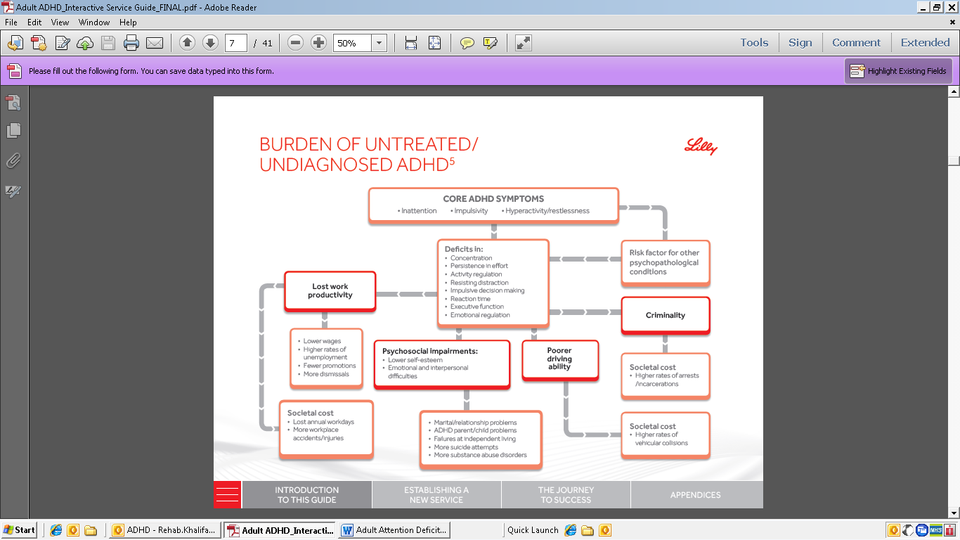

Objectives of the workshop
- Increase awareness of Adult ADHD, with a particular focus on Definition, history of the disorder, Epidemiology, symptomatology across lifespan& DSM5 criteria.

- Diagnosis of ADHD in Adults; presentation, impairment & diagnostic dilemmas.

- Introducing Assessment tools: DIVA 2.0 Diagnostic Interview for ADHD in Adults

- Discussion on Overlaps in diagnosis, which is which.

- Co-morbidity in ADHD, the evidence.

- Vignettes & case discussions.

- Treatment of Adult ADHD ; pharmacological, psychoeducation and psychological interventions

References
1. Faraone SV et al. The age dependent decline of attention deficit hyperactivity disorder: a meta analysis of follow up studies. Psychological Medicine 2006; 36.
2. NICE. Attention deficit hyperactivity disorder. Diagnosis and management of ADHD in children, young people and adults. Clinical Guideline 72. London: NICE; September 2008. http://guidance. nice.org.uk/CG72.
3. Biederman J. Attention-deficit/hyperactivity disorder: a selective overview. Biol Psychiatry 2005;57(11):1215-20.
4. NICE. ADHD The commissioning and benchmarking toolkit. London; March 2012. Available: http// www.nice.org.uk/usingguidance/commissioning guides/adhd/adhdmainpage.jsp. Last accessed 25th September 2013.
5. Asherson et al. Under Diagnosis of Adult ADHD: Cultural Influences and Societal Burden. Journal of Attention Disorders Supplement to 16 (5) 20S-38S.Kind regards
6. Fayyad J, De Graaf R, Kessler R, et al. Cross-national prevalence and correlates of adult attention deficit hyperactivity disorder. British Journal of Psychiatry 2007; 190: 402-9
7. Biederman J. Impact of Comorbidity in Adults With Attention-Deficit/Hyperactivity Disorder. J Clin Psychiatry 2004;65[suppl 3]:3–7.
8. Kolar D et al. Treatment of adults with attention-deficit/hyperactivity disorder. Neuropsychiatric Disease and Treatment 2008:4(2) 389–403. 9. Rao P and Place M Prevalence of ADHD in four General Adult Outpatient Clinics in the North East of England Progress in Neurology and Psychiatry 2011; 15: 7-11. 10. Syed H, Masaud TM, Nkire N, Iro C and Garland MR (2010) Estimating the prevalence of adult ADHD in the psychiatric clinic: a cross-sectional study using the adult ADHD self-report scale (ASRS). Irish Journal of Psychological Medicine, 27(4): 195-197. 11. NICE. Attention deficit hyperactivity disorder. Issued July 2013. Quality Standard 39 (QS39)

