The human skin bacteria Staphylococcus epidermidis fermentation end product ameliorates UVB-induced ROS generation through production of free electron transfer.
Arun Balasubramaniam¹, Chun-Ming Eric Huang^{1,2*}
1- Department of Biomedical Science and Engineering, National Central University, Taoyuan, Taiwan;
2-Division of Dermatology, Department of Medicine, University of California, San Diego, CA, USA;

UVB-induced skin damage results in various inflammatory disorders through the induced generation of reactive oxygen species (ROS) that quickly inundate tissue antioxidants and in severe cases it can lead to skin cancer. To investigate efficacies of human skin commensal bacteria S. epidermidis (ATCC12228) with its specific skin fermentation inducer (SFI), named as Ncueh1 that on fermentation produces antioxidant electrons against UVB induced skin damage. In vivo affirmation on ICR mice has confirmed the photoprotective role and maintained sufficient Anti-4 hydroxynonenal (4-HNE), a major biomarker of oxidative stress and lipid peroxidation, has been recognized as an important molecule in UVB-induced skin damage. Results in the Western blot analysis using antibodies to 4-HNE demonstrate that 4-HNE is induced in mouse skin overexposure to UVB. On the topical application of S. epidermidis (ATCC12228) plus its specific prebiotic Ncueh1 onto mouse skin before and after UVB exposure significantly reduced the UVB-induced 4-HNE. Application of S. epidermidis (ATCC12228) alone or prebiotic Ncueh1 alone does not influence the level of 4-HNE in UVB exposed skin. Electrochemical behavior of S. epidermidis (ATCC12228) with and without Ncueh1 has been determined to produce electron transfer this result suggests that electrogenic and antioxidant property of S. epidermidis (ATCC12228). We have also tested the similar efficacy from the human skin isolated S. epidermidis to prove the similar function of bacteria in compared to ATCC12228 Strain that can mediate prebiotic Ncueh1 to produce free electron which may effectively neutralize and scavenges the formation of free radical by UVB irradiation.
Biography
I’m Arun Balasubramaniam, currently pursuing my PhD in Biomedical Sciences and Engineering. My research focus is skin microbiome health and their impact on antioxidative role played by them to scavenge free radical generation there by maintaining skin antioxidants number and mitochondrial health.
Email ID: arunb2895@gmail.com
Presenter Name: Arun Balasubramaniam
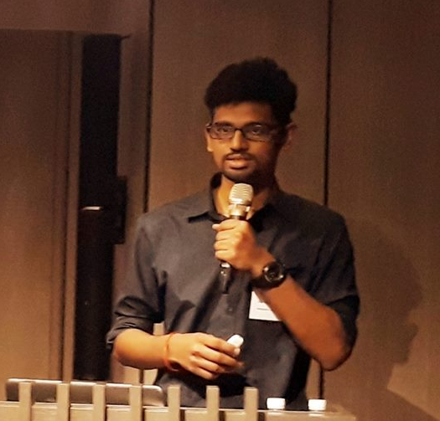

Type of Presentation: Oral/Poster
Contact Number: +886-9842145556

