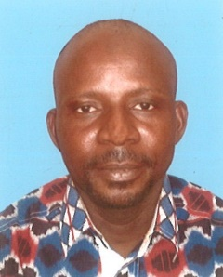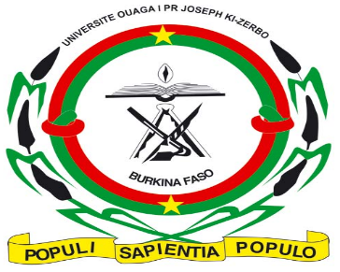
LABIA
Laboratoire de Biochimie et
d’Immunologie Appliquées

Title: Isolation and characterization of probiotics from traditional cereal-based porridges in Burkina Faso
Boureima Kagambega, kagambou@gmail.com, Phone: +22678101611
Laboratoire de biochimie et d’Immunologie Appliquée, Université OUAGA I Pr. Joseph KI-ZERBO, 03 BP 7021 Ouagadougou 03
Abstract
Fermented foods are an important part of the diet of West African populations. Among these are fermented porridges with large microorganisms, some of which have probiotic potential. . The general objective of the study is the analysis of the quality of traditional porridge, and more specifically the isolation and characterization of microorganisms with probiotic potential.
The study focused on 120 porridge producers identified in the city of Ouagadougou. The information collected from the producers mainly concerned the age and experience in the sector, the ethnic group and religion, the quantity of cereals used and the income per sale, the stages of production, the type of porridge, the appreciation of the premises of production and sales
Microbiological analyzes were carried out and allowed to isolate microorganisms such as lactic acid bacteria, yeasts, molds, E. coli and pathogens that will be characterized by the method of molecular biology (PCR). Physicochemical analyzes were used to quantify sugars, proteins, lipids, dry matter, minerals and vitamins. The energy values ​​of the porridges were calculated, and their viscosities measured, which made it possible to establish links. The characterization of microorganisms as probiotic and ferment from locally produced porridges will open a way for the establishment of starter cultures that will allow formulation to optimize production and better control of the fermentative process.
Biography
Bouraima Kagambega is a PhD student in Microbiology and Applied Immunology. The research theme focuses on the microorganisms of traditional porridges. He holds a Master's degree in Human Nutrition and a DEA in Microbial and Cell Biotechnology. He also has experience in secondary education where gives courses in life sciences and earth (SVT).

