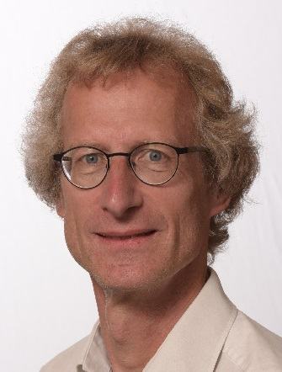



The future of probiotics; using trial registries as a crystal ball

Name: Arthur C. Ouwehand
Global Health & Nutrition Sciences, DuPont Nutrition & Health, 02460 Kantvik, Finland

Probiotics and to lesser extent prebiotics, have been widely used over the past 25 years. However, with the increased capabilities in microbiome research and associated fields such as proteomics and metabolomics, these product groups have gained interest and new potential targets are being identified. There is also an increased understanding in the mechanism by which these ingredients work, which is expected to lead to the development of better targeted, more efficacious and more versatile probiotics and prebiotics.
Microbiome techniques are also providing opportunities for identifying novel so-called next generation probiotics, from new genera and species. Similarly, new prebiotic components will be identified; targeting different organisms then the usual lactobacilli and bifidobacteria.
To understand where the pro- and prebiotic research fields are going, one can look data bases such as PubMed or in patent data bases; these, however, only allow us to look back at research that has been done. Doing a similar exercise with clinical trial registries may provide us a peek into the future; what intervention studies are being planned. We will see that some clinical end-points have reached maturity while other continue to attract attention and new end-points gain interest.
In any case, the area of pro- and prebiotics is very much alive and follows the technological developments. It is expected that this will translate itself into the products we will see on the market in the future.

Biography
Dr. Ouwehand received his B.Sc. in biology and chemistry in Utrecht (the Netherlands) 1987, his M.Sc. degree (1992) in cell biology from Wageningen University (the Netherlands) and his Ph.D. degree (1996) in microbiology from Göteborg University (Sweden). Since 1999 he is Adjunct Professor in Applied Microbiology at the Turku University (Finland) and since 2004 he has been working for Danisco; now DuPont Nutrition and Health. Dr. Ouwehand is the author of more than 250 journal articles and book chapters; he is the editor of four books on lactic acid bacteria and the intestinal microbiota and co-inventor on 15 approved patents.

