[6]-Gingerol as a Natural Scavenger of Chemical Carcinogens - a Computational Approach
Veronika Furlan, Martin Gladović, Urban Bren, Faculty of Chemistry and Chemical Technology, University of Maribor, Slovenia

Abstract
Cancer is a major cause of death in developed countries, second after cardiac disease. In most of the cases, carcinogenesis is associated with chemical modification of DNA. Therefore, exogenous chemical carcinogens are indeed implicated in the aetiology of an increasing number of cancer types. The focus of the current contribution was to examine [6]-gingerol from ginger as a natural scavenger of nine ultimate chemical carcinogens: aflatoxin B1 exo-8,9-epoxide, β-propiolactone, 2-cyanoethylene oxide, ethylene oxide, chloroethylene oxide, glycidamide, propylene oxide, styrene oxide and vinyl carbamate epoxide. To evaluate [6]-gingerol efficiency, we expanded our research with an examination of glutathione - the strongest endogenous scavenger of chemical carcinogens in human cells. Ab initio calculations of activation free energies were performed at the Hartree-Fock level of theory in conjunction with three flexible basis sets. Our results obtained with implicit solvation imply that glutathione cannot efficiently protect us from all studied chemical carcinogens, meaning that additional protection is required for prevention of chemical carcinogenesis. According to our results, [6]-gingerol proved to be a universal and extremely efficient natural scavenger of all chemical carcinogens of the epoxy type. Therefore, additional protection could be assured by [6]-gingerol prophylaxis. Moreover, the obtained results present strong evidence in favor of the validity of the proposed SN2 reaction mechanism for the alkylation reactions of [6]-gingerol and glutathione with chemical carcinogens of the epoxy type and point to the applicability of quantum chemical methods to studies of early chemical carcinogenesis.
The results of our study identified a novel natural scavenger, namely [6]-gingerol, that could efficiently prevent DNA alkylation damage by covalently binding to all studied ultimate carcinogens via a lower activation barrier. Therefore, we strongly believe that this research represents the basis for further computational, experimental and clinical studies of anticarcinogenic properties of [6]-gingerol and for development of novel selective dietary supplements.

Image

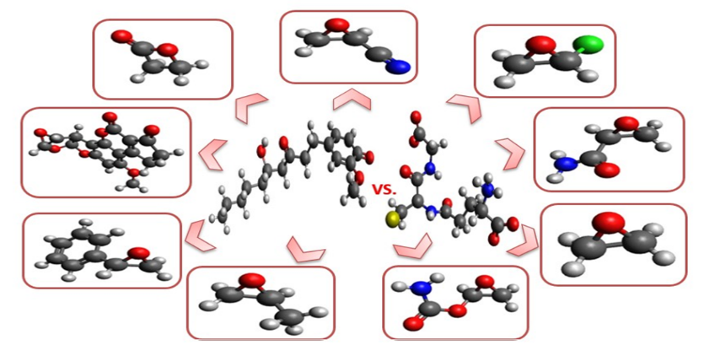
Figure 1 : [6]-gingerol versus glutathione as natural scavengers of ultimate chemical carcinogens.

Recent Publications
1. Srinivasan K (2017) Ginger rhizomes (Zingiber officinale): a spice with multiple health beneficial potentials. PharmaNutrition 5:18-28.
2. Bren U, Guengerich FP, and Mavri J (2007) Guanine alkylation by the potent carcinogen aflatoxin B1: quantum chemical calculations. Chemical Research in Toxicology 20:1134-1140.
3. Galesa K, Bren U, Kranjc A, and Mavri J (2008) Carcinogenicity of acrylamide: a computational study. Journal of Agricultural and Food Chemistry 56:8720-8727.
4. Gladovic M, Spaninger E, and Bren U (2018) Nucleic bases alkylation with acrylonitrile and cyanoethylene oxide: a computational study. Chemical Research in Toxicology 31:97-104.
5. Lajovic A, Nagy LD, Guengerich FP, and Bren U (2015) Carcinogenesis of urethane: simulation versus experiment. Chemical Research in Toxicology 28:691.

 Biography
Veronika Furlan received a Bachelor’s Degree in Chemistry in 2015 and Master’s Degree in Chemistry in 2017 under the supervision of Prof. Dr. Urban Bren at the Faculty of Chemistry and Chemical Technology, University of Maribor, Slovenia. Her Master’s Thesis was focused on the examination of polyphenol [6]-gingerol from ginger and three-peptide glutathione as natural scavengers of ultimate chemical carcinogens. Veronika was awarded for her Master’s Thesis in 2017. In 2017 she also started her PhD work in Chemistry at the Faculty of Chemistry and Chemical Technology, University of Maribor and joined Prof. Dr. Urban Bren’s laboratory. In her current projects, Veronika is applying quantum-mechanical simulations to identify the most potent blocking agents from various natural sources for cancer prevention and for the development of novel dietary supplements. She is also focused on applying molecular docking as well as molecular dynamics simulations to understand the binding mechanism of suppressing agents to enzymes associated with carcinogenesis.

Email: veronika.furlan@um.si

Notes/Comments:

