Title: Mechanistic Modeling: The Pathway to Precision Medicine
Dr. V. A. Shiva Ayyadurai, Ph. D.,
Chairman and CEO, CytoSolve, Inc.

Abstract (300 word limit)
There is a growing and critical need for integrating molecular systems science with computation to model complex disease processes for accelerating drug discovery, drug repurposing, validation of complementary and alternative medicine (CAM) therapies, and identification of efficacious multi-combination therapeutics, while ensuring a personalized and precise medicine. Such needs cannot be advanced without collaborative integration of knowledge across biological disciplines. This talk will share the recent successes, through multiple case studies, in the use of CytoSolve, a computational systems biology collaboratory, developed at M.I.T., that provides an integrative approach to address these critical needs.
Previous approaches, largely based on statistical techniques, have been unscalable and largely useless to scientists who seek to understand complex biological mechanisms. CytoSolve’s successes have been published in peer-reviewed journals and have received recognition in Nature for its potential to develop multi-combination therapies. These successes including: FDA allowance for a multi-combination pancreatic cancer therapeutic; the Department of Defense (DoD) and the United States Pharmacopeia (USP) understanding of toxicity and adverse reaction multi-combination nutritional supplements; and, modeling of rare diseases in orphan drug domains such as Neuromyelitis Optica (NMO) and Hereditary Angioedema (HAE) have inspired major nutraceutical researchers, cancer centers such as MD Anderson, National Cancer Institute and others to explore the use of CytoSolve for integrating CytoSolve’s collaboratory with modern in vitro and in vivo methods to accelerate the development of multicombination therapeutics. This talk that will provide an introduction to a disruptive platform that will likely revolutionize development of therapeutics in the 21st century.

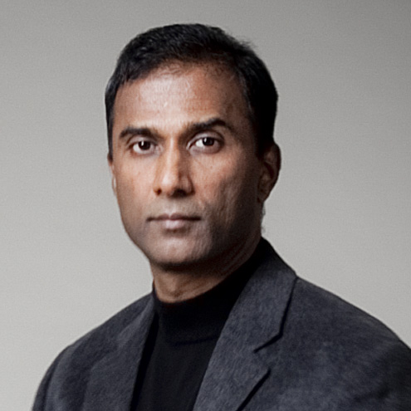Biography (150 word limit)
Dr. V.A. Shiva Ayyadurai, the inventor of email and polymath, holds four degrees from MIT and is a world-renowned systems scientist. He is a Fulbright Scholar, Lemelson-MIT Awards Finalist, First Outstanding Scientist and Technologist of Indian Origin (STIO), Westinghouse Science Talent Honors Award recipient, and was nominated for the U.S. National Medal of Technology and Innovation. In 1982, the US government recognized Ayyadurai as the inventor of email by awarding him the first Copyright for “Email” at a time when Copyright was the only way to protect software inventions. His interest in human health also began early, when as a child, he observed his grandmother, a village farmer and healer, practice Siddha, India’s oldest system of traditional medicine. This motivated his future study and research in systems biology at MIT, leading to his discovery of Systems Health®, a major breakthrough that provides an integrative framework linking eastern and western medicine. His latest invention CytoSolve®, emerging from his doctoral research at MIT, provides a revolutionary platform for modeling complex biological phenomena, to support the development multi-combination medicines without animal testing. Here is a video link to the State of the Art Lecture Dr. V.A. Shiva Ayyadurai delivered at the 2017 Annual Meeting of the American Society for Clinical Pharmacology and Therapeutics (ASCPT).
Email:vashiva-office@vashiva.com
- Full Name: Dr. V. A. Shiva Ayyadurai
- Personal Email:
- Mobile Number: +1 (617) 553-1015
- Linked In:
- Facebook:
- Session Name/ number:
- Category: Oral presentation
- Date of Birth:
- Postal Address: 701 Concord Avenue, Cambridge, MA 02138

Notes or Comments:

