Bioinformatic Tools for determination of high-affinity Peptides as alternative to treatment of Obesity

Ivonne M Bartsch, Pontifical Catholic University of Valparaíso, Chile. Sergio Marshall , PhD. Pontifical Catholic University of Valparaíso, Chile, Fanny Guzmán Q , PhD. Pontifical Catholic University of Valparaíso, Chile, Constanza Cárdenas C, PhD. Pontifical Catholic University of Valparaíso, Chile

Abstract (300 word limit)

Opsonin C3b is an important part of the immune system, being able to trigger phagocytosis by binding to the complement receptors (CR1) of macrophages. The coating of cells with C3b, positions them at risk of destruction¹. The AQP7 protein is highly specific in adipocytes^{2,3}, therefore they can be targets for the generation of dual agonist of adipose cells and CR1, through hybrid peptides for the activation of the phagocytosis of the former. In this work we will perform a bioinformatic analysis through the design of peptides, based on these sequences to trigger phagocytosis adipocytes as an alternative to obesity treatment. Materials and Methods: For the development of this work, we used Uniprot, NCBI PROTEIN BLAST, and PDBsum as databases, Patchdock and FireDock for the realization of the Docking and I-Tasser for the modeling of the AQP7 protein; All of them of free access.

To analize if there is binding between peptides and AQP7 protein, it was used fibroblast 3T3-L1 cell line and differenciated to adipocytes. To analize if peptides binds to CR1 protein, it was used THP-1 monocytes cell line.

Conclusions: From the interaction sites between C3b and CR1 it was possible obtain four receptor agonist peptides. From the modeling and subsequent docking between AQP7 and other protein structures (IgG) were found six binding peptides. For the design of the hybrid peptides, a matrix was generated with 36 resulting peptides capable of binding to CR1 to AQP7.

Of these peptides, two are capable to bind to AQP7 and two binds to CR1. The final matrix of 4 peptides needs to be proved by a co-culture of this two cell lines and demonstrate phagocytosis activation

Image
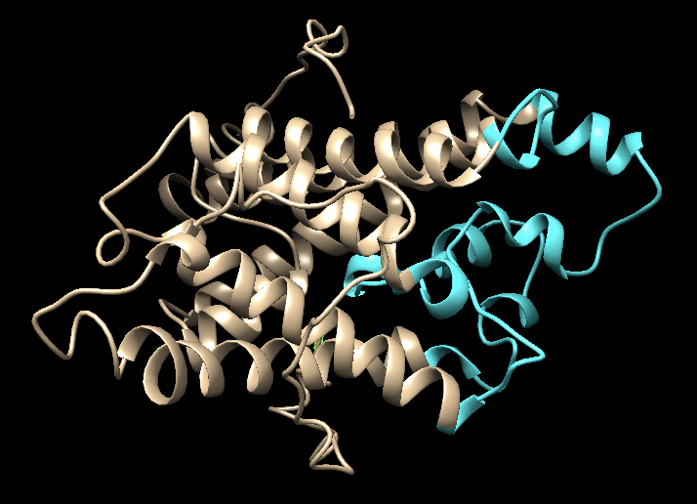
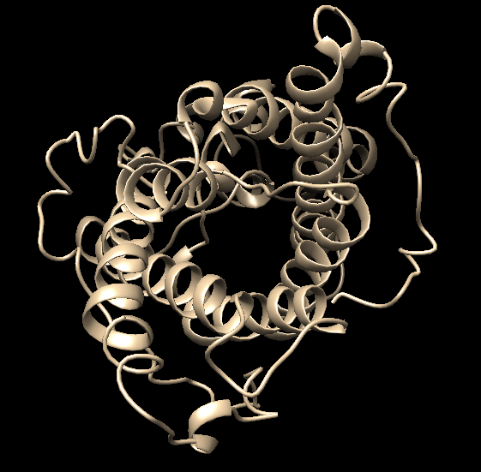
B

A

Fig 1: Modeling through I-Tasser AQP7. A) Front view. B) Side view, in magenta,
Extracellular portion

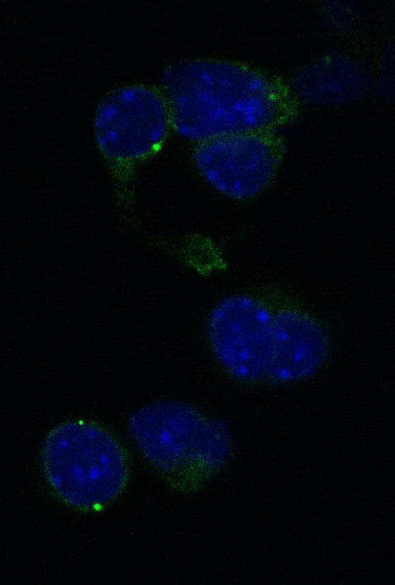
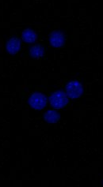
B

A

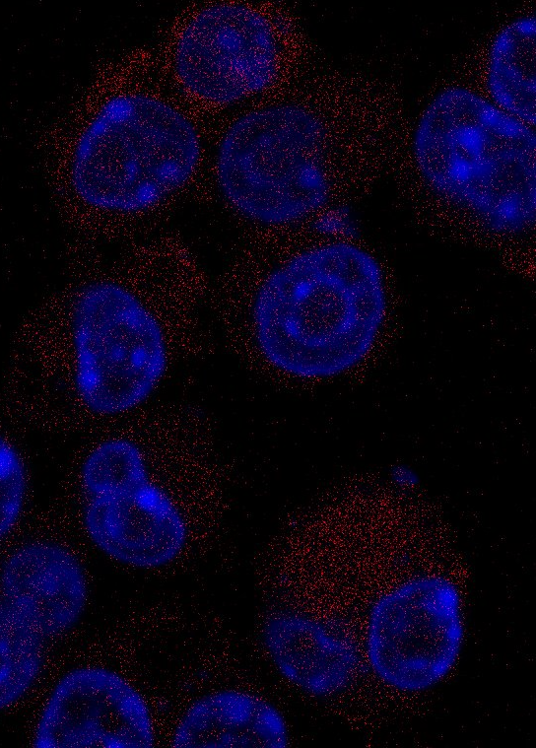
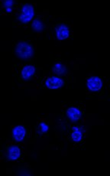
D

C

Fig 2: Localization of CR1 protein in THP-1 cells. Cells were incubated with antibody anti CR1 (A) or without (B). FITC was used as secondary antibody.
C) THP-1 cells incubated with a bioinformatically designed peptide Rhodamine labeled 100 uM for 60 min at 37ºC. D) THP-1 cells incubated with a non-specific peptide. Blue: Topro. Red: Rhodamine B. Green: FITC.

Recent Publications (minimum 5)
- Haka, A. S., Barbosa-Lorenzi, V. C. V. C., Lee, H. J., Falcone, D. J., Hudis, C. A., Dannenberg, A. J., & Maxfield, F. R. (2016). Exocytosis of macrophage lysosomes leads to digestion of apoptotic adipocytes and foam cell formation. Journal of Lipid Research, 57(6), 980–92.
- Maeda, K., Cao, H., Kono, K., Gorgun, C. Z., Furuhashi, M., Uysal, K. T., … Hotamisligil, G. S. (2005). Adipocyte/macrophage fatty acid binding proteins control integrated metabolic responses in obesity and diabetes. Cell Metabolism, 1(2), 107–119.
- Matsumura, K., Chang, B. H., Fujimiya, M., Chen, W., Kulkarni, R. N., Eguchi, Y., … Chan, L. (2007). Aquaporin 7 is a beta-cell protein and regulator of intraislet glycerol content and glycerol kinase activity, beta-cell mass, and insulin production and secretion. Mol Cell Biol, 27(17)
- Rojek, A., Praetorius, J., Frokiaer, J., Nielsen, S., & Fenton, R. A. (2008). A Current View of the Mammalian Aquaglyceroporins. Annual Review of Physiology, 70, 301–327.
5. Sárvári, a K., Doan-Xuan, Q.-M., Bacsó, Z., Csomós, I., Balajthy, Z., & Fésüs, L. (2015). Interaction of differentiated human adipocytes with macrophages leads to trogocytosis and selective IL-6 secretion. Cell Death & Disease, 6(January), e1613.

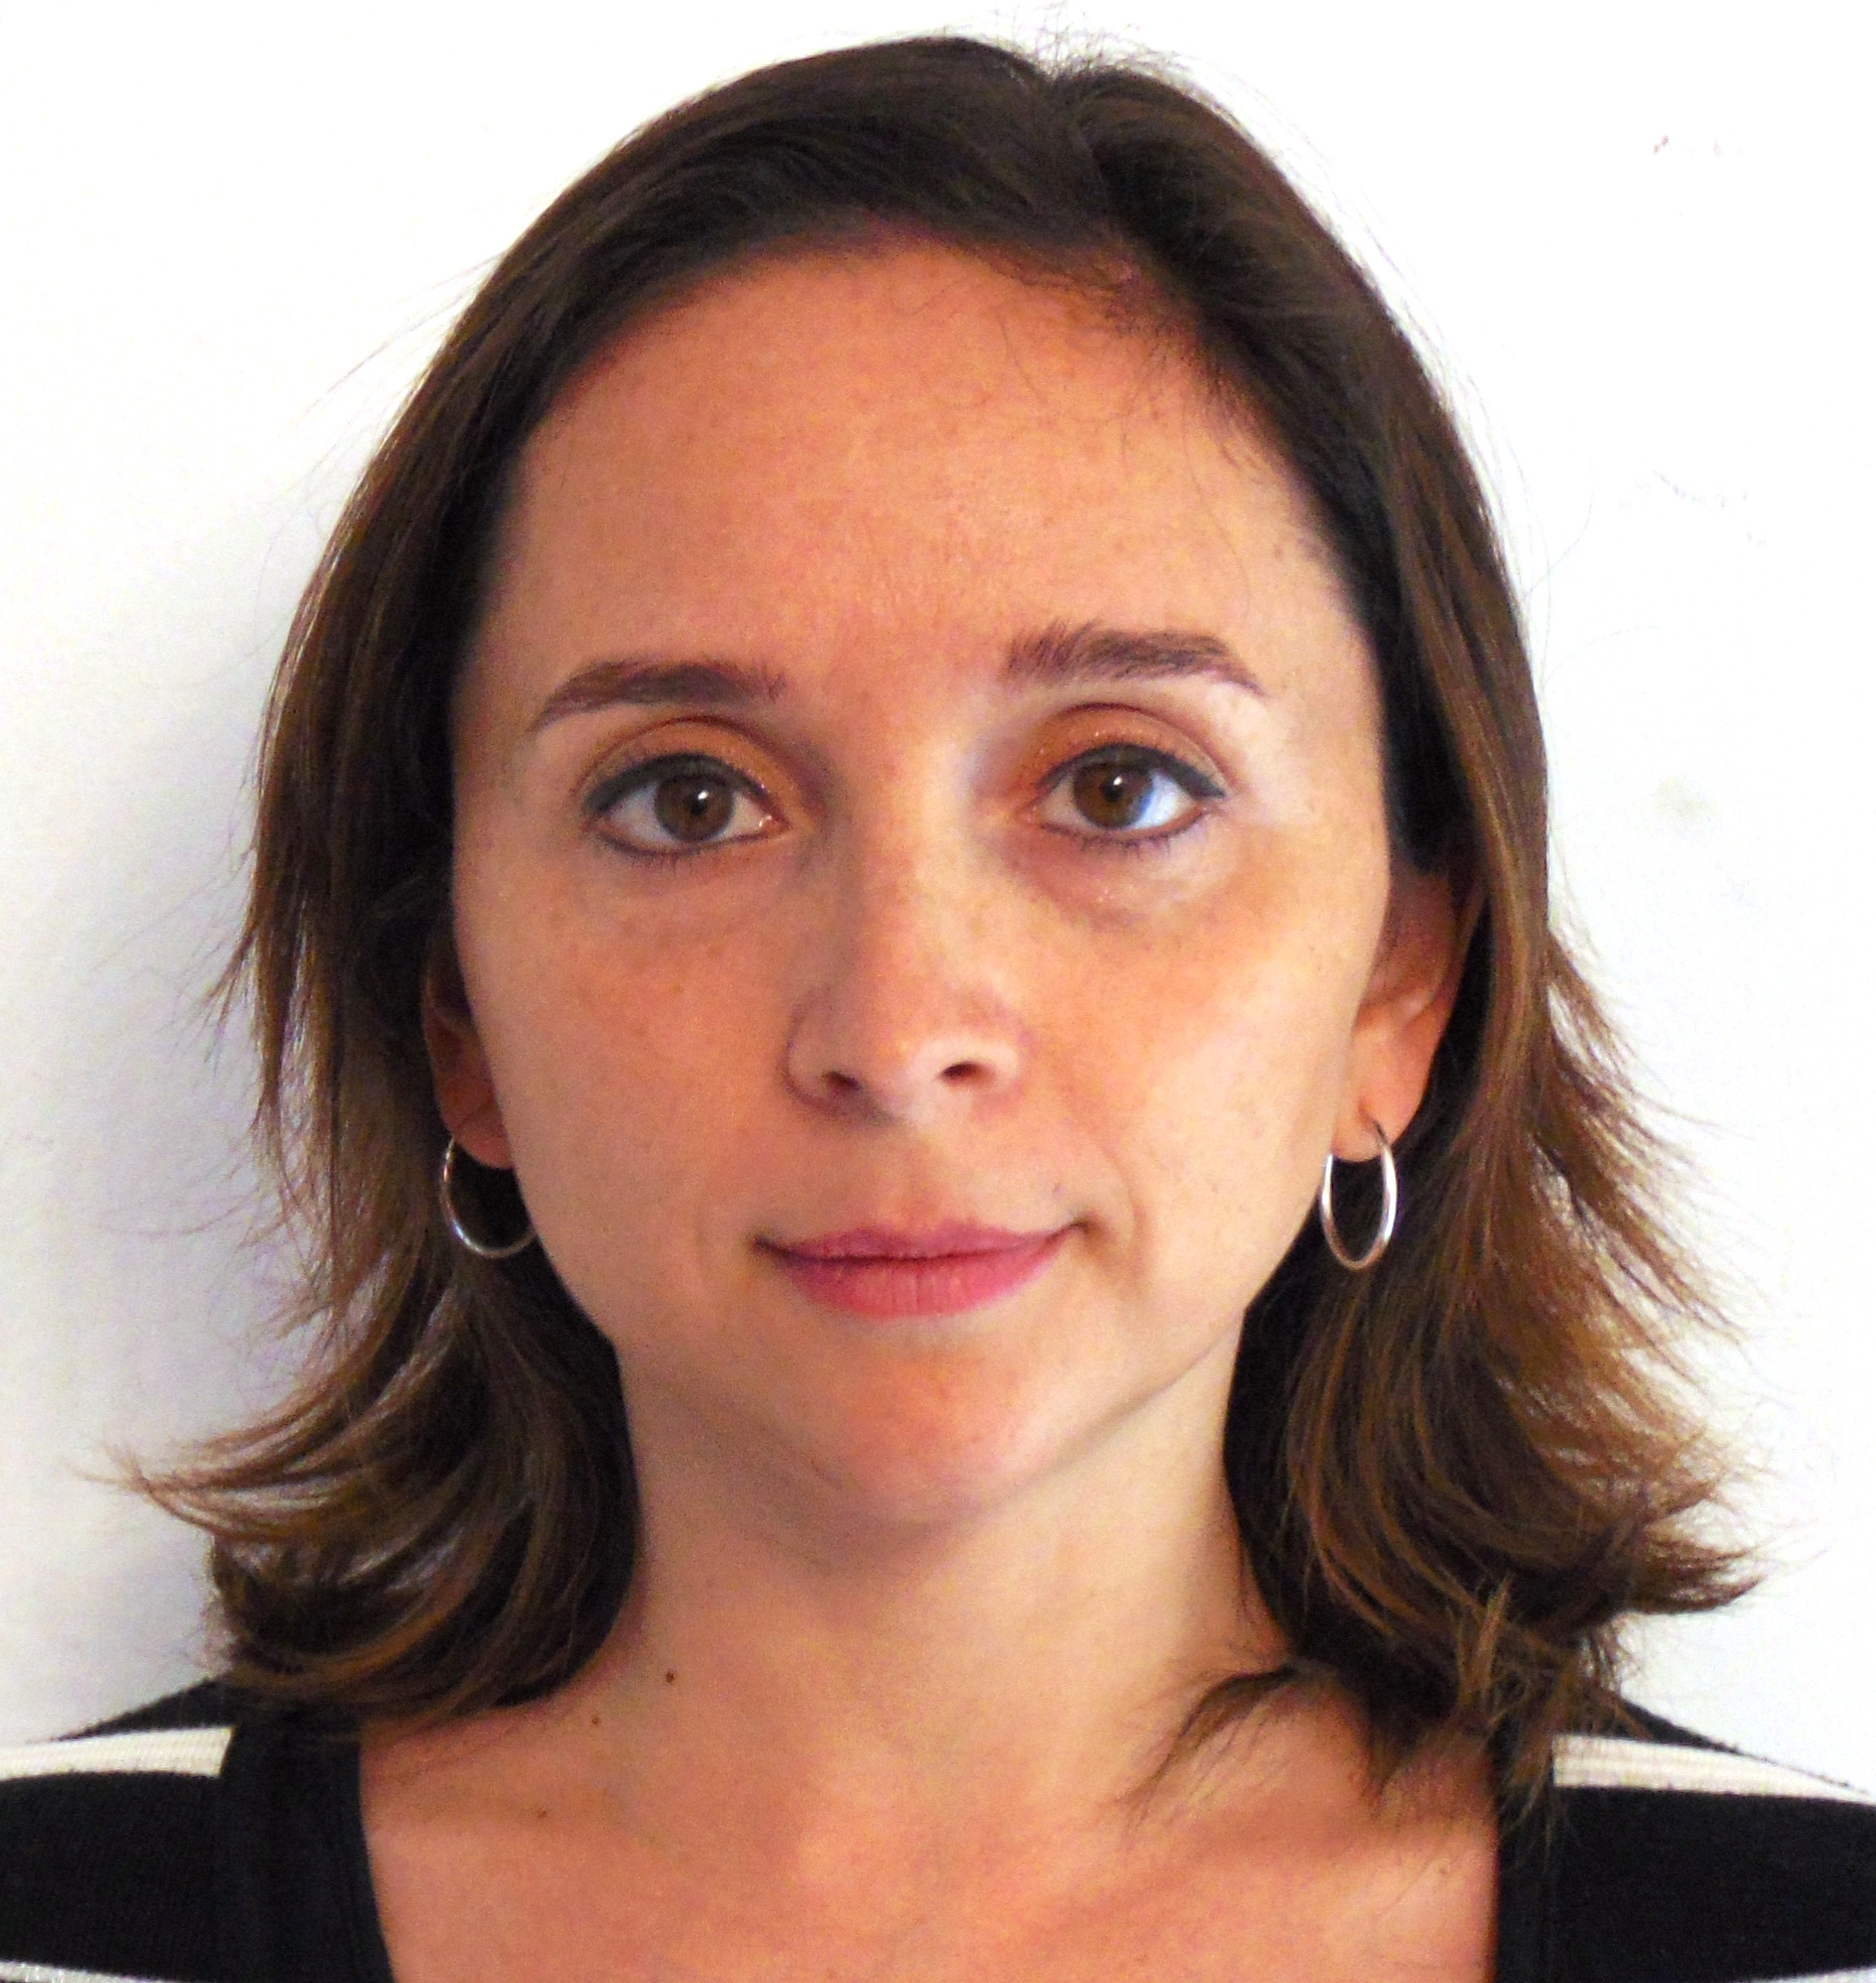Biography (150 word limit)
Ivonne Bartsch

Ivonne Bartsch is a B.S. Pharmacist and Ph.D. Biotechnology student at Pontifical Catholic University of Valparaíso, Chile. From 2008 to 2013: founder and director of a private Quality Control Drugs laboratory (Bioeq). Diplomate in Pharmaceutical Management and a Post-title Care Pharmacy at University of Valparaiso. Since 2013, Auxiliar Professor Quality Control, Medical School in Andrés Bello University, Viña del Mar, Chile. Presenter in XL annual meeting of the society of Biochemistry and Molecular Biology, Chile.

Email: ivonne.bartsch.j@mail.pucv.cl

Notes/Comments: Acknowledgments to National Commission for Scientific and Technological Research, CONICYT. Chile's goverment

