Toxoplasma gondii: transmission, diagnosis and prevention

Nouran Shami,Msc.,University College, Khalifa University

Abstract (300 word limit)
Toxoplasmosis, caused by the protozoan parasite Toxoplasma gondii, is one of the most common parasitic infections of man and other warm-blooded animals. It has been found world-wide from Alaska to Australia. Nearly one-third of humanity has been exposed to this parasite. In most adults it does not cause serious illness, but it can cause blindness and mental retardation in congenitally infected children and devastating disease in immunocompromised individuals.

Image
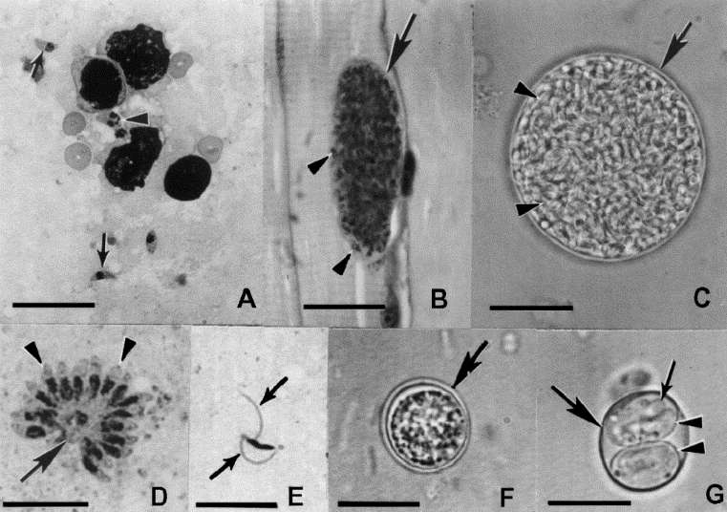
Figure 1: Stages of Toxoplasma gondii. Scale bar in (A) to (D) ¼ 20 mm, in (E) to (G) ¼10 mm. (A) Tachyzoites in impression smear of lung. Note crescent-shaped individual tachyzoites (arrows), dividing tachyzoites (arrowheads) compared with size of host red blood cells and leukocytes; Giemsa stain. (B) Tissue cysts in section of muscle. The tissue cyst wall is very thin (arrow) and encloses many tiny bradyzoites (arrowheads); haematoxylin and eosin stain. (C) Tissue cyst separated from host tissue by homogenization of infected brain. Note tissue cyst wall (arrow) and hundreds of bradyzoites (arrowheads); unstained. (D) Schizont (arrow) with several merozoites (arrowheads) separating from the main mass; impression smear of infected cat intestine, Giemsa stain. (E) A male gamete with two flagella (arrows); impression smear of infected cat intestine, Giemsa stain. (F) Unsporulated oocyst in faecal float of cat feces; unstained. Note double-layered oocyst wall (arrow) enclosing a central undivided mass. (G) Sporulated oocyst with a thin oocyst wall (large arrow), two sporocysts (arrowheads). Each sporocyst has four sporozoites (small arrow) which are not in complete focus; unstained.
Recent Publications (minimum 5)
- Tang, Q., Abdelfattah, N. S., Blackburn, J. S., Moore, J. C., Martinez, S. A., Moore, F. E., ... & Liwski, R. S. (2014). Optimized cell transplantation using adult rag2 mutant zebrafish. Nature methods, 11(8), 821.
- Abdelfattah, N., Chen, E., Perales-Patón, J., Rosen, E., Ko, A., Peisker, F., ... & Losman, J. A. (2015). Physical Interaction between mutant calreticulin and the thrombopoietin receptor is required for hematopoietic transformation.
- Elf, S., Abdelfattah, N. S., Baral, A. J., Beeson, D., Rivera, J. F., Ko, A., ... & Mullally, A. (2017). Defining the requirements for the pathogenic interaction between mutant calreticulin and MPL in MPN. Blood, blood-2017.
- Elf, S., Abdelfattah, N. S., Chen, E., Perales-Patón, J., Rosen, E. A., Ko, A., ... & Morgan, E. A. (2016). Mutant calreticulin requires both its mutant C-terminus and the thrombopoietin receptor for oncogenic transformation. Cancer discovery.Experimental neurology 213:10-17.

Biography (150 word limit)
Nouran Shami won two scholarships in 2009 and 2014 for her BA. in Clinical Sciences from Khalifa University, UAE and same for her her Msc. Degree. Upon graduation, she worked for Worcester Polytechnic Institute and become fascinated by the field of cancer biology and its vast molecular processes. For her research at Teejan Labs in UAE, she chose to focus on stem cell biology and cancer using the genetically-tractable zebrafish model of T-cell Acute Lymphoblastic Leukemia discipline.
Email: nouran.shami@teejanuae.com

Notes/Comments:

