Dr.Hemanth Kumar Nambari,PharmD,MHPP,IOT

Abstract :

Introduction: Adverse drug reactions (ADRs) Reporting is provides safety and Improves strength of Drug adverse reaction to the Drug. Such ADR reporting programs encourage surveillance for ADRs, promote the reporting of ADRs and stimulate the education of health professionals regarding potential ADRs. Objective: ADR monitoring is an important part of post marketing surveillance which helps in generating data on safety of medications. Main Aim to ADRs Monitoring is to the Promoting rational use of drugs, Safe use of Medicine, Improving patient care, improving public health. Methods and Material: This was a prospective, observational, voluntary reporting study. Study was conducted in H.S.K Hospital and Research centre, Navanagar, Bagalkot, Karnataka. Samples was collected from Skinand VD, General Medicine, Pediatric Department and in all age groups. We are taken support of WHO Scale, Naranjo scale, Hartwig scale, CDSCO Form to collect the data. Result: In our study observed 77 ADRs in overall 59 patients of with ADRs reported from 180 patients was reported from both inpatients and outpatients, in this outpatients were less compared to inpatient. Highest ADRs are reported in (28.4%) skin rashes, General Medicine (69.7%) in different organs like Hematology, Cardiology, and Central nerves system, Hepatic, Renal, Endocrine, Respiratory and Gastrointestinal. In those study Antibiotic (20.8%) were causes high ADRs in those moderate level (75.3%) ADRs high than sever (10.4) in those as per WHO scale casual assessment probable (46.8%) ADRs were high. As per age group Incidence of ADRs among 0-15 age is 1.7% is less than 16-30 age group is 32.2% and is significantly higher than other age groups. In these studies we got type-A reactions as 26.08% is less than type-B reactions as 73.92%. Conclusion: The present evaluation has revealed opportunities for interventions especially for the avoidable ADRs which will help in promoting safer drug use, information to the healthcare professionals. Improve the quality of patient care and educate to increase awareness.

Image
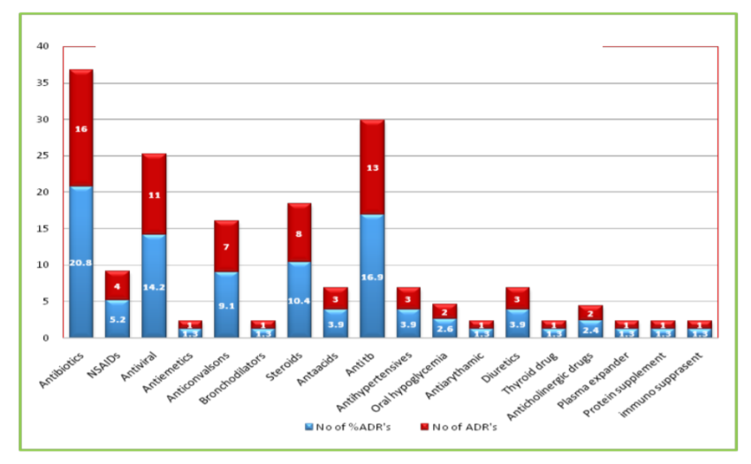
Recent Publications
- phase iii trials on Erictle Dysfunction of an drug (unmarketed) in 7 months by Ajanta pharmaceuticals (biosphere cro)
- Hospital Formulary and its Management in journal of international pharmaceutical sciences (jips)
- ADR monitoring and reporting at HSK hospital and Reserch center in indian journal of pharmacy practice (ijpp)
- suspected adverse drug reactions in elderly patients in international journal of pharmacotherapy (ijp)
- Technical analysis of Water in 100 villages of Uddanam region and its Solutions(Unpublished)


Biography
Hemanth Kumar Nambari has her expertise in evaluation and passion in improving the health and wellbeing. He is a Pharmacist with Pharm-D qualification along with professional certification of MHPP(Mobile Helth and Pharmacy Practice) and IOT(Internet of Things) significantly wish to explore the field of clinical pharmacy and sharpen my theoretical, hands on knowledge of clinical pharmacy activities like Adverse drug reactions, drug interactions, patient counseling and drug information. I want to explore the vast knowledge in the field of clinical research, pharmacotherapeutics, and pharmacology and also in Clinical Research.
Email: dr.hemanthpharmd@gmail.com Ph:+91949461089,+918555859357

