Color Comparison Study on the Methanolic and Aqueous Extracts of Areca catechu “Nganga” (Arecaceae) Fruit, Bixa orellana “Atsuete” (Bixaceae) Seed and Hibiscus rosa-sinensis Linn. “Gumamela” (Malvaceae) Flower as a Red Dye using UV-Vis Spectrophotometry

By
Cura, Cary U.
Custodio, Dennice R.
Dañas, Adeline N.
De Castro, Maicheryll I.
Eman, Mark Angelo F.
Famini, Bianca Joyce F.
Gonzales, Ronnell John R.

ABSTRACT
Natural colorants are used in the coloration of food, handicraft items, toys, textiles and in leather processing. Many of the color-yielding plants are used as medicines in various traditional medicinal systems. Interest for natural colorants has increased dramatically worldwide due to the awareness of possible toxicity that can be caused by modern synthetic dyes. Synthetic colors have been banned in certain countries due to allergic and carcinogenic symptoms that they can cause. More eco-friendly colorants are now being developed to replace synthetic dyes which can be toxic and hazardous to health. Thus, the researchers wanted to study natural colorants from three botanical sources namely, Areca carechu, Bixa orellana and Hibiscus rosa-sinensis as possible alternative for the commercially used Food, Drug and Cosmetic colorant, Allura Red. UV-Vis Spectrometry was used to measure the transmittance of the samples which were used to obtain their CIELAB values and to compare the colorants quantitatively. Natural colorant from Areca catechu, Bixa orellana, and Hibiscus rosa-sinensis mean L* values were 21.6097, 44.3664 and 19.0708 respectively; mean a* values were 89.2146, 65.3665 and 69.7741 respectively; and mean b* values were 99.0016, 110.3789 and 21.6674 respectively. These results revealed that the natural colorants from Areca catechu, Bixa orellana, and Hibiscus rosa-sinensis all fall within the dark, red and yellow spectra of colors. Using One Way Analysis of Variance (ANOVA), it was found out that both the natural colorants from A. catechu and B. orellana yielded p-values of 0.042 and 0.024 respectively. These are both lower than the level of significance at ∝ 0.05 which means that there is a significant difference between the combined CIELAB values for color characterization of the natural colorants obtained from A. catechu and B. orellana to that of Allura Red. Thus it can be inferred that they can’t be utilized and further studied as possible alternative colorants to Allura Red. Only H. rosa-sinensis yielded a p-value of 0.641 that is greater than the level of significance at ∝ 0.05. This means that there is no significant difference between the combined CIELAB values for color characterization of the natural colorant obtained from Hibiscus rosa-sinensis to that of the standard, Allura Red making it a potential alternative. It can also be inferred through such data that among the three natural colorants that were analyzed in this study, the natural colorant from H. rosa-sinensis is the closest to Allura Red in term of combined color characteristics.

CARY U. CURA
Brgy. Tunhac 2 Famy, Laguna ǀ 09478537014 ǀ curacary@yahoo.com

EDUCATION

2013 – Present National University Bachelor of Science in Pharmacy

2009 – 2013 Liceo de Pakil
Secondary

2004 – 2009 Blessed James Cusmano Academy
Primary

POSITIONS HELD & AFFILIATIONS

2015 – 2016 NU College of Pharmacy Student Council Zeta Chapter
Head, Socio-cultural Committee

2012 – 2013 Liceo de Pakil, Campus Youth Ministry
4th Year Representative

2012 – Present Federation of Junior Chapters Philippine Pharmacists Association
Member

INTERNSHIP EXPERIENCE

Manufacturing Pharmacy
June – November 2016 First Asia Manufacturing Corporation

Community Pharmacy
April – May 2013 Watsons Drugstore

DENNICE R. CUSTODIO
616 T. Claudio St. Sagbat Maybancal Morong, Rizal ǀ 09279050099 ǀ dennice.custodio123@gmail.com

EDUCATION

2016 – Present National University Bachelor of Science in Pharmacy

2012 – 2013 Adamson University Bachelor of Science in Pharmacy

2008 – 2011 Morong National High School
Secondary

2003 – 2008 Maybancal Elementary School
Primary

POSITIONS HELD & AFFILIATIONS

2011 – 2013 NU College of Pharmacy Student Council Zeta Chapter
Head, Finance and Sponsorship Committee

2014 – 2015 NU College of Pharmacy Student Council Zeta Chapter
2nd Year Representative

2012 – Present Federation of Junior Chapters Philippine Pharmacists Association
Member

2014 – Present Philippine National Red Cross National University Chapter Member

INTERNSHIP EXPERIENCE

Manufacturing Pharmacy
May – June 2016 Akita Herbal Product

Hospital Pharmacy
April – June 2017 Lung Center of the Philippines

Community Pharmacy
April – May 2013 Watsons Drugstore
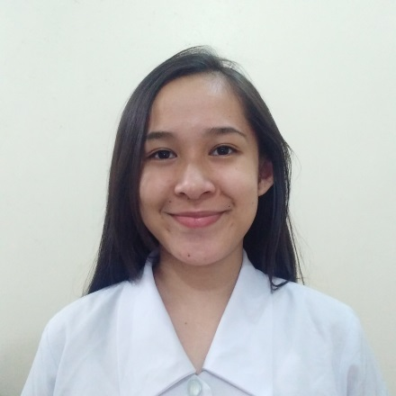

ADELINE N. DAÑAS
Silk Residences Santol St. Sta. Mesa, Manila ǀ 09155616575 ǀ adelinedanas@gmail.com

EDUCATION

2014 – Present National University Bachelor of Science in Pharmacy

2010 – 2014 Lopez National Comprehensive High School
Secondary

2004 – 2010 Lopez West Elementary School Bldg.1
Primary

POSITIONS HELD & AFFILIATIONS

2016 – 2017 NU College of Pharmacy Student Council Zeta Chapter
Treasurer

2015 – Present Red Cross Youth – Manila Chapter
Member

2014 – Present Federation of Junior Chapters Philippine Pharmacists Association
Member

INTERNSHIP EXPERIENCE

Hospital Pharmacy
June – July 2017 East Avenue Medical Center

Manufacturing Pharmacy
October – November 2016 Pharmahex Inc.

Community Pharmacy
April – May 2016 Mercury Drug Corp.
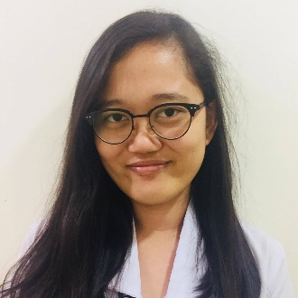
MAICHERYLL I. DE CASTRO
316 Pulang Lupa, Brgy. Locloc, Bauan, Batangas ǀ 09172761168 ǀ decastromai_97@yahoo.com

EDUCATION

2017 – Present National University Bachelor of Science in Pharmacy

2014 – 2017 St. Jude College- Manila Bachelor of Science in Pharmacy

2010 – 2014 Sta. Teresa College
Secondary

2004 – 2010 Locloc Elementary School

Primary

POSITIONS HELD & AFFILIATIONS

2014-Present Youth Task Force Development
Member

INTERNSHIP EXPERIENCE

Manufacturing Pharmacy
December 2016 – February 2017 Medicamenta Inc.

Hospital Pharmacy
August – October 2016 St. Jude Hospital

Community Pharmacy
September- October 2015 Mercury Drug Corporation



MARK ANGELO F. EMAN
#20 Pagalagala, Pinamalayan Oriental Mindoro, 5208, Philippines ǀ 09153868809 ǀ markangeloeman@yahoo.com

EDUCATION

2013 – Present National University Bachelor of Science in Pharmacy

2009 – 2013 Immaculate Heart of Mary Academy
Secondary

2004 – 2009 Quinabigan Elementary School
Primary

POSITIONS HELD & AFFILIATIONS

2014 – Present Philippine National Red Cross-National University Chapter Member

2013 – Present Federation of Junior Chapters Philippine Pharmacists Association
Member

2012 – 2013 IMHA School Council of Students
Treasurer

2010 – 2012 IMHA School Council of Students
Business Manager

INTERNSHIP EXPERIENCE

Manufacturing Pharmacy
April– May 2016 Akita Herbal Products

Hospital Pharmacy
May – June 2017 Philippine Children’s Medical Center

Community Pharmacy
April – May 2014 Watsons Your Personal Store – San Lazaro

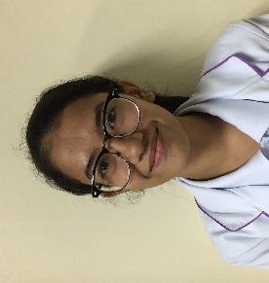
BIANCA JOYCE F. FAMINI
313 Masikap St. Tawiran Extn., Santolan, Pasig City ǀ 09065794850 ǀ bianca_famini@icloud.com

EDUCATION

2017 – Present National University Bachelor of Science in Pharmacy

2014 – 2017 St. Jude College- Manila Bachelor of Science in Pharmacy

2010 – 2014 Christ the King College of Cavite Foundation
Secondary

2004 – 2010 Grace Horizon Grade School

Primary

POSITIONS HELD & AFFILIATIONS

2016-2017 St. Jude College - Manila
Assistant Treasurer

2013 –2014 Christ the King College of Cavite Foundation Newspaper Publication
Editor

INTERNSHIP EXPERIENCE

Manufacturing Pharmacy
April –May 2017 Medicamenta Inc.

Hospital Pharmacy
December 2016- February 2017 St. Jude Hospital

Community Pharmacy
September- October 2015 Mercury Drug Corporation

RONNELL JOHN R. GONZALES
Block 19 Lot 12 District 1-B EPZA Pulung Cacutud, Angeles City, Pampanga ǀ 09482293935 ǀ rongonzalespharma@gmail.com

EDUCATION

2016 – Present National University Bachelor of Science in Pharmacy

2013 – 2014 Our Lady of Fatima University – Valenzuela Bachelor of Science in Pharmacy

2011 – 2013 Angeles University Foundation Bachelor of Science in Pharmacy
Dean’s Lister (Four Consecutive Semesters)

2007 – 2011 Angeles University Foundation – Integrated School
Secondary
6th Honorable Mention

2001 – 2007 EPZA Resettlement Elementary School
Primary
Batch Valedictorian

POSITIONS HELD & AFFILIATIONS

2017 – 2018 NU College of Allied Health Student Council
President

2011 – 2013 The AlliMed Explorer Collegiate Publication
News Correspondent

2010 – 2011 Hi-News High School Publication
News Editor

2013 – Present Federation of Junior Chapters Philippine Pharmacists Association
Member

INTERNSHIP EXPERIENCE

Manufacturing Pharmacy
April – May 2017 Soapking Incorporated

Hospital Pharmacy
May – June 2014 Philippine General Hospital

Community Pharmacy
April – May 2012 Watsons Drugstore

