Formulation and characterization of hydrophilic drug Tramadol hydrochloride nanoparticles in transdermal drug delivery system
Mina Abbasnia – Department of pharmaceutics – Hamedan university of medical science

Abstract:

Tramadol hydrochloride is a synthetic Opioid analgesic, with a suitable effect on cancer and post-op pains. Its addiction and short half-life make it hard to use. Its main metabolite (O-des methyl Tramadol) is a pure agonist of µ receptors and the cause of addiction. Transdermal Drug Delivery System (TDDS), is a delivery system that can control the drug release perfectly and it has no First Pass Metabolism (FPM), and is non-invasive. In order to modify this delivery system features, Solid Lipid Nanoparticles (SLNs) can be used as the carrier of choice. Tramadol Hydrochloride loaded SLNs were prepared using Double Emulsification-Solvent Evaporation technique and a Central-Composite design, based on two independent variables (lipid/soy lecithin ratio and the amount of drug), which used to reduce the number of required experiments. In order to examine the experimental design method, Polydispersity index (PdI), particle size, Zeta potential, Entrapment and Loading efficiency and In-vitro release studies were determined using Zetasizer NanoZS and HPLC system. Also the microscopic pictures of the particles were taken using a Transmission Electronic Microscope. The optimum results for Tramadol HCl loaded SLNs were as follows: Size: 197 nm, PdI: 0.21 , Zeta: -19.8 , EE: %89.4 , LE: %9.74. Also, up to 30 % of incorporating drug was released from optimized SLNs in the initial period of 6 h and up to 40 % of the drug was released in a period of 24 h, and according to these results the SLNs formulation follows Fickian diffusion. Also the TEM images showed a nearly spherical shape of the particles. As a result, there was no significant difference between calculated and measured data, Tramadol HCl loaded SLNs can be used as a local analgesic. Although Further experiments (specially pharmaceutical and pharmacological) will be needed in order to use this product clinically.

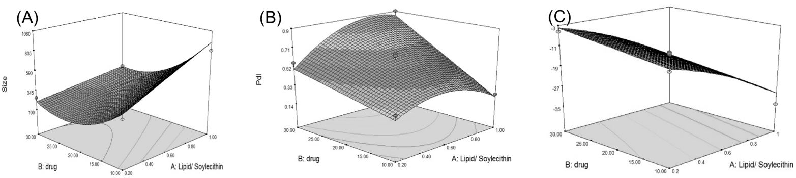
Image:
Figure 1 - Response surface (3D) plots illustrating: A) the effect of the lipid/SL ration and the amount of drug on particle size; B) and PDI and C) and on the zeta potential.

Recent publications:

- H. O. Ammar, M. Ghorab, S. A. El-Nahhas, R. Kamel. Polymeric Matrix System for Prolonged Delivery of Tramadol Hydrochloride, Part I: Physicochemical Evaluation. AAPS PharmSciTech.10(4), 2009.
- Kovacevic A., Savic S., Vuleta G., Muller R.H., Keck C.M. - Polyhydroxy surfactants for the formulation of lipid nanoparticles (SLN and NLC): effects on size, physical stability and particle matrix structure. - Int. J. Pharm., 406, 163-172, 2011.
- Z. Rahman, A.S. Zidan, M.A. Khan, Eur. J. Pharm. Biopharm. Non-destructive methods of characterization of risperidone solid lipid nanoparticles. European Journal of Pharmaceutics and Biopharmaceutics.; 76 (1): 127-137, 2010.
- Singh S., Dobhal A.K., Jain A., Pandit J.K., Chakraborty S. - Formulation and evaluation of solid lipid nanoparticles of a water soluble drug: Zidovudine. - Chem. Pharm. Bull. (Tokyo), 58, 650-655, 2010.
- M. Nabi-Meibodia, A. Vatanaraa, A. R. Najafabadi, M. R. Rouinia, V. Ramezania, K. Gilania, et al. The effective encapsulation of a hydrophobic lipid-insoluble drug in solid lipid nanoparticles using a modified double emulsion solvent evaporation method. Colloids and Surfaces B: Biointerfaces. 112 (1): 408-414, 2013.

Biography:
Mina Abbasnia a recently graduate, from Hamedan university of medical science in Pharmacy. Her interest and line of work was mostly in pharmaceutical sciences especially Topical delivery systems and nanotechnology. This study was her final thesis which was a work done mostly in Tehran university of medical science under the observation of Dr. A. Vatanara. She was also an assistant in many other similar cases. She wishes to continue her work and study in the same field, especially possible ways to use Transdermal Delivery System in cosmetics.

Email: mina.abbasnia@gmail.com

