Development and Evaluation of Co-polymeric Carrier System of Risedronate for the Treatment of Osteoporosis
Supriya Verma, Panjab University, Chandigarh
ABSTRACT
AIM: The study was intended to develop copolymer based carrier system of drug Risedronate (RIS) for its effective bone delivery at the target site for the treatment of osteoporosis (porous bone disease).
SUMMARY OF THE PROBLEM: Risedronate is a FDA-approved third generation bisphosphonate drug which acts as antiresorptive agent in the treatment of osteoporosis. It is a versatile drug molecule, which has been used for the treatment of postmenopausal osteoporosis, glucocorticoid-induced osteoporosis, male osteoporosis and Paget’s disease. It is available in the market as oral tablet dosage forms but has some challenges like patience incompliance, low drug permeability and is prone for metal chelation, which leads to GIT irritation.
METHODOLOGY & THEORETICAL ORIENTATION: The chosen drug (RIS) was entrapped in copolymer based carrier system, which consists of chitosan, tripolyphospate (TPP) and eudragit. Chitosan and eudragit copolymer based nanoparticles were prepared by using ionic gelation followed by coacervation method
OBSERVATIONS: The prepared system has been characterized for particles size, PDI, zeta potential and entrapment efficiency, which were found as 272.8 nm, 0.184, 17.9 mV and 77.05 % respectively. FTIR studies proved the useful interaction of the drug with the polymeric shells of the system. Moroever, it’s in vitro release has been carried out in various pH media, i.e., 1.2, 6.8 and 7.4 and was found tremendously better than the conventional system. In ovariectomized rat (in vivo) model, its efficiency and safety were proved 7 times and 10 times of the conventional system respectively. Moreover, the formulation was found stable for the period of six months.
SUMMARY & CONCLUSION: Hence, this is a simple, commercial and easy to scale up method for the preparation of novel drug delivery based nanoparticle system of our choice of drug, i.e., Risedronate.
Keywords: Risedronate, copolymer based nanoparticles, target-specific (bone) drug delivery system

Image
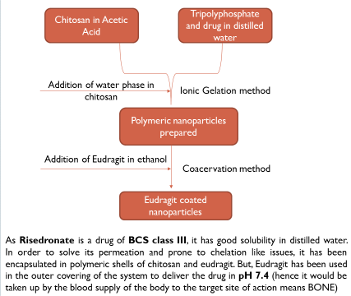

Recent Best Poster Presentations
- Supriya Verma, Neeraj K Garg, Gajanand Sharma, Bhupinder Singh and O P Katare (2017). Development of Aceclofenac Loaded-Nano Structured Lipid Carriers (NLCS) For Inflammatory Disorder(S): By QbD Approach at NanoSciTech 2017, held in Panjab University. [Best Poster Award]
- Supriya Verma, Gajanand Sharma, Sheetu Wadhwa, Bhupinder Singh and O.P. Katare (2017). Fusidic Acid-Loaded Liposomal System as a potential delivery system for the management of Chronic Plaque Psoriasis at Chascon conference, held in Panjab University, Chandigarh [Best Poster Award]
- Supriya Verma, Bhupinder Singh and Om Prakash Katare (2017). Development of methotrexate (MTX) loaded nanostructured lipid carriers (NLCs) for safe and effective transdermal delivery for the treatment of Rheumatoid Arthritis at Next-Gen Challenges in Pharmaceutical Sciences symposium, held in Panjab University, Chandigarh [Best Poster Award]
- Supriya Verma, Neeraj K. Garg, Gajanand Sharma, Bhupinder Singh and O.P. Katare (2016). Transdermal Delivery of methotrexate via nanostructured lipid carriers: a novel therapeutic approach in Rheumatoid Arthritis at ISBMR conference, held in Hinduja hospital, Mumbai [Best Oral Presentation Award]
- Supriya Verma, Gajanand Sharma, Manmeet Kaur, and O.P. Katare (2016). Formulation, Development and characterization of aceclofenac-cyclodextrin complex loaded liposomes: a dual carrier approach for topical delivery at NanoSciTech conference, held in Panjab University, Chandigarh [Best Poster Award]
- Supriya Verma, Gajanand Sharma, Himanshu Goyal, Poonam Negi and O.P. Katare (2014). Novel transferosomal system of aceclofenac with enhanced topical delivery potential at Chascon conference, held in Panjab University, Chandigarh [Best Poster Award]
LIST OF PUBLICATIONS
- Amanpreet Kaur, Kamalpreet , Gajanand Sharma, Supriya Verma, Shishu Goindi, Om Prakash Katare [2017]. Oral microemulsion of phytoconstituent found in licorice aschemopreventive against benzo(a)pyrene induced forestomach tumors in experimental mice model. Journal of Drug Delivery Science and Technology:39;523e530 (Publisher: Elsevier; Impact Factor: 1.11)
- Amanpreet Kaur , Pratibha , Gajanand Sharma, Supriya Verma, Shishu Goindi, Om Prakash Katare. Fabrication of solid lipid based colloidal nanoparticles of fenoprofen calcium with desired physicochemical attributes and promising therapeutic performance efficacy in animal studies (Under Processing for the Artificial Cells, Nanomedicine and Biotechnology journal, Impact Factor 5.1)
- Supriya Verma, Pradip Nirbhavane, Gajanand Sharma, O.P.Katare. Review on Osteoporosis: Pathogenesis, Treatment and Opportunities. (Under Processings for University journal PHARMACOS)

PREVIOUS ABROAD VISIT

Have delivered an oral presentation in the 3rd International Conference on Eye and Vision, held in Toronto, Canada (21st August- 23rd August, 2017) at Holiday Inn Hotel

Biography

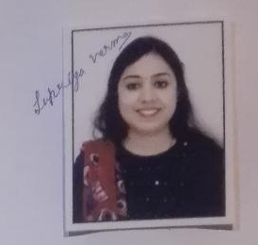

Email id: supriya_punjab@yahoo.com
Mobile Number: + 91 9463453377
Supriya Verma has been engaged in experimental laboratory work that includes formulation development, in vitro characterization and in vivo evaluation of the novel drug delivery based formulations i.e., liposomes, niosomes, solid lipid nanoparticles, nanostructured lipid carriers, etc. Her area of research is based on systematic design and development of nanostructured delivery system of Aceclofenac and Risedronate. In the last four years of research experience, she has got wonderful exposure on topical and oral drug delivery systems in an industry (Panacea Biotech, Lalru) as well as in an academic institute (University Institute of Pharmaceutical Sciences, Panjab University, Chandigarh). She has not only involved in research but also undertaking teaching of Undergraduate and Postgraduate classes. Moreover, she is having collaboration with medical institutes i.e., PGIMER, Chandigarh and AIIMS, New Delhi for the assistance of clinical studies over there. Also she is writing research articles and book chapters related to her professional domain. She has attended various National as well as International level conferences and been awarded with six best paper awards in the last four years.

