LIMB SALVAGE IN AN EXTENSIVE AND COMPLICATED VASCULAR LESION IN AN INFANT

Dr Sujata Sai
Manipal Hospital, Bangalore, India

Abstract :
Background :
Extensive vascular lesions can endanger the life of a child by their virtue of consumptive coagulopathy or cardiac failure. A conservative surgical approach is difficult and can be life-threatening due to uncontrolled bleeding. We report successful limb salvage in an infant despite an extensive and infected arterio-venous malformation of upper limb, complicated by severe consumptive coagulopathy

Case :
A term male, 3.2kgs, presented with a swelling over left arm detected antenatally. Antenatal scan- soft tissue swelling 10.8 x 6.8 x 5.4cm from left shoulder to elbow with heterogeneous cystic spaces and minimal vascularity.O/E- non compressible, no bruit heard.

Investigations:
Doppler – hypoechoic lesion+ heterogeneous echotexture, numerous cystic spaces, weak color Doppler signal- S/O- Hemangioma
MRI- lobulated soft tissue mass 17 x 16 x 9.5cm with an intensive enhancement, necrotic and hemorrhagic areas, involving flexor and extensor muscles of the arm.Supplied by branches of axillary and brachial arteries.Diagnosed as- Hemangioma , hence was started on propranolol 0.5 mg/kg/ day. At 4 months of age surgery became an imperative life saving mode of treatment.

Operative procedure :
Planned for amputation/ disarticulation.
Axillary vessels identified and controlled
Tumor excised in toto
Flexor and extensor muscles preserved as much as possible
Radial nerve through the tumor was divided and re-anastomosed
Disarticulation was hence avoided.
Arm and hand movements preserved at 10mth follow-up.

Conclusion :
A conservative limb salvage surgery is possible even in case of an extensive vascular anomaly. A good vascular control is a must to prevent life threatening hemorrhage in a conservative surgery.

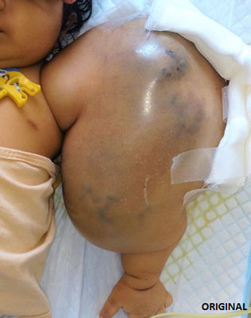
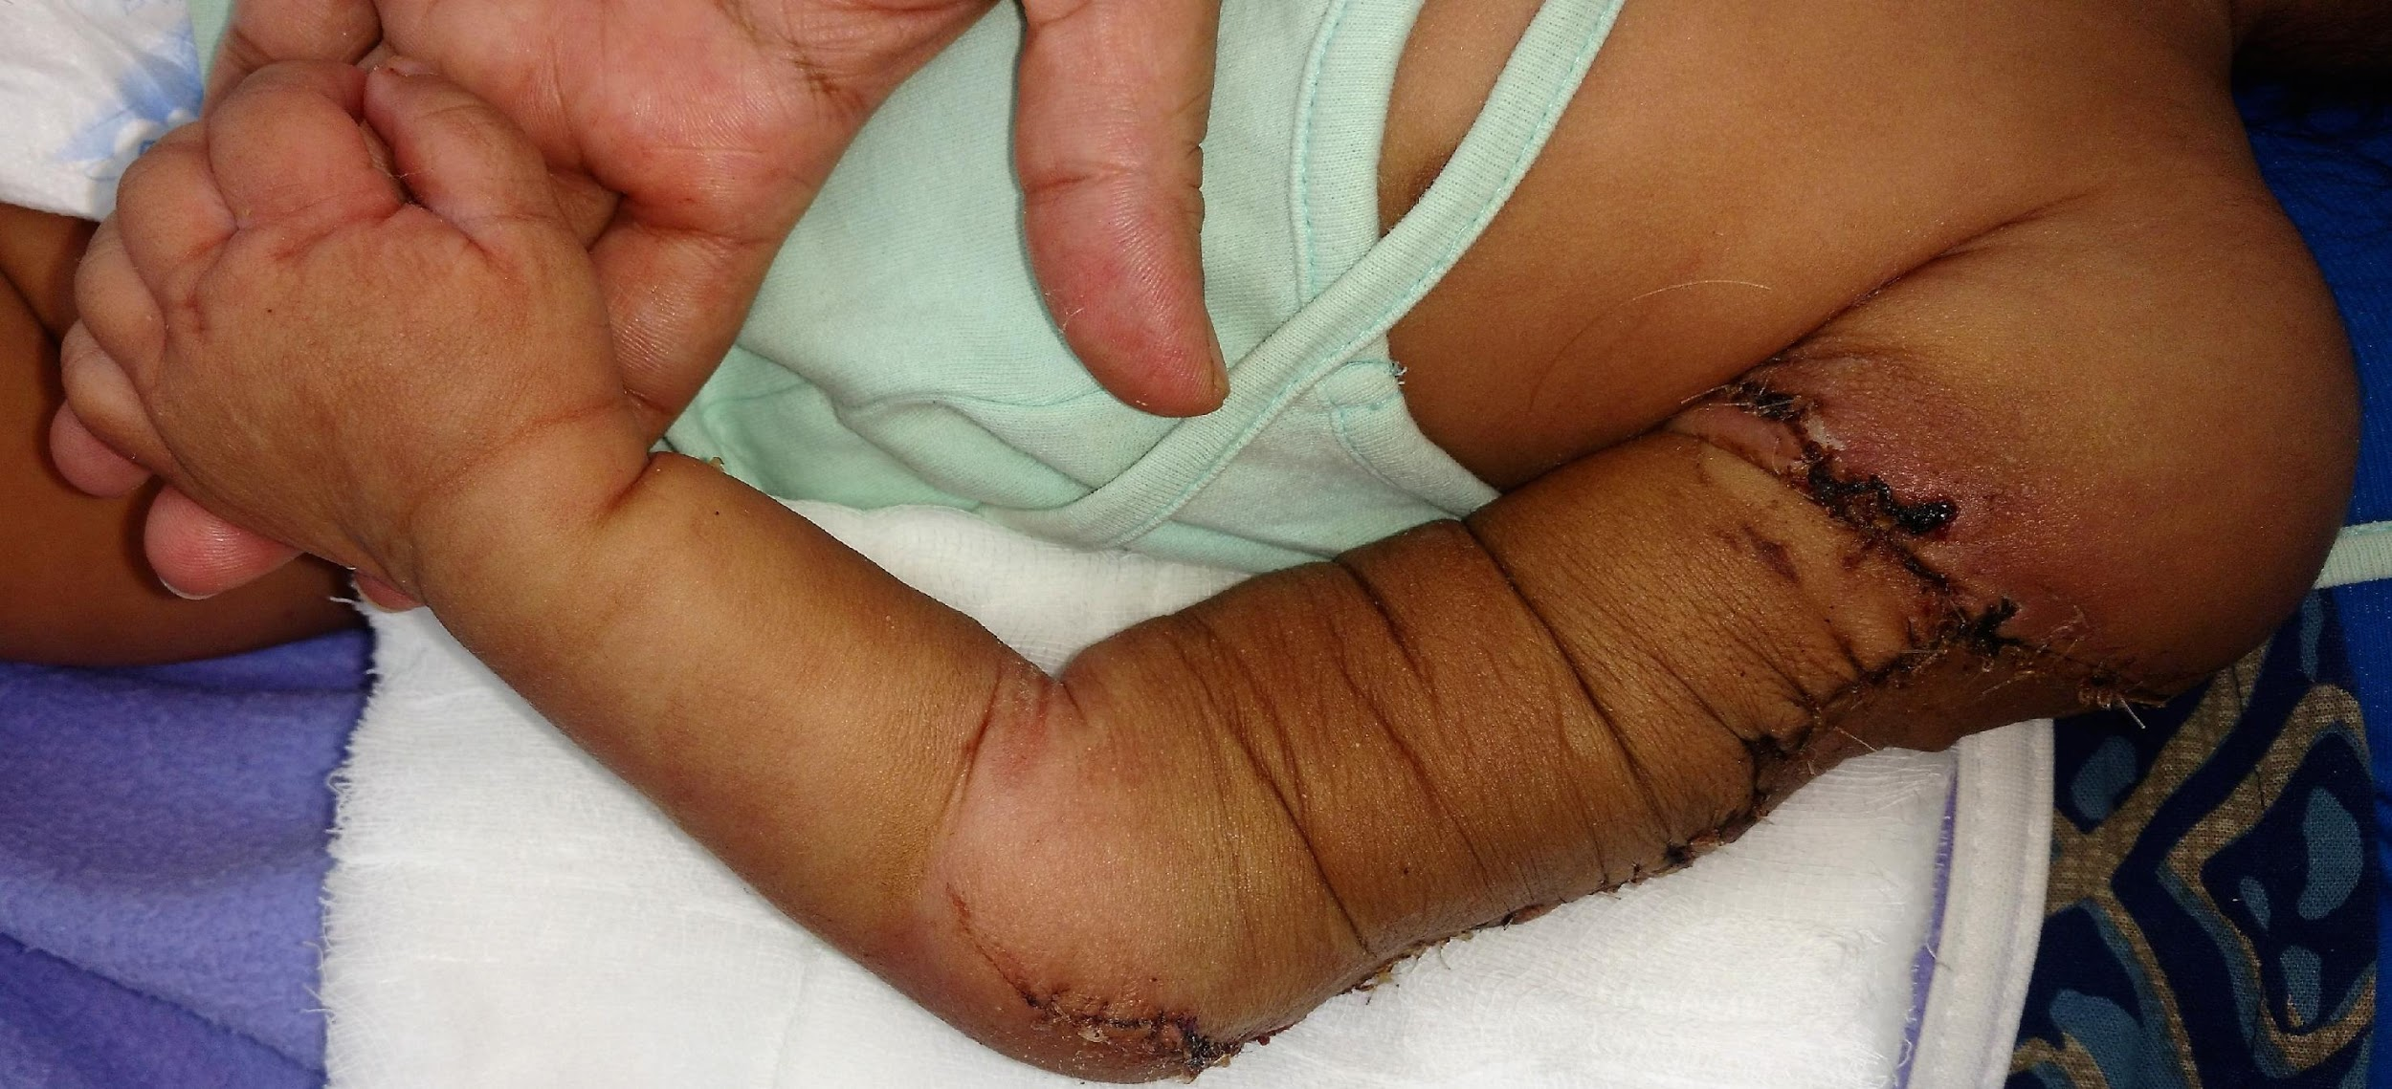

 Biography
Sujata Sai is a resident in surgery at Manipal Hospital, Bangalore. She is passionate about saving and changing lives. She also enjoys blogging about her experiences as a surgical resident. She has consistently done excellently academically, and has excelled in multiple extra curricular activities as well – She has given the Trinity College of Music Piano exams, is a part of several volunteer organisations for social service and participates in several sports as well.
Email: drsujatasai@gmail.com
Phone: +91-9886715213

Notes/Comments:

