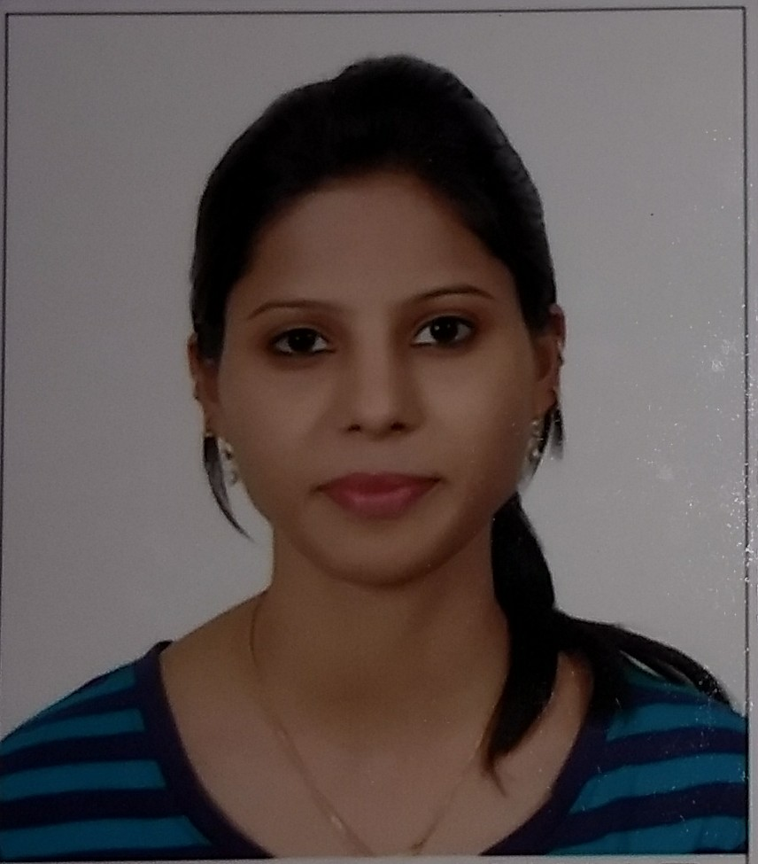
Title: PERCEPTION OF MOTHERS OF THE NEWBORNS RECEIVING KANGAROO MOTHER CARE IN A TERTIARY CARE HOSPITAL
Name: Dr. Richa Rajawat
Vardhman Mahavir Medical College & Safdarjung Hospital, New Delhi, India

“STUDY OF KANGAROO MOTHER CARE – AS PERCEIVED BY THE PARENTS” attempts to scrutinize the parent’s satisfaction and confidence in terms of their needs, expectations and outcomes from a tertiary care hospital regarding the care of low birth weight (LBW) infant during their stay in KMC ward by a structured questionnaire method and thereby analyzing the quality of care from parent’s perspective. A cross-sectional study was conducted from December 2018 to February 2019 in Department of Pediatrics, VMMC & Safdarjung Hospital, New Delhi on 400 mothers of admitted newborns weighing less than 1.8 kg. Exclusion criteria were parents of newborns with gross congenital anomalies, congenital heart diseases and surgical diseases. On discharge, mothers were interviewed by a pre-structured questionnaire regarding various domains contributing to the needs of the parents and satisfaction with the neonatal care. Each domain was scored independently for the overall quality of care of LBW infant on a Parent Satisfaction Scale of 1 to 4. Mean domain scoring was computed and the frequencies were correlated with the characteristics of the caregiver. 90.24% of interviewed parents gave positive responses regarding information, communication and parental education aspects of KMC services. Parental dissatisfaction is noticed prominently (27.75%) in the inadequacy of the information provided by the treating doctors particularly in explaining about the probable outcome of the baby’s illness. Open ended questioning revealed that information conveyed via nursing staff was more easy and understandable (88.00%) as compared to conveyed via doctors (80.50%). Parents considered behaviour of the healthcare staff as very important part of communication and told that the positive behaviour encouraged the mothers to overcome the difficult situations while handling their babies and also provided emotional support. Interpersonal relationship with the staff members emerged as one of the most important factors affecting satisfaction of mothers regarding the care of the newborn.

Biography

Dr Richa Rajawat has completed her MBBS degree at the age of 25 years from Barkatullah University, India. She is currently pursuing post graduation in Pediatrics from GGSIP University, India. She has presented many posters in national level pediatric conferences in India.
Presenting author details
Full name: Dr Richa Rajawat
Contact number: +919870320571
Twitter account:
Linked In account: richarajawat@gmail.com
Session name/ number: Breastfeeding/Neonatology
Category: (Oral presentation)

