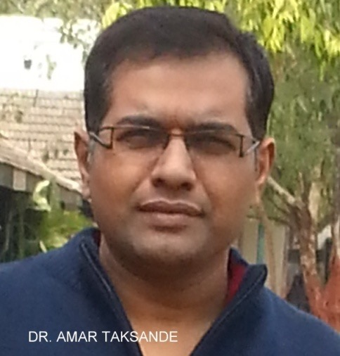

Title: Accuracy of palpable second heart sound for diagnosing Pulmonary Arterial Hypertension (PAH) in Congenital Heart Disease Children.

Dr. Amar Mohanrao Taksande,
Professor, Department of Pediatrics,
Jawaharlal Nehru Medical College, Sawangi (Meghe),
Wardha, Maharashtra state, India 442004

Abstract
Background: Pulmonary Hypertension is a complex problem characterized by non-specific signs and symptoms and having multiple potential causes. Delays in the diagnosis of PAH lead to postponement of treatment and thus may have deleterious effects. Aim: To determine the accuracy of palpable second heart sound for diagnosing pulmonary hypertension in Congenital Heart Disease Children. Study design: Hospital-based cross-sectional study. Participants: Clinically suspected Congenital Heart Disease Children in AVBRH hospital, Sawangi (Meghe), Wardha.
Methods: Three paediatric residents, trained by a cardiologist for detection of Pulmonary Hypertension in CHD cases assessed 140 clinically suspected CHD cases. They looked for palpable second heart sound (P2) and findings were correlated with 2 Dimensional Echocardiography findings . Data was entered into SPSS for statistical analysis.
Results: Out of 140 cases of CHDs, 41 cases (29.2%) had Pulmonary hypertension. The sensitivity , specificity , positive predictive value ,negative predictive value , negative LR for palpable P2 by the first observer was 70.73% , 100% , 100 % , 89.19 % , 0.29 , which was almost equal with the findings of other two observer
Conclusion: We demonstrate that palpable second heart sound are effective in diagnosing the presence of PAH in CHD children
Key words: Pulmonary Hypertension , Heart sound , palpable P2 , Echocardiography.

BIOGRAPHY
Dr.Amar Taksande is presently working as Professor in Deptt. of Pediatrics, at Jawaharlal Nehru Medical College (JNMC),DMIMS, Sawangi. He completed his residency from Mahatma Gandhi Institute of Medical Sciences (MGIMS) Medical college, Sevagram. He got Fellowship in Pediatric Cardiology at Innova children heart hospital, Hyderabad. He received an award of Visiting Fellowship by Royal College of Pediatric and Child Health (RCPCH), United Kingdom. He has published over 135 paper in national and international journals and is author of several pediatrics titles. He is life member of Indian Academy of Pediatrics, Pediatric Cardiology Society of India and several other medical organizations. He is also a peer reviewer of international Journals like congenital heart disease, Journal of Pediatrics, Journal of Pediatric Infectious disease etc.

Presenting author details
Full name: Dr.Amar Taksande
Contact number: 9822369233
Twitter account:
Linked In account:
Session name/ number: Neonatology
Category: (Oral presentation/ Poster presentation) : Oral Presentation

