The roles of Toll-like receptor 4 in the pathogenesis of pathogen-associated biliary fibrosis caused by Clonorchis sinensis
Chao Yan^{1,＋}, Bo Li^{1,2＋}, Fang Fan¹, Ying Du¹, Rui Ma¹, Xiao-Dan Cheng¹, Xiang-Yang Li¹, Bo Zhang¹, Qian Yu¹, Yu-Gang Wang¹, Ren-Xian Tang^{1**}, Kui-Yang Zheng^{1*}
¹ Jiangsu Key Laboratory of Immunity and Metabolism, Department of Pathogenic Biology and Immunology, Laboratory of Infection and Immunity, Xuzhou Medical University, Xuzhou, 221004, Jiangsu Province, People's Republic of China
² The Second Affiliated Hospital of Nanjing Medical University, Nuclear Medicine Department, Nanjing, 210011, Jiangsu Province, People's Republic of China
⁺These authors contributed equally to this work. **Co-corresponding author: E-mail: Tangrenxian-t@163.com (RXT)
*Corresponding author: E-mail: ZKY02@163.com (KYZ)

Abstract (300 word limit)

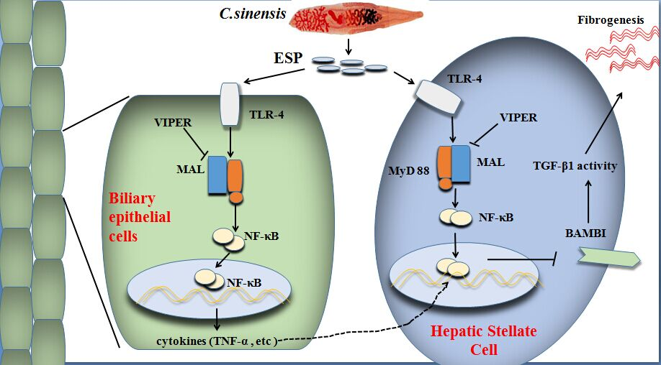
Pathogen-associated biliary fibrosis (PABF) is a type of liver fibrosis characterized by injuries of cholangiocytes and extra cellular matrix (ECM) deposition around bile ducts caused by various bacteria, fungi, virus and parasites. Recent studies show that TLR4 plays an important role in several other types of liver fibrosis, but the mechanism of TLR4 in PABF is yet really unclear. In the present study, a PABF mouse model was established by a trematode infection-Clonorchis sinensis which dwells in the bile ducts and causes severe biliary fibrosis of mice. The results showed that the levels of collagen depositions, α-SMA and hydroxyproline (Hyp) contents in TLR4^{mut} mice infected by C. sinensis were significantly lower than in those of TLR4^{wild} ones. Furthermore, we found that the activation of TGF-β signaling was impaired in the TLR4^{mut} mice, compared with wild mice when they were challenged to the same dose of C. sinensis metacercariae. Moreover, the mice with TLR4 mutation showed a decreased activation of hepatic stellate cells indicated by the expression of α-SMA, when compared with TLR4^{wild} mice. These data demonstrate that TLR4 contributes to PABF caused by C. sinensis and TLR4 signaling may be a potential medical target for treatment of PABF.
Image

Figure Legend: Combined with our previous study ^{[1]} and other study ^{[2]}, our study demonstrates that TLR4 contributes to pathogen associated biliary fibrosis caused by Clonorchis sinensis.

Recent Publications (minimum 5)
- Yan C#, Wang YH #, Yu Q, Cheng XD, Zhang BB, Li B, Zhang B, Tang RX*, Zheng KY*(2015) Clonorchis sinensis excretory/secretory products promote the secretion of TNF-alpha in the mouse intrahepatic biliary epithelial cells via Toll-like receptor 4. Parasites& Vectors; 8(1):559.
- Liu C, Chen X, Yang L, Kisseleva T, Brenner DA, Seki E (2014) Transcriptional repression of the transforming growth factor beta (TGF-beta) Pseudoreceptor BMP and activin membrane-bound inhibitor (BAMBI) by Nuclear Factor kappaB (NF-kappaB) p50 enhances TGF-beta signaling in hepatic stellate cells. The Journal of biological chemistry; 289(10): 7082-91.
- Wells RG (2014) Portal Fibroblasts in Biliary Fibrosis. Current pathobiology reports2(4):185-190.
- Seki E, De Minicis S, Osterreicher CH, et al. TLR4 enhances TGF-beta signaling and hepatic fibrosis. Nature medicine 2007; 13(11): 1324-32.
- Kinnman N, Housset C (2002) Peribiliary myofibroblasts in biliary type liver fibrosis. Frontiers in bioscience 7: d496-503.

Biography (150 word limit)
Professor Kui-Yang Zheng, MD, PhD, Professor and Head, Department of Pathogenic Biology and Immunology, the president of Xuzhou Medical University, his interests focus on exploring the roles of innate immunity such as Toll-like receptors in regulating T helper cells differentiation as well as biliary fibrosis caused by Clonorchis sinensis, a food-borne trematode that dwells in the biliary ducts and causes severe biliary fibrosis.
Email: zky02@163.com;

Notes/Comments:

