Hepatitis B Vaccine and Murine Schistosomiasis
Ossama N Mohamed*, Safeya M. Ali, Maha M. Eissa, Sonia R. Allam and Lobna A. El-Zawawy.
Microbiology department, High institute of Public health* and Parasitology department, Faculty of Medicine, Alexandria university,Egypt.

Abstract (300 word limit)
Statement of the Problem: In tropical countries, the effect of some infections on the immunological response to vaccination regimens should be considered. Schistosomiasis which is a major health problem in these areas, results in a suppressed immune response to a variety of antigens. Conversely, some killed bacteria or viruses have been reported to elicit protective effect against schistosomal infection. Methodology & Theoretical Orientation: the aim of the present study was to investigate the influence of schistosomal immunosuppression on the antibody response to hepatitis vaccine and to study if the vaccine has any protective effect on experimental Schistosoma mansoni (S. mansoni) infection. Swiss strain albino mice were vaccinated with hepatitis vaccine at varying intervals in relation to S. mansoni infection. Assessment of both; effect of S. mansoni infection on the immune response to hepatitis B vaccine and the possible protective effect of the vaccine on S. mansoni infection was carried out. Findings: of the present study revealed that S. mansoni infection reduced the serum antibody level against hepatitis B vaccine in almost all experimental groups. Parasitological and histopathological findings showed significant protection against S. mansoni infection. Conclusion & Significance: Interrelationship between Schistosoma infection and hepatitis B vaccine was related to duration of Schistosoma infection when Schistosoma was initiated before or simultaneously with hepatitis B vaccine the compromising effect of Schistosoma predominated while if infection was acquired after immunization the stimulant effect of the vaccine took the upper hand Recommendation in order to reduce virus B infections in schistosomiasis endemic areas public health officials should evaluate a policy for regulation of hepatitis B vaccine booster immunization to enhance the population immunity against hepatitis B infection.
Image
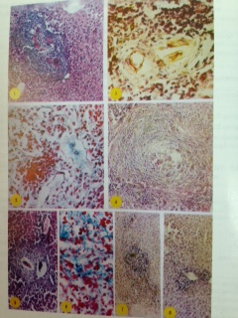
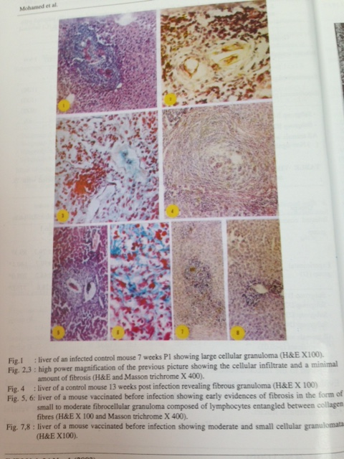
Recent Publications (minimum 5)
- 1. Iman F. Abou-El-Naga∗, Suzanne M.F. El-Nassery, Sonia R. Allam, Rasha F.M. Mady. In vitro interactions between the defense systems of resistant and susceptible Biomphalaria alexandrina and sporocysts of Schistosoma mansoni. Veterinary Parasitology 205 (2014) 712–716
- Suzanne M El-Nassery, Iman F Abou El Naga, Sonia R Allam, Eman A Shaat, Rasha F Mady. Genetic Variation between Biomphalaria alexandrina Snails Susceptible and Resistant to Schistosoma mansoni Infection. BioMed Research International 2013, Article ID 160320, 6 pages, 2013. doi:10.1155/2013/160320
- Iman F Abou El Naga, Suzanne M El-Nassery, Sonia R Allam, Eman A Shaat, Rasha F Mady. Biomphalaria species in Alexandria water channels. Parasitology International 2011; 60: 247-254.
- Shen C, Lee JA, Allam SR, Bae YM, Han ET, , Takeo S,, Tsuboi T, Hong ST, Choi MH Serodiagnostic applicability of recombinant antigens sinensis expressed by wheat germ cell-free protein synthesis. Diagn Microbiol Infect Dis 2009 Jul 64 (3): 334-9
- . H. Awadalla, A. Khalifa, A. Abou-Zeid, S. Allam and S. Mossallam. Comparison of light microscopy and polymerase chain reaction in the diagnosis of intestinal microsporidiosis. Medimonde international proceedings of the 11th international congress of parasitology ICOPA XI Glasgow August 6-11, 2006

Biography (150 word limit)
Sonia Allam has her expertise and passion in academic teaching of medical students and parasitology related research especially those infections prevalent in the area like schistosomiasis and its control as well as protozoal infections . Also served as mentor and supervised post graduate dissertations and thesis of master and PH degrees for several candidates. All research areas aimed to contribute to better environmental conditions. Also has visited and gave lectures in different universities in other middle east countries. One of members of the Egyptian Society of parasitology and Egyptian Parastilogists United, Member of the medical education department KFU. Attended several congresses in USA previously. Interested in new ways of medical education and attended online (problem based learning: Priciples and design) provided by Maastricht university (November-December 2015)
Email: Sonia_allam@hotmail.com

Notes/Comments:

