Prevalence Amebiasis of the patients in King Fahad General Hospital within 5 years.
Dr. Amal Sultan, Head of Parasitology lab. KFH, Jeddah, Saudi Arabia

Abstract  Amoebiasis is the third most frequent cause of mortality after malaria and schistosomiasis. In developed countries, amebiasis is also seen in migrants who have travelled to endemic areas.  The rate of infection by E. histolytica differs among countries, socio-economic and sanitary conditions, and populations. It is highly endemic throughout poor and socio-economically deprived communities in the tropics and subtropics. Environmental, socio-economic, demographic, and hygiene-related behavior is known to influence the transmission and distribution of intestinal parasitic infections.  The goal of this retrospective study was to determine the prevalence of E. histolytica parasites detected through routine stool examination in a laboratory at King Fahad Hospital, Saudi Arabia, a period of 5 years. Brief descriptions of these 2 intestinal protozoans were presented, with emphasis on their diseases caused, modes of transmission and signs and symptoms. Preventive and control measures were likewise discussed purposely to educate the vulnerable people, thus reducing the risk of infection with intestinal parasites. | Image  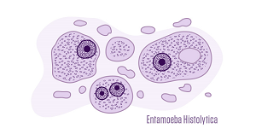  Recent Publications  1- Evidence incriminating midges (Diptera:  Ceratopogonidae) as potential vectors of  Leishmania in Australia. International Journal for  Parasitology, Volume 41, Issue 5, April 2011, Pages  571-579.  2- Diagnosis of clinical samples spotted on FTA cards  using PCR-based methods. J Egypt Soc Parasitol  2009 Apr; 39(1):227-46

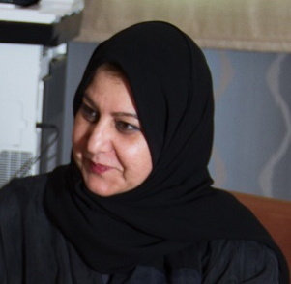
Dr. Amal Sultan is a head of parasitology laboratory at KFH. and her education as following: 2008-2009 Postdoctor at Liverpool School of Tropical Medicine (Affiliated to the University of Liverpool), UK. (Testing drugs with Leishmania mexicana).
2004 -2008 Degree of Doctor in Philosophy (PhD), Molecular biochemistry of parasitology at Liverpool School of Tropical Medicine
(Affiliated to the University of Liverpool), UK.
She win the first place winner for poster computation held by Surrey University, UK at the 3rd Saudi International Conference.
Achievement:
- 6 - 7 May 2015 4th Parasitology course " Parasitology update".
- 30 - 31 Mar 2014 3rd Parasitology course " Common parasitic disease".
- 5 Sep 2012 Organized one day Parasitology course at: The Training studies & research center at PHC- Jeddah.
- 15 – 17 Oct.2011 Organized three days Parasitology course (Wide scope of parasitic disease at research center in King Fahad Hospital,
Jeddah, KSA.
- 14 June 2011 Organized the International day of Blood Donation at King Fahad Hospital, Jeddah, KSA.
ahsultan@moh.gov.sa

