In vitro efficacy of three approved drugs and their synergistic interaction against Leishmania infantum

Iman Fathy Abou. El. Naga, Rasha Fadly Mady, Nermine Mogahed Fawzy Hussien

Medical Parasitology Department, Faculty of Medicine, Alexandria University
Abstract
Leishmaniasis is one of the most neglected tropical diseases. The available drugs have many side effects and drug resistance. In the current work the leishmanicidal effect of three approved drugs acting on three different enzymes namely auranofin, aluvia and sorafenib had been done.Their synergistic, additive or antagonistic effects against L.infantum promastigotes were investigated. The ultrastructural changes of the parasite treated by the aforementioned drugs was studied. This study demonstrated evidences that auranofin, aluvia and sorafininb had significant antileishmanial effect against the promastigotes of L. infantum and auranofin showed the highest effect. The combined administration of the drugs in two way combinations led to additive interactions. Furthermore, the combination of the three drugs had shown synergistic action. The electron microscopic study revealed that the three drugs exerted their leishmanicidal action by inducing apoptosis while alluvia leads also to autophagy.
Key words: Leishmania infantum, synergism, additive, apoptosis,autophagy.
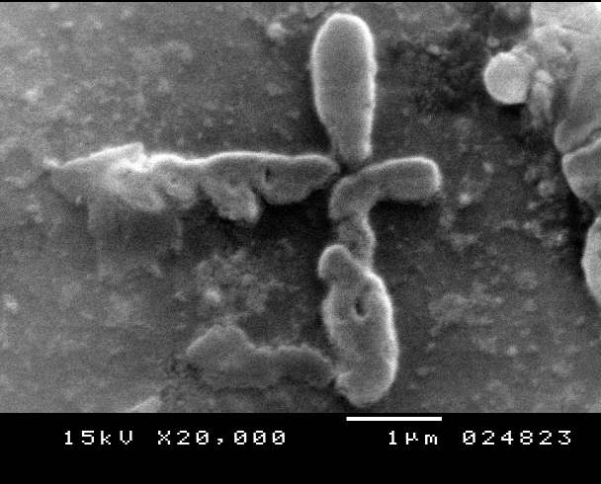

Recent Publications (minimum 5)
- El Azzouni MZ, Mady RF, Gaafar MR, Arafa FM, Elhadidi A. Protective capacity of cercarial transformation fluid alone or in combination with crude cercarial antigen against challenge infections of Schistosoma mansoni in mice. J Helminthol. 2016; 28:1-8. doi:10.1017/S0022149X1600002X
- Mady RF, El-Hadidy W, Elachy S. Effect of Nigella sativa oil on experimental toxoplasmosis. Parasitol Res. 2016;115(1):379-90. doi: 10.1007/s00436-015-4759-6.
- Mady RF, Diab RG, Abdelmonsif D. Microsporidia and Zingiber officinale (Ginger); an emerging parasite and an old medicinal plant: In vivo trial. Egyp J Med Sci. 2015; 36(2):537-556
- Abu-Akkada SS, El Kerdany ED, Mady RF, Diab RG, Khedr GA, Ashmawy KI, Lotfy WM. Encephalitozoon cuniculi infection among immunocompromised and immunocompetent humans in Egypt. Iran J Parasitol. 2015 Oct-Dec;10(4):561-70.
- Sadaka HA, Gaafar MR, Mady RF, Hezema NN. Evaluation of ImmunoCard STAT test and ELISA versus light microscopy in diagnosis of giardiasis and cryptosporidiosis. Parasitol Res. 2015 Aug;114(8):2853-63. doi: 10.1007/s00436-015-4486-z.

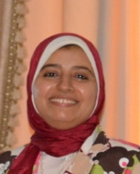
Biography (150 word limit)
Rasha Mady has her expertise in Medical Parasitology. She is an assistant prof in Alexandria faculty of Medicine. She has built this model after years of experience in research, and education in Medical Parasitology Dep. She also had good experience in propagation of toxoplasma and leishmanial in Laboratory. The fine specialty is study of Schistosomiasis in Egypt, its methods of diagnosis in low areas of transmission. She had post-doctoral research in Welcome trust Laboratory, Natural History Museum, London.
Email: rasha.madi@alexmed.edu.eg

