Mechanisms related to the upregulation of IL-10 expression of dendritic cells by parasite-derived molecule Sj16 from Schistosoma japonicum
Xi Sun ^{1,2}, Fan Yang ^{1,2,3}, Jia Shen ^{1,2}, Zhen Liu ^{1,2}, Jinyi Liang ^{1,2}, Huanqin Zheng ^{1,2}, Mingqiu Fung ⁴, Zhongdao Wu ^{1,2*}

1 Department of Parasitology, Zhongshan School of Medicine, Sun Yat-sen University, Guangzhou, Guangdong, China,
2 Key Laboratory for Tropical Diseases Control, the Ministry of Education, Guangzhou, China,
3 Department of Biotherapy, The 3rd Affiliated Hospital of Sun Yat-sen University, Guangzhou, China.
4.Department of Biology, Chinese University of Hongkong, Hongkong, China,

*Corresponding author, Email: wuzhd@mail.sysu.edu.cn

Abstract (300 word limit)
Schistosomes are parasitic worms flourishes in the human host despite the development of a pronounced immune response. Understanding how the immune system deals with such pathogens still daunting challenge. Initiative regulation of host immune response by releasing some schistosome-derived molecules is an important mechanism of immune evasion of Schistsoma japonicum. Previously, our groups have identified a 16-kD secretory protein, Sj16, from Schistosoma japonicum. Sj16 is produced and secreted by all stages of the parasite and confirmed as an important protein in the alleviating of inflammation damage when the cercariae penetrated into the skin and was closely involved in to the immune escape of the Schistosomasis. Using recombinant Sj16(rSj16) protein expressed from E.coil, we demonstrated that this recombinant protein has a potent strong immuno-modulation effect and significantly alleviate rat adjuvant-induced arthritis(AA). In this study，we confirmed that rSj16 enter into the nuclear of host cells using the NLS1 and promote the production of IL-10 which mediates the inhibitory effect of rSj16 on LPS-induced BMDCS.

Image
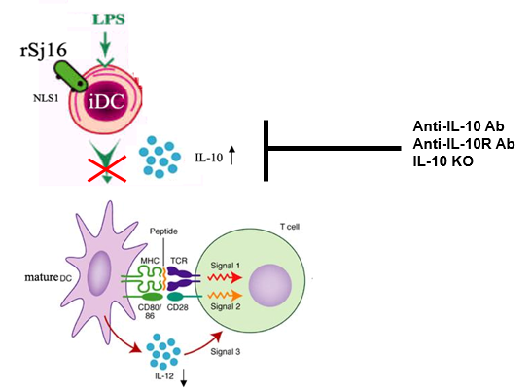

Recent Publications (minimum 5)
- Peng H, Zhang Q, Li X, Liu Z, Shen J, Sun R, Wei J, Zhao J, Wu X, Feng F, Zhong S, Sun X, Wu Z(2016).IL-33 Contributes to Schistosoma japonicum-induced Hepatic Pathology through Induction of M2 Macrophages. Sci Rep. 21;6:29844
- Chen AL, Sun X, Wang W, Liu JF, Zeng X, Qiu JF, Liu XJ, Wang Y(2016). Activation of the hypothalamic-pituitary-adrenal (HPA) axis contributes to the immunosuppression ofmice infected with Angiostrongylus cantonensis.J Neuroinflammation. 12;13(1):266.
- Wu F, Wei J, Liu Z, Zeng X, Yu Z, Lv Z, Sun X, Wu Z.(2016)Soluble antigenderived from IV larva of Angiostrongylus cantonensis promotes chitinase-like protein 3 (Chil3)expression induced by interleukin-13. Parasitol Res, 115(10):3737-46.

Biography (150 word limit)
Xi Sun was graduated from Sun-yat sen university and got Phd Degree in 2011. Now she is the Associated professor in department of parasitology, Sun Yat-sen university. She’s work is focus on the infection and immunology.
Email: sunxi2@mail.sysu.edu.cn

Notes/Comments:

