Clonochis sinensis lysophospholipase A upregulates IL-25 expression in macrophages as a potential pathway to liver fibrosis
Lina Zhou, Master, Sun Yat-sen University, China
Xinbing Yu*, PhD, Sun Yat-sen University, China
Yan Huang*, PhD, Sun Yat-sen University, China

*: corresponding author

Abstract
Statement of the Problem: Liver fibrosis is an excessive wound-healing reaction requiring the participation of inflammatory cells and hepatic stellate cells (HSCs). The pathogenesis of liver fibrosis caused by viruses and alcohol has well been elaborated, but the molecular mechanisms of Clonorchis sinensis (C. sinensis)-induced liver fibrosis are poorly understood. Lysophospholipase A (LysoPLA) which is characterized as deacylating lysophospholipids plays a critical role in virulence and pathogenesis of parasites and fungi; however, the roles of C. sinensis lysophospholipase A (CsLysoPLA) in C. sinensis induced liver fibrosis remain unknown. Methodology & Theoretical Orientation: Mouse macrophage cell line (RAW264.7) was cultured and treated with CsLysoPLA. IL-25 and signaling pathway were detected by quantitative real-time PCR, Western blotting or immunofluorescent staining. Human hepatic stellate cell line (LX-2) was cultured and exposed to IL-25. The activation markers of LX-2 cells were examined with quantitative real-time PCR, Western blotting and immunofluorescent staining. The migration was analyzed by transwell plate. Findings: We show that treatment of RAW264.7 cells with CsLysoPLA significantly induced IL-25 expression. The elevation of PKA, B-Raf, and ERK1/2 mRNA levels and phosphorylations of B-Raf and ERK1/2 were detected in CsLysoPLA-stimulated RAW264.7 cells. Whereas, PKA inhibitor H-89 weakened the phosphorylations of B-Raf and ERK1/2 and AKT activator SC79 attenuated the phosphorylation of ERK1/2 in RAW264.7 cells. Both H-89 and SC79 could inhibit IL-25 up-regulation induced by CsLysoPLA. In addition, stimulation of LX-2 cells with IL-25 upregulated the expression of mesenchymal cell markers including α-smooth muscle actin (α-SMA) and collagen type I (Collagen-I) and promoted migration of the cells. Conclusion & Significance: Our results propose that CsLysoPLA activates HSC by upregulation of IL-25 in macrophage through PKA-dependent B-Raf/ERK1/2 pathway and plays a potential promotion role in hepatic fibrosis during the C. sinensis infection.

Image
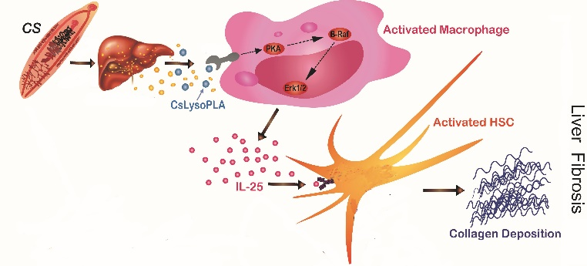
Recent Publications
- Huang Y#, Chen W#, Wang X, Liu H, Chen Y, Guo L, Luo F, Sun J, Mao Q, Liang P, Xie Z, Zhou C, Tian Y, Lv X, Huang L, Zhou J, Hu Y, Li R, Zhang F, Lei H, Li W, Hu X, Liang C, Xu J*, Li X*, Yu X* (2013) The carcinogenic liver fluke, Clonorchis sinensis: new assembly, reannotation and analysis of the genome and characterization of tissue transcriptomes. PLoS One 8(1):e54732.
- Huang Y#, Huang Y#, Fang Y, Wang J, Li Y, Wang N, Zhang J, Gao M, Huang L, Yang F, Wang C, Lin S, Yao Y, Ren L, Chen Y, Du X, Xie D, Wu R, Zhang K, Jiang L*, Yu X*, Lai X* (2012) Relatively low level of antigen-specific monocytes detected in blood from untreated tuberculosis patients using CD4+ T-cell receptor tetramers. PLoS Pathog 8(11):e1003036.
- Wang X#, Chen W#, Tian Y, Mao Q, Lv X, Shang M, Li X, Yu X*, Huang Y* (2014) Surface display of Clonorchis sinensis enolase on Bacillus subtilis spores potentializes an oral vaccine candidate. Vaccine 32(12):1338-1345.
- Chen X#, Li S#, He L, Wang X, Liang P, Chen W, Bian M, Ren M, Lin J, Liang C, Xu J, Wu Z, Li X, Huang Y*, Yu X* (2013) Molecular Characterization of Severin from Clonorchis sinensis Excretory/Secretory Products and Its Potential Anti-apoptotic Role in Hepatocarcinoma PLC Cells. PLoS Negl Trop Dis 7(12):e2606.
- Hu Y, Zhang E, Huang L, Li W, Liang P, Wang X, Xu J, Huang Y*, Yu X. (2014) Expression profiles of glyceraldehyde-3-phosphate dehydrogenase from Clonorchis sinensis: a glycolytic enzyme with plasminogen binding capacity. Parasitol Res 113(12):4543-4553

Biography (150 word limit)
Yan Huang work in the department of Parasitology, Zhongshan School of Medicine, Sun Yat-sen University (Guangzhou, China) now. She has her expertise in genome, functional genomics of clonorchis sinensis (Chinese liver fluke) and pathogenesis of food-borne parasitic diseases. Her team has finished the whole genome sequencing of Clonorchis sinensis and screened out key molecules which play potential roles in pathogenesis of liver fibrosis or carcinogenesis induced by the infection of Clonorchis sinensis.
Email: huang66@mail.sysu.edu.cn

Notes/Comments:

