Random Amplified Polymorphic DNA (RAPD) and Internal Transcribed Spacer 2 (ITS-2) rDNA study of some Paramphistome Isolates from Southern Africa.
Madeline Sibula, MSc. (Applied Microbiology and Biotechnology), National University of Science and Technology, Zimbabwe.

Abstract
Paramphistomes are parasites of both domestic and wild ruminants whose effects still remain underestimated. Limited studies in Africa have been done using molecular techniques to resolve problems associated with taxonomical groupings and epidemiology of these parasites. In this study, the genetic variability of nine representative paramphistome isolates collected from different geographical locations in Southern Africa (namely South Africa, Botswana, Zambia and Zimbabwe) was assessed using RAPD data analysis and ITS 2 rDNA sequence data. All isolates were sectioned for morphological characterisation and for molecular analyses; DNA was extracted, amplified and purified. Sagittal sections revealed three species of paramphistomes belonging to three different sub-families: one Stephanopharynx compactus isolate, a member of the Stephanopharyngidae sub-family, one Carmyerius dollfusi isolate, a member of the Gastrothylacidae sub-family and seven Calicophoron microbothrium isolates belonging to the Paramphistomidae sub-family. The ITS 2 rDNA sequences were submitted to Genbank and were assigned accession numbers (KP639630-KP639638). Two isolates S.compactus (KP639630) and C.dollfusi (KP639636) were first reported in this study. Phylogenetic reconstruction of the paramphistome isolates based on the ITS 2 rDNA sequence data obtained using Mega 6 separated them into three clades representing the three species. However, the clade with all the C. microbothrium isolates is the only one that was supported by a higher bootstrap value of 92% although there was no differentiantion of these isolates according to geographical locations. The low divergence values on the ITS 2 sequences of the C. microbothrium isolates indicate that ITS rDNA sequence data can be used as a molecular tool to infer knowledge for resolving taxonomic groupings. RAPD data analysis using Popgene 32 clustered the paramphistome isolates according to their geographic origin in spite of the differences in species of the isolates. There was significant variability between the isolates with an average genetic distance value of 0.4381. These results show that RAPDs can be used as a molecular marker for epidemiological studies of C. microbothrium and could possibly show that cross fertilisation between species does occur.

Image
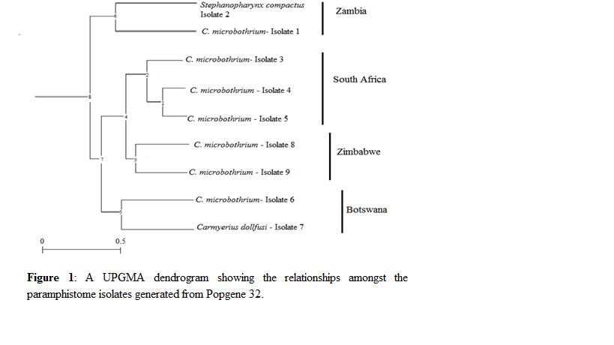
Recent Publications
1. M. Sibula., Z. Dhlamini and S. Dube. 2014. Molecular characterization of paramphistome isolates from cattle from matebeleland using RAPDs. Advances in Bioresearch.
2. S.Dube., Z. Dhlamini and M.Sibula. 2015. Molecular analysis of some paramphistome isolates from Southern Africa. Journal of Helminthology.


Madeline Sibula has a passion for biotechnology in the area of veterinary parasitology. Her interests are mainly focused on helminths particularly of both domestic and wild ruminants that are water-borne. She is currently doing a population genetic study of paramphistomes of both cattle and wild ruminants in order to develop tools that can be used for early detection of these parasites in the wild and for epidemiological studies. With her skills in histology, she has managed to merge traditional techniques with modern tools for significant taxonomic studies of paramphistomes – a work in progress.
.
Email: maddy.hove@gmail.com
Notes/Comments:

