In Search of Pre-Columbian Parasites in Huecoid and Saladoid Coprolites from Vieques, Puerto Rico
R. Wiscovitch-Russo¹, J. Rivera-Perez¹, Y.M. Narganes-Storde², L. Chanlatte², R. Cano³, and G.A. Toranzos¹
¹Environmental Microbiology Laboratory, University of Puerto Rico, San Juan, Puerto Rico
²Center for Archaeological Research, University of Puerto Rico, San Juan, Puerto Rico
³California Polytechnic State University, San Luis Obispo, CA
Abstract
DNA extraction and sequencing of pre-Columbian coprolites has provided information on the fecal microbiota and parasite burden of ancient humans. Nine pre-Columbian coprolites from the Island of Vieques, Puerto Rico, were utilized to determine parasite infection in two co-existing cultures; the Huecoid and Saladoid. The cores of the coprolites were used for DNA isolation and metagenomic shotgun sequencing. We performed a descriptive analysis of identified parasite sequences. Since these cultures co-existed in Vieques, a similar parasite infection scenario was expected between cultures. Also, given the matrix enteric parasites were anticipated. Polyparasitism was apparent, which lead to suspect poor overall health of the Huecoid and Saladoid cultures. Local and remote BLAST+ search revealed sequences of important enteric parasites Ascaris spp., Enterobius spp., and Parastrongyloides spp. with a query cover > 80% and percent of identity > 98%. Among the detected parasite sequences, Onchocerca spp., and Spirometra spp. reads were successfully mapped producing assemblies of > 500bp with a map quality > 35 and a map error rate < 0.03.
Interestingly, several identified parasites were unexpected as they had not been detected in previous paleoparasitological research. These include Haemonchus spp., Onchocerca spp., Parastrongyloides spp. and Spirometra spp. Preliminary analysis of direct microscopy of the Huecoid and Saladoid coprolites identified Ascaris spp. and Enterobius spp. eggs, though parasite sequences without evidence of direct microscopy does not necessarily indicate its absence. Most of the detected parasites can be transmitted by the fecal-oral route and usually cause enteritis, an affliction incompatible with the formation of coprolites. Finding coprolites clearly indicated that there were no symptoms associated with gastroenteritis. Therefore, this may be a result of coevolution allowing host resistance to diseases brought about by enteric parasites.

Images
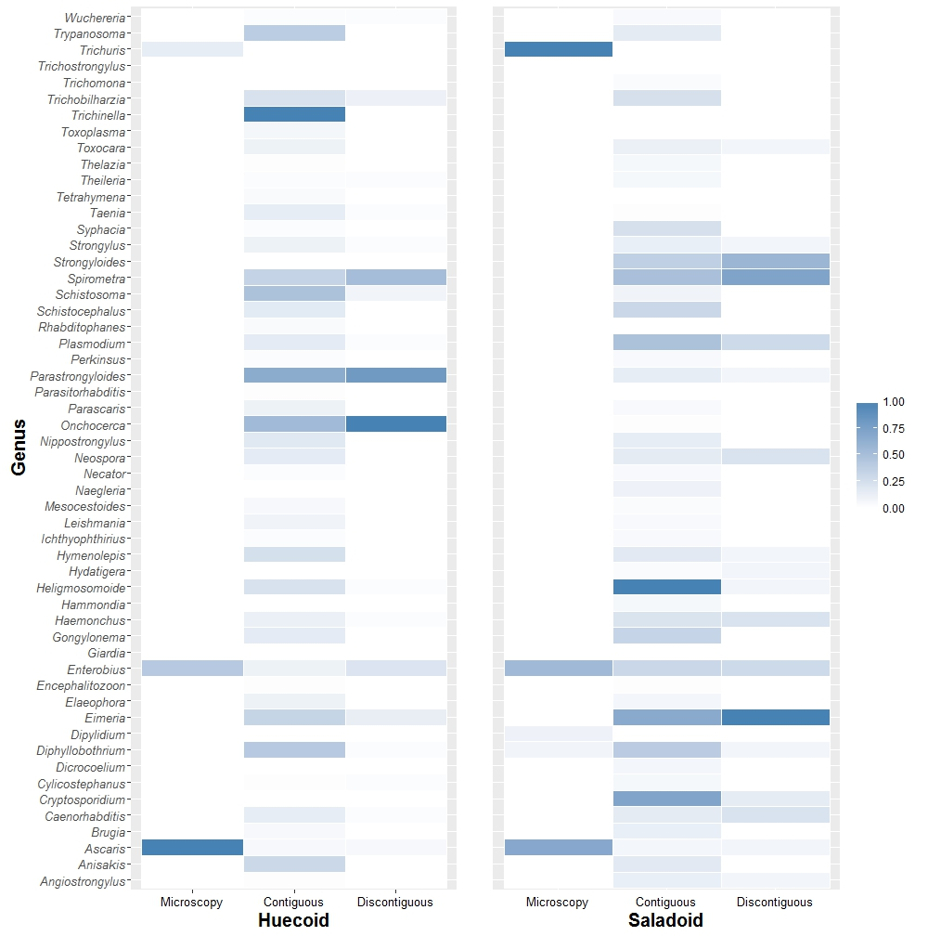
Fig 1. Relative abundance of parasites detected using direct microscopy along with BLAST+ contiguous and discontiguous megablast.
Tab 1. Previous paleoparasitological studies and their findings. Haemonchus spp., Onchocerca spp., Parastrongyloides spp., and Spirometra spp. were not identified in pre-Columbian South America
Biography
Rosana Wiscovitch is a third year doctoral student at the University of Puerto Rico, Rio Piedras. She is currently analyzing possible environmental and pathogenic organisms of the Huecoid and Saladoid cultures through which assumption of the cultures life styles and diets are made based on current knowledge of the detected organism.
Email: rosana.wiscovitch@upr.edu

