The Application of Phase-shifting Technique in Surface Topographic Measurement
Yuhe Li, Jiahua Kou, Tsinghua University, China

Abstract
Statement of the Problem: Surface topographic measurement plays an increasingly significant role in optical measurement, such as automatic visual inspection, ultra-precision manufacturing and other fields. The latest hard drives and optical instruments require the chips with ultra-fine surfaces, as well as the corresponding detecting technique to carry out online measurement and monitor the relevant parameters. The phase-shifting interferometry is one of the most widely applied technique, of which the principle is introducing time modulation into the phase difference of two beams of coherent light. By the photoelectric detector the phase can be demodulated from the interference pattern via considerable phase-unwrapping algorithms. However, the inevitable noise leads to the error and distortion of several points in the phase diagram. Methodology & Theoretical Orientation: We propose a K-means clustering unwrapping algorithm for the error reduction. Based on "bad points" to avoid the path integral, our algorithm can complete the three-dimensional morphology online. Compared with the traditional algorithms which might result in failure to unwrap when the reference points happen to be noise points, our algorithm is put forward to extract independent noise areas, such as faults, holes, etc. and can separate the effective phase information by using the clustering analysis. The detailed algorithm is as follows: (a) Giving pixel gray difference T of each cluster center, and then calculating the clustering parameter K based on the interference pattern; (b) Considering K and the gray values g of each pixel as variables and analyzing the pixel set G in clustering process; (c) Establish the original image index matrix, generating new clustering image by replacing the original pixel values with new clustering centroids and separating independent noise area according to the distance d and weight τ; (d) Completing the unwrapping calculation. Conclusion & Significance: We build the surface topographic experiment system and the error has been successfully made less than 0.004 µm. Therefore, the K-means clustering unwrapping algorithm, of which the result is compared to that of the calibration equipment, has been valid. Consequently, the relevant online measurement can be more accurate.
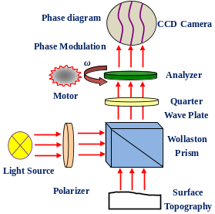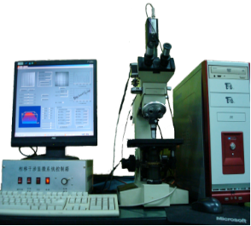
Fig.1 System Schematic Diagram Fig.2 Phase-shifting Measurement
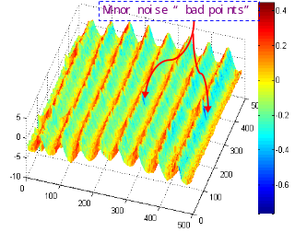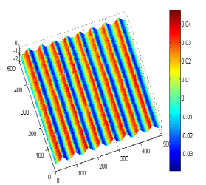
Fig.3 K-means Cluster Unwrapping Fig.4 3D Surface Based on “Bad points”

Image
Recent Publications
- Yuhe LI, Kaisen GUAN, Zhaohui HU.(2016) Fiber optic displacement measurement model based on finite reflective surface. Optics and Laser Technology, 84(2016)32–39
- Yuhe LI, Kaisen GUAN, Zhaohui HU and Yanxiang CHEN.(2016) Optical Fiber Displacement Measurement Method and Experiments Based on Reflective Grating Panel. Sensors, 2016, 16, 808
- Zhendong Qiao, Yuhe Li, Kai Sen Guan. Animal Fiber Diameter Automatic Measurement Based on Image Recognition. ICFMM 2015, P127-131
- Yuhe Li, Yongrong Qiu, Yanxiang Chen, Kaisen Guan. A novel orientation and position measuring system for large & medium scale precision assembly. Optics and Lasers in Engineering, 62 (2014) 31–37
- Xiaogen Hu, Yuhe Li, Yanxiang Chen. (2012) Transmissive Fiber Optical Displacement Sensor Using Cutting Plate. Microwave and Optical Technology Letters, Vol.54(2):446-448


Biography

Li Yuhe received his Ph.D. degree in 2001 from Tsinghua University, now he is associated professor in Tsinghua University. His main research interests include micro and Nano measurement and machine vision.


Kou Jiahua received his bachelor degree in 2014 from Tianjin University, and now he is studying for a master’s degree in Tsinghua University. His main research orientations are medical instruments and blood coagulation testing.

Email: liyuhe@mail.tsinghual.edu.cn
Phone: 86+010+62794630

Notes/Comments:

