Nanofiber-Decellularized Amniotic Membrane Composite Scaffold Improves Limbal Stem Cell Transplantation in a Rabbit Model of Corneal Epithelial Defect
Da Long, MD, Changsha, P. R. China
Zhengbing Zhou, MD, CSU, P.R.China
Hai-Quan Mao, INBT,JHU, USA

Abstract (300 word limit)
Limbal stem cell deficiency (LSCD) results in severe functional disorders of the ocular surface, including corneal conjunctivalization, chronic inflammation, persistent loss of corneal epithelium, corneal opacity, and vision loss. Human amniotic membrane (AM) is the most effective substrate for limbal stem cell (LSC) transplantation due to its inherent pro-regenerative and anti-inflammatory properties. However, the widespread use of AM in clinical settings is limited by its weak mechanical strength, rapid degradation, and high cost associated with preserving fresh AM. We have recently developed a composite membrane consisting of an electrospun bioabsorbable polymer fiber mesh interfacially bonded to a decellularized AM (dAM) sheet. Here we evaluate the effectiveness of this composite membrane in repairing corneal epithelial defects in a rabbit LSCD model when used in combination with in vitro-expanded LSCs. This study demonstrates the translational potential of our composite membrane for the treatment of ocular surface damage in the setting of LSCD.

Image
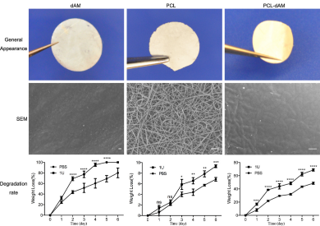
Figure 1. General appearance, SEM images and degradation rate of dAM, PCL and the composite membranes prepared from PCL fiber meshes. *p < 0.05, **p < 0.01, ***p < 0.001, ****p < 0.0001, ns: no significance.
Recent Publications (minimum 5)
- Long D, Kanan Y, Shen J (2018) VEGF/VEGFR2 blockade does not cause retinal atrophy in AMD-relevant models[J]. 2018.
- Kanan Y, Valeria Lorenc, Long D, Egli M (2019) Metipranolol Promotes Structure and Function of Retinal Photoreceptors in the rd10 Mouse Model of Human Retinitis Pigmentosa. 鈥Journal of Neurochemistry.148, 307--318
- Da Long, Jun Zeng (2012)Vitreous amyloidosis in two large mainland Chinese kindreds resulting from transthyretin variant Lys35Thr and Leu55Arg.Ophthalmic Genetics.33,28-33.

Biography (150 word limit)
Da Long has her expertise in retinal disease and engineering treatment for ophthalmology . She works as a ophthalmology surgery and researcher in hospital and eye institution. Email:cajcajlongda@gmail.com

Notes/Comments:

