

Glaucomatous Optic Nerve Head Assessment in Residency Program Using Discus Software

Faisal A. Almobarak. King Saud University, Riyadh, Saudi Arabia

ABSTRACT

Objective/Purpose
To validate Discus software and establish reference data for the performance and reproducibility of residents evaluating optic nerve head damage.
Materials/Methods
54 residents tested themselves 3 times using the freely available online Discus software
displaying 100 disc photographs: 80 non-stereophotographs of VF negative optic nerves and 20 of VF positive glaucomatous discs. 26 photographs were repeated (2 glaucomatous and 20 healthy) to test the reproducibility of answers. At the end of the test, online submission and analysis of results is done where then each resident will repeat the test other day and will finally submit the file to the residency office where new identification numbers will be created. Online feedback was given to each resident. Interclass correlation, Bland-Altman test, average of diagnostic performance and ROC curves were calculated.
Results
The mean response latency was 4.91 seconds with no difference in the response between all residents (p=0.28, Wilcoxon test). The interclass correlation showed high degree of reliability of the 3 tests (0.76). The Bland-Altman test showed good agreement and reproducibility of 3 tests among all residents with more convergence in senior residents, and only two repeated tests were more than one standard deviation but within two standard deviations. Senior residents had better performance that junior residents where the AUROC was 0.68, 0.68, 0.69 and 0.71 for the first, second, third and fourth year residents respectively (p=0.04, Kruskal-Wallis test). There was no correlation between the performance and the response latency (ρ=-0.03, p=0.89). There was a moderate correlation with experts, 0.59 (±0.1), for all level, but fourth years residents had the highest correlation among others(r=0.64 (±0.08)) which was significantly different when compared to junior residents (p=0.02).
Conclusion
Senior residents had better performance and less variability on repeated tests compared to junior residents and had the highest correlation with experts. Discus allows a rapid and efficient assessment of residents performance of different levels in disc damage, which can help improving training defects whenever present.

Fig. 1. Bland-Altman plot showing overall good reproducibility of three tests
performed by each resident.
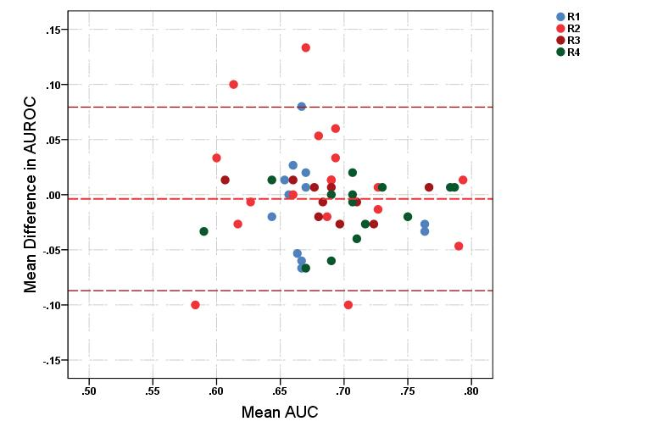

Fig. 2. Scatterplot showing average AUROC of three tests. The size of the circle increase as the correlation with experts increase. Dashed line represent the mean performance of the whole group.
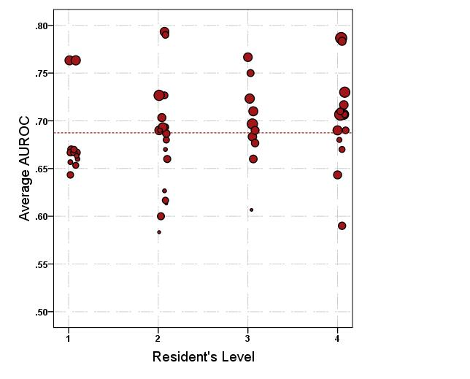
Fig. 3. Density scatterplot showing no correlation between the response latency and the performance (p=-0.03, p=0.89). Dashed lines represents the mean.
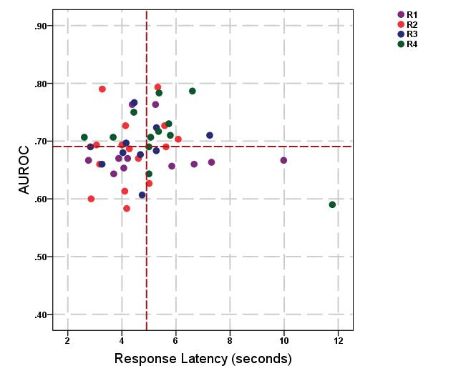

Fig. 4. Density scatterplot showing slightly positive correlation between the
number of glaucoma rotations and the average performance which is not
statistically significant (p=0.25, p=0.07).

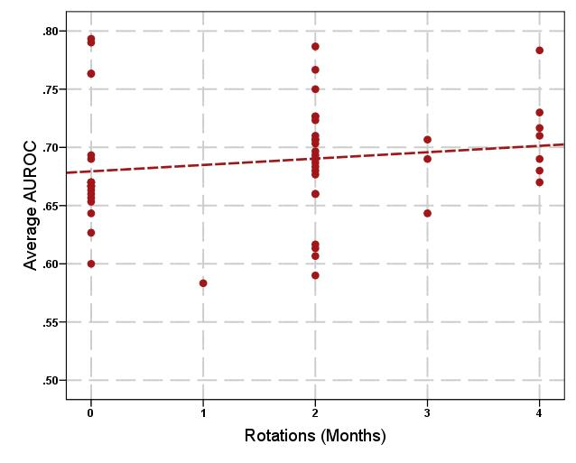

Recent Publications

- Almobarak FA, Alharbi AH, Morales J, Aljadaan I. Intermediate and Long-term Outcomes of Mitomycin C-enhanced Trabeculectomy as a First Glaucoma Procedure in Uveitic Glaucoma. J Glaucoma. 2017 Feb 23. doi: 10.1097/IJG.0000000000000653. [Epub ahead of print]
- Almobarak FA, Alharbi AH, Morales J, Aljadaan I. The Influence of Phacoemulsification on Intraocular Pressure Control and Trabeculectomy Survival in Uveitic Glaucoma. J Glaucoma. 2017 Feb 23. doi: 10.1097/IJG.0000000000000646. [Epub ahead of print]
- Almobarak FA, Alharbi AH, Morales J, Aljadaan I. Analysis of Cyclin-Dependent Kinase Inhibitor-2B rs1063192 Polymorphism in Saudi Patients with Primary Open-Angle Glaucoma. Genet Test Mol Biomarkers. 2016 Oct;20(10):637-641.
- Almobarak FA, Alharbi AH, Morales J, Aljadaan I. Analysis of Polymorphism rs1900004 in Atonal bHLH Transcription Factor 7 in Saudi Patients with Primary Open Angle Glaucoma. Genet Test Mol Biomarkers. 2016 Nov;20(11):715-718.
- Almobarak FA, Alharbi AH, Morales J, Aljadaan I. Outcomes of Trabeculectomy with Mitomycin C in Uveitis Associated with Vogt-Koyanagi-Harada Disease. J Glaucoma. 2016 Jun;25(6):528-32
- Alobeidan SA, Almobarak FA. Incidence and management of haemorrhagic Descemet membrane detachment in canaloplasty and phacocanaloplasty. Acta Ophthalmol. 2016 Aug;94(5)e298-304
- Osman EA, Almobarak FA. Ciliochoroidal effusion with persistent hypotony after trabectome surgery. Indian J Ophthalmol. 2015 Mar;63(3):272-4
- Morales J, Al Qahtani M, Khandekar R, Al Shahwan S, Al Odhayb S, Al Mobarak FA, Edward DP. Intraocular Pressure Following Phacoemulsification and Endoscopic Cyclophotocoagulation for Advanced Glaucoma: One Year Outcomes. J Glaucoma 2015 Aug;24(6): e 157-62
- Almobarak FA, Neil O’Leary, Reis AS et al. Automated Segmentation of Optic Nerve Head Structures with Spectral Domain Optical Coherence Tomography. Invest Ophthalmol Vis Sci. 2014 Feb 26;55(2):1161-1168
- Chauhan BC, O'Leary N, Almobarak FA et al. Enhanced detection of open angle glaucoma with an anatomically accurate optical coherence tomography-derived neuroretinal rim parameter. Ophthalmology. 2013 Mar;120(3):535-43
- Almobarak FA, Khan AO. Two year survival of Ahmed valve implantation in the first 2 years of life with and without intraoperative mitomycin C. Ophthalmology. 2009 Oct;116(10):1862-5
- Khan AO, Almobarak FA. Comparison of polypropylene and silicone Ahmed valve survival 2 years following implantation in the first 2 years of life. Br J Ophthalmol. 2009 Jun;93(6):791-4
- Almobarak FA, Khan AO. Complications and 2 year valve survival Following Ahmed valve implantation during the first 2 years of life. Br J Ophthalmol. 2009 Jun;93(6):795-8

Biography

Dr. Faisal Almobarak is an assistant professor and consultant at King Saud University, Saudi Arabia. He is the chief of the glaucoma and cataract division and the director of the glaucoma and cataract fellowship program in the department of ophthalmology. Advance surgical management of glaucoma, cataract and laser surgeries are the areas of his subspecialty expertise.
Dr. Almobarak is heavily involved in research, medical education and a national level glaucoma awareness programs. He is interested in designing new surgical methods for treating glaucoma and currently holds a patency on Schlemm’s canal tube.
Dr. Almobarak has published several peer-reviewed articles and has won awards and honors for posters research papers. He is actively participating in several international meetings and involved in surgical and diagnostic glaucoma courses and workshops as a supervisor and instructor.

E-mail: falmobarak@ksu.edu.sa

