

Incidence, management and visual outcomes of haemorrhagic Descemet membrane detachment in canaloplasty and phacocanaloplasty

Faisal A. Almobarak. King Saud University, Riyadh, Saudi Arabia

ABSTRACT

Objective/Purpose
To report the incidence and management of haemorrhagic Descemet membrane detachment (HDMD) in canaloplasty and phacocanaloplasty.
Materials/Methods
This study included 105 eyes of 92 patients with uncontrolled open angle glaucoma who underwent canaloplasty and phacocanaloplasty between 2010 and 2014. Eyes that developed either HDMD or non-HDMD were identified. The main outcome measures were the development of HDMD and non-HDMD, best corrected visual acuity, recovery time after Descemet membrane detachment (DMD), intra-ocular pressure (IOP) and number of
antiglaucoma medications. Each eye was managed according to the time of development, type and extent of DMD.
Results
Ten eyes (9.5%) developed DMD- four eyes underwent canaloplasty (3.8%) and six eyes underwent phacocanaloplasty (5.7%). Three of 10 eyes developed non-HDMD while seven of 10 developed HDMD, the majority of HDMD cases occurred in combination with phacocanaloplasty (five of seven). The non-HDMD eyes resolved completely within 2 weeks without intervention. One eye with HDMD was observed for 2 weeks, before a 15% sulphur
hexafluoride (SF6) intracameral injection was given. The patient developed a dense corneal stain that was resolving slowly over 30 months. One eye with HDMD underwent YAG laser membranotomy 2 weeks after being identified, which regained corneal transparency 1 month after treatment, while the remaining five eyes underwent immediate surgical drainage and regained corneal transparency 1 day post-procedure.
Conclusion
HDMD occurred in up to 6.7% in canaloplasty and phacocanaloplasty procedures, mostly during catheter withdrawal and the viscodilation step. Early recognition and management prevented further manipulation.

Fig. 1. (A) Haemorrhagic DMD after canaloplasty in patient with primary open angle glaucoma. (B) SF6 15% injection given after 2 weeks to push the blood away from visual axis. Best corrected visual acuity (BCVA) was counting fingers. (C) One month later, DMD resolved but corneal stain developed. BCVA was 20/100. (D) After 1 year, the stain was regressing and shrinking in size. BCVA was 20/60. (E) Two and half years later, the stain significantly regressed. BCVA was 20/60.

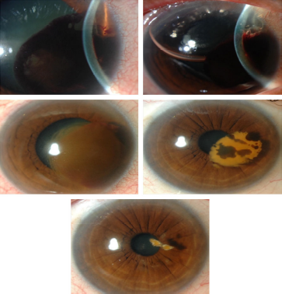

Fig. 2. (A) Haemorrhagic DMD after canaloplasty in patient with uveitic open angle glaucoma. (B) One day postoperatively, trans-epithelial incision was carried out along with intracameral air bubble injection to help aspirating the blood and Healon GV. (C) Two weeks later, haemorrhagic Descemet membrane detachment resolved with residual oedema. Best corrected visual acuity (BCVA) was 20/100. (D) After 6 months, the cornea was clear but the BCVA was 20/100 because of cataract. (E) One year later, the patient underwent uneventful phacoemulsification and regained BCVA of 20/30.
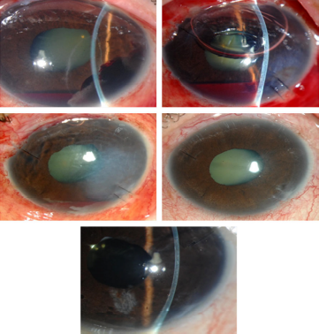

Fig. 3. (A) Haemorrhagic DMD after phacocanaloplasty in patient with primary open angle
glaucoma. (B) YAG laser membranotomy carried out 2 weeks after phacocanaloplasty. Best
corrected visual acuity (BCVA) was 20/80. (C) Two weeks later, DMD resolved. BCVA was
20/60. (D) After 6 weeks, the cornea showed regressing haemorrhage. BCVA was 20/60.
(E) Six months later, the cornea was clear. BCVA was 20/100 because of diabetic macular
oedema.
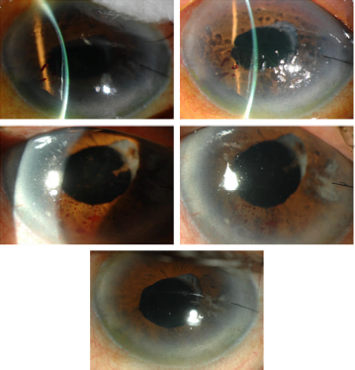

Recent Publications

- Almobarak FA, Alharbi AH, Morales J, Aljadaan I. Intermediate and Long-term Outcomes of Mitomycin C-enhanced Trabeculectomy as a First Glaucoma Procedure in Uveitic Glaucoma. J Glaucoma. 2017 Feb 23. doi: 10.1097/IJG.0000000000000653. [Epub ahead of print]
- Almobarak FA, Alharbi AH, Morales J, Aljadaan I. The Influence of Phacoemulsification on Intraocular Pressure Control and Trabeculectomy Survival in Uveitic Glaucoma. J Glaucoma. 2017 Feb 23. doi: 10.1097/IJG.0000000000000646. [Epub ahead of print]
- Almobarak FA, Alharbi AH, Morales J, Aljadaan I. Analysis of Cyclin-Dependent Kinase Inhibitor-2B rs1063192 Polymorphism in Saudi Patients with Primary Open-Angle Glaucoma. Genet Test Mol Biomarkers. 2016 Oct;20(10):637-641.
- Almobarak FA, Alharbi AH, Morales J, Aljadaan I. Analysis of Polymorphism rs1900004 in Atonal bHLH Transcription Factor 7 in Saudi Patients with Primary Open Angle Glaucoma. Genet Test Mol Biomarkers. 2016 Nov;20(11):715-718.
- Almobarak FA, Alharbi AH, Morales J, Aljadaan I. Outcomes of Trabeculectomy with Mitomycin C in Uveitis Associated with Vogt-Koyanagi-Harada Disease. J Glaucoma. 2016 Jun;25(6):528-32
- Alobeidan SA, Almobarak FA. Incidence and management of haemorrhagic Descemet membrane detachment in canaloplasty and phacocanaloplasty. Acta Ophthalmol. 2016 Aug;94(5)e298-304
- Osman EA, Almobarak FA. Ciliochoroidal effusion with persistent hypotony after trabectome surgery. Indian J Ophthalmol. 2015 Mar;63(3):272-4
- Morales J, Al Qahtani M, Khandekar R, Al Shahwan S, Al Odhayb S, Al Mobarak FA, Edward DP. Intraocular Pressure Following Phacoemulsification and Endoscopic Cyclophotocoagulation for Advanced Glaucoma: One Year Outcomes. J Glaucoma 2015 Aug;24(6): e 157-62
- Almobarak FA, Neil O’Leary, Reis AS et al. Automated Segmentation of Optic Nerve Head Structures with Spectral Domain Optical Coherence Tomography. Invest Ophthalmol Vis Sci. 2014 Feb 26;55(2):1161-1168
- Chauhan BC, O'Leary N, Almobarak FA et al. Enhanced detection of open angle glaucoma with an anatomically accurate optical coherence tomography-derived neuroretinal rim parameter. Ophthalmology. 2013 Mar;120(3):535-43
- Almobarak FA, Khan AO. Two year survival of Ahmed valve implantation in the first 2 years of life with and without intraoperative mitomycin C. Ophthalmology. 2009 Oct;116(10):1862-5
- Khan AO, Almobarak FA. Comparison of polypropylene and silicone Ahmed valve survival 2 years following implantation in the first 2 years of life. Br J Ophthalmol. 2009 Jun;93(6):791-4
- Almobarak FA, Khan AO. Complications and 2 year valve survival Following Ahmed valve implantation during the first 2 years of life. Br J Ophthalmol. 2009 Jun;93(6):795-8

Biography

Dr. Faisal Almobarak is an assistant professor and consultant at King Saud University, Saudi Arabia. He is the chief of the glaucoma and cataract division and the director of the glaucoma and cataract fellowship program in the department of ophthalmology. Advance surgical management of glaucoma, cataract and laser surgeries are the areas of his subspecialty expertise.
Dr. Almobarak is heavily involved in research, medical education and a national level glaucoma awareness programs. He is interested in designing new surgical methods for treating glaucoma and currently holds a patency on Schlemm’s canal tube.
Dr. Almobarak has published several peer-reviewed articles and has won awards and honors for posters research papers. He is actively participating in several international meetings and involved in surgical and diagnostic glaucoma courses and workshops as a supervisor and instructor.

E-mail: falmobarak@ksu.edu.sa

