Изменения цитоархитектоники и хронобиологии эпителиальных клеток роговицы при ортокератологической терапии

Changes of cytoarchitectonics and chronobiology epithelial cells of the cornea in orthokeratology therapy
S. L. Pervykh, medical center of « OphthalNova», Moscow, Russia

Material and methods:
In the experiment, we used 35 animals (rabbits). To ensure the full simulation orthokeratology therapy wearing lenses was performed in the night period using temporal blepharorrhaphy by Golovin within 14 days (right eye of the animal). The left eye was used as control. Animals were removed from the experiment on the 15th day. After enucleation, the corneas were subjected to histological examination (staining with hematoxylin and eosin staining) by light microscopy.
Results:
A distinctive feature is the change of the spatial orientation of epithelial cells of the cornea, i.e. displacement of the center of the structural unit. This displacement leads to the formation of three-dimensional defects (bulls) in the structure. There is also the change of polarity of cells, increased cell density and transformation of the basal membrane.
Conclusions:
Changing the stiffness of the cornea detected in the application of orthokeratology therapy, in some cases directly related to bulk defects, of changing its physical properties and transformation of the basal membrane. The presence of these changes gives reason to recommend the introduction OCT of the cornea as the "gold standard" in preparation for orthokeratology therapy.
Keywords:
Orthokeratology, epithelium, basement membrane, bulls, polarity of cells, gold standard survey, epithelio-stromal relationships

At the moment it is considered that the prevalence of myopia has increased worldwide in the last two decades. Asian countries show the highest rates of myopia, although with significant variations from country to country. The percentage of patients aged 18 years with a diagnosis of myopia of up to 80% in Taiwan and 96.5% in South Korea in Hong Kong, the percentage of 6-year-old children with high myopia is 0.7% and 18.3% other degrees. To 12 years, these figures reach as high as 3.8% and 61.5%, respectively [15].
The increase in the number of cases of so-called school myopia and its progressive nature are the subject of constant attention of ophthalmologists. In this regard, very urgent search for new methods of correction of myopia in children and ways of its stabilization. In recent years, increasingly adopted orthokeratology is a method of temporary reduction or elimination of myopic refraction by wearing rigid gas permeable contact lenses reverse geometry that changes shape and optical power of the cornea[1].
Orthokeratology, or OK - therapy, is a relatively new and fast developing area in contact vision correction. Particularly active in recent years began to appoint a of OK - lenses children progressive nature of myopia [3].
The main principle of this method is the development of progressive myopia are: the controlled variation of the thickness of the first anterior segment of the cornea-layered nonkeratinizing epithelium and the formation of the mid-peripheral zone [2]. It is due to the change of the morphometric parameters of the cornea cannot change its refractive power, which ultimately leads to better visual acuity [4].
The study of patterns of implementation actions orthokeratology lenses payment progressive myopia is one of the leading directions of the modern contact lenses in ophthalmology [6].
Despite the large number of studies on the morphological aspects of the effect of orthokeratology therapy [5,7], it is worth noting the main drawback of all studies is the wearing of orthokeratology lenses in the experiments with animals was constant [7,8,9,11].
The purpose of the study:
To study the changes of cytoarchitectonic and chronobiology epithelial cells of the cornea, with full respect for wearing orthokeratology lenses (orthokeratology simulate a standard treatment) in the experiment with animals.
Materials and methods:
Were used in the experiment 35 animals. The choice, given the diameter and structure of the cornea, is almost identical to human, was made in favor of Mature individuals of Soviet chinchilla breed. To ensure the full simulation orthokeratology therapy wearing lenses was carried out in the night period using temporal bivariate for Golovin within 14 days (right eye of the animal). The left eye was used as control. Animals were removed from the experiment on the 15th day in a humane way. After eye enucleation, the cornea was subjected to standard histological examination (staining with hematoxylin and eosin), followed by light microscopy.
Results and discussion:
The studied material was represented by a complete (from limb to limb) cut the cornea, passing through the optical center.
According to morphological investigation revealed the following features of the layers of the cornea undergoing orthokeratology therapy:
1. The presence of multiple volumetric drain defects (bull) in various layers of multilayer plane not becoming Horny epithelium (Fig.1, 2, 3);
2. The violation and loss of polarity of cells (Fig. 4,6);
3. Thinning and discontinuity of the basement membrane (Fig.5,6);
4. The accumulation of signs of apoptosis (condensation of heterochromatin in the nucleus (Fig.7). The number of cells of the corneal epithelium undergoing orthokeratology therapy with these characteristics exceeds the number in the control samples at 32%;
5. A violation of standard cytoarchitectonic and offset layered structure (Fig. 7);
Under high magnification shows that the basal membrane is intermittent, the color of its reduced intensity. Due to the fact that the basal membrane acts as the controller regeneration of the epithelium, it can be assumed that the detected change in polarity of cells and disturbance of epithelial-stromal relationships are associated with changes in the basement membrane under the effect of orthokeratology lenses.
Change stratified nature of corneal epithelium leads to displacement of the mosaic cycle of cell replacement, which probably manifests the change of contents in the layers of cells with condensed heterochromatin. Reorganization of the architectonics is accompanied by the change of the spatial geometry of the structural-functional units of the epithelium and the isomerization of the structural components of the anterior segment of the cornea.
The above changes in the control samples are not detected.
However, when analyzing the results of the above studies consider the following facts: the conducted studies were performed in experiments with animals, which allows the use of standard histological examination. All changes are fixed for the standard structure of the cornea and do not include the individual characteristics of its components in patients.
Conclusion:
Investigations revealed that some features change cytoarchitectonic and chronobiology epithelial cells of the cornea with orthokeratology treatment. All these facts do not allow to make unambiguous conclusions, therefore, is highly relevant to further study the corneal response to OK therapy. However, changes in the basic structures of the cornea confirmed the morphological study, allow us to recommend the OST of the cornea as an important element in the standard of the examination in preparation for orthokeratology therapy.

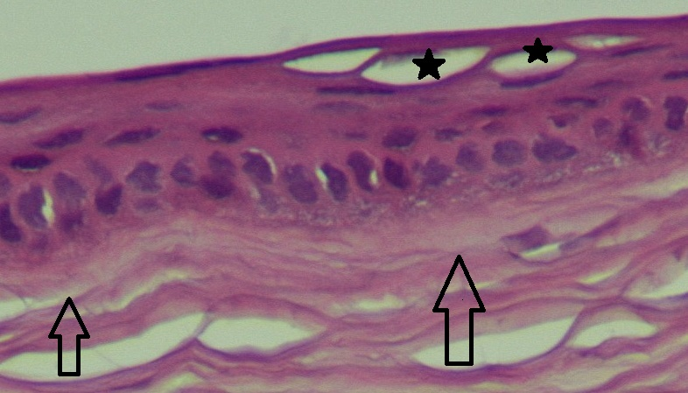

Fig.1 stratified squamous nonkeratinizing epithelium of the cornea of the rabbit with OK therapy. Colouring with hematoxylin+eosin. Fill in paraffin. X 270
On the micrograph clearly visible layers of multilayer plane not becoming Horny epithelium to the underlying basal membrane and the anterior part of the stroma. Volumetric three-dimensional defects in the layer of flat cells (black asterisks) do not break the surface of the epithelium.

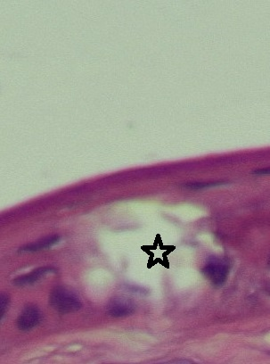

Fig.2 stratified squamous nonkeratinizing epithelium of the cornea of the rabbit with OK therapy. Colouring with hematoxylin+eosin. Fill in paraffin. X 540
On the micrograph clearly visible layers of multilayer plane not becoming Horny epithelium to the underlying basal membrane. Volumetric three-dimensional defect (asterisk) in the basal and spinous (wing cells) the layer does not violate the surface epithelium.

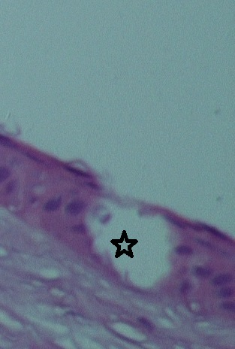

Fig.3 stratified squamous nonkeratinizing epithelium of the cornea of the rabbit with OK therapy. Colouring with hematoxylin+eosin. Fill in paraffin. X 540
On the micrograph clearly visible layers of multilayer plane not becoming Horny epithelium to the underlying basal membrane and the anterior part of the stroma. Huge transepithelial three-dimensional defect (asterisk) passes through all layers of the multilayer epithelium, only partially breaking the surface of the epithelium.

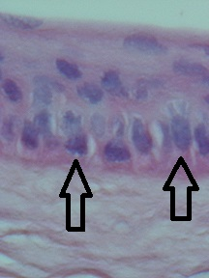

Fig.4 stratified squamous nonkeratinizing epithelium of the cornea of the rabbit with OK therapy. Colouring with hematoxylin+eosin. Fill in paraffin. X 540
On the micrograph clearly shows changes in a polarity and cytoarchitectonic normal layered structure of the cornea. The displacement of the nucleus (arrows) of the basal layer of the epithelium and the orientation of the sides of the cells affect the General cytoarchitecture.

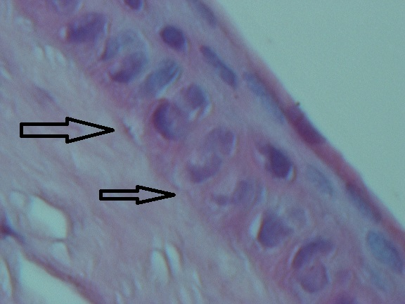

Fig.5 stratified squamous nonkeratinizing epithelium of the cornea of the rabbit with OK therapy. Colouring with hematoxylin+eosin. Fill in paraffin. X 540
On the micrograph clearly visible layers of multilayer plane not becoming Horny epithelium to the underlying basal membrane and the anterior part of the stroma. Clearly visible the discontinuity and the violation of correct ternary structure of the basal membrane of the epithelium (arrows).

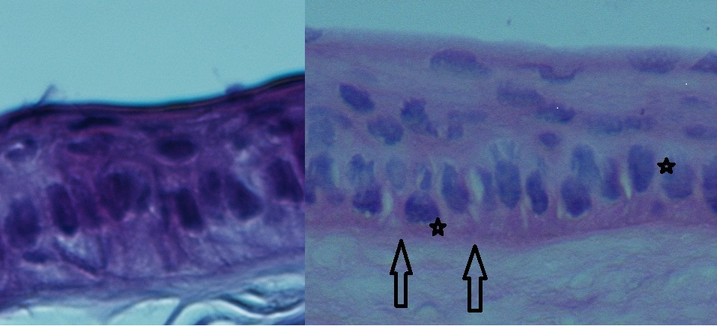

Fig.6 stratified squamous nonkeratinizing epithelium of the cornea of the rabbit. Colouring with hematoxylin+eosin. Fill in paraffin. X 540. Comparison picture: left-the control sample, on the right with OK therapy.
On the micrograph clearly visible layers of multilayer plane not becoming Horny epithelium to the underlying basal membrane and the anterior part of the stroma. In the control sample (left) preserved a strict orientation of the cells maintain their polarity, the localization of the nucleus. In the material subjected to OK-therapy, clearly visible the discontinuity and the violation of correct ternary structure of the basal membrane of the epithelium (arrow) and a disruption of cell polarity (asterisk).

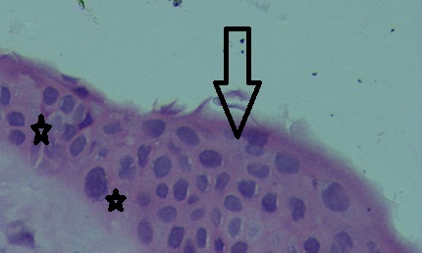

Figure 7. Stratified squamous nonkeratinizing epithelium of the cornea of the rabbit with OK therapy. Colouring with hematoxylin+eosin. Fill in paraffin. X 540
On the micrograph clearly visible layers of multilayer plane not becoming Horny epithelium to the underlying basal membrane. There have been signs of apoptosis (condensation of heterochromatin in the nucleus (asterisk) and a violation of standard cytoarchitectonic and offset layered structure (arrow).

- Alharbi A. The effects of overnight orthokeratology lens wear on corneal thickness / A. Alharbi, H. A. Swarbrick // Investigative Ophthalmology & Visual Science. — 2003. — Vol. 44, N. 6. — P. 2518-2523.
- Alharbi A. Overnight orthokeratology lens wear can inhibit the central stromal edema response / A. Alharbi, D.L. Hood, H.A. Swarbrick // Investigative Ophthalmology & Visual Science. — 2005. — Vol. 46, N. 7. — P. 2334-2340.
- Berke B. Corneal reshaping demystified / B. Berke // Vision by design 2009. — Phoenix, AZ. — October 18, 2009.
- Chen D. Posterior corneal curvature change and recovery after 6 months of overnight orthokeratology treatment / D. Chen, A.K. Lam, P. Cho // Opthalmic and Physiological Optics. 2010. — Vol. 30, N. 3. — P. 274-280.
- Cheah P.S. Histomorphometric profile of the corneal response to short-term reverse-geometry orthokeratology lens wear in primate corneas: a pilot study / P.S. Cheah [et al.] // Cornea. — 2008. — Vol. 27, N. 4. — P. 461-470.
- Choo J.D. Morphologic changes in cat epithelium following continuous wear of orthokeratology lenses: a pilot study / J.D. Choo [et al.] // Contact Lens & Anterior Eye. — 2008. — Vol. 31, N. 1. — P. 29-37.
- Coon L.J. Orthokeratology. Part II. Evaluating the Tabb method / L. J. Coon // Journal of the American Optometric Association. — 1984. — Vol. 55. — P. 409-418.
- Haque S. et al. Corneal and epithelial thickness changes after 4 weeks of overnight corneal refractive therapy lens wear, measured with optical coherence tomography // Eye & Contact Lens. — 2004. — Vol. 30, N. 4. — P. 189-193.
- Jayakumar J. The effect of age on short-term orthokeratology / J. Jayakumar, H.A. Swarbrick // Optometry and Vision Science. — 2005. — Vol. 82, N. 6. — P. 505-511.
- Li Y. Corneal Pachymetry Mapping with High-speed Optical Coherence Tomography / Y. Li, R. Shekar, D. Huang // Ophthalmology. — 2006. — Vol. 113, N. 5. — P. 779-783.
- Lam C. Prevalence of myopia among Hong Kong Chinese schoolchildren: changes over two decades/.Lam, C.-H., Cheng, S. C.-K. and Chan, L. Y.-L // Ophthalmic and Physiological Optics.-2012- Vol.32, N.1.-P. 17–24.
- Matsubara M. Histologic and histochemical changes in rabbit cornea produced by an orthokeratology lens / M. Matsubara [et al.] // Eye & Contact Lens. — 2004. — Vol. 30. — P. 198-204.
- Mao X.J. A study on the effect of the corneal biomechanical properties undergoing overnight orthokeratology / X.J. Mao [et al.] // Chinese Journal of Ophthalmology. — 2010. — Vol. 46, N. 3. — P. 209-213.
- Munnerlyn C.R. Photorefractive keratectomy: a technique for laser refractive surgery / C.R. Munnerlyn, S.J. Koons, J. Marshall // Journal of Cataract & Refractive Surgery. — 1988. Vol. 14. — P. 46-52.
- Nichols J.J. Overnight orthokeratology / J.J. Nichols [et al.] // Optometry and Vision Science. — 2000. — Vol. 77. — P. 252-259.
- Owens H. Posterior corneal changes with orthokeratology / H. Owens [et al.] // Optometry and Vision Science. — 2004. — Vol. 81, N. 6. — P 421-426.
- Queirós A. Anterior and posterior corneal elevation after orthokeratology and standard and customized LASIK surgery / A. Queirós [et al.] // Eye & Contact Lens. — 2011. — Vol. 37, N. 6. — P. 354-358.
- Reinstei D.Z. Epithelial, stromal, and corneal pachymetry changes during orthokeratology / D.Z. Reinstein [et al.] // Optometry and Vision Science. — 2009. — Vol. 86, N. 8. — P. 1006-1014.
- Soni P.S. Overnight orthokeratology: visual and corneal changes / P.S. Soni // Eye & Contact Lens. — 2003. — Vol. 29. — P. 137-145.
- Sridharan R. Corneal response to short-term orthokeratology lens wear / R. Sridharan, H. Swarbrick // Optometry and Vision Science. — 2003. — Vol. 80. — P. 200-206.
- Swarbrick H.A. Corneal response to orthokeratology / H.A. Swarbrick, G. Wong, D.J. O’Leary // Optometry and Vision Science. — 1998. — Vol. 75, N. 11. — P. 791-799.
- Walline J.J. Slowing myopia progression with lenses / Jeffrey J. Walline // Contact Lens Spectrum. — 2007. — June.
- Wang Q. The effect of orthokeratology on corneal cell densities / Q. Wang [et al.] // Optometry and Vision Science. — 2004. — Vol. 81. — P. 28.

