A case of ocular HIV with no systemic manifestations
A 38 yrs old patient presented to OPD with chief complaints of dimunition of vision and seeing floaters in both eye since 1 month. He was apparently alright 1 month back when he suddenly noticed intermittent floaters associated with progressive vision loss in both eyes. He reported only being able to make out shadows in the left eye and blurry figures in the right eye. He denied painful vision, headache, photophobia, neck stiffness, nausea, vomiting, and focal neurological deficits. No history of systemic illness.
On examination
Parameters | Right eye | Left eye
Visual acuity | 6/36 | 6/60
Iop | 16 mm Hg at 11.30AM | 18 mm Hg at 11.30 AM
Anterior segment | Cells 2+  Flare +  Pupil round regular reacting to light | Cells 3+  Flare +  Pupil round regular reacting to light
Posterior segment | Disc 0.3:1 cup with normal NRR  Multiple hemorrhages with cotton wool spots at macula and peripheral retina . | Disc 0.3:1 cup with normal NRR  Macular edema present . Sheathing of retinal vessels present . Multiple hemorrhages with cotton wool spots with 360 degree peripheral necrosis of retina .

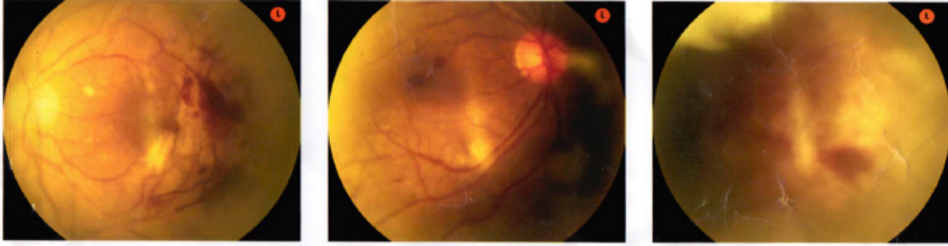
Fundus picture of both eye showing vascular sheathing with hemorrhages and peripheral necrosis of retina

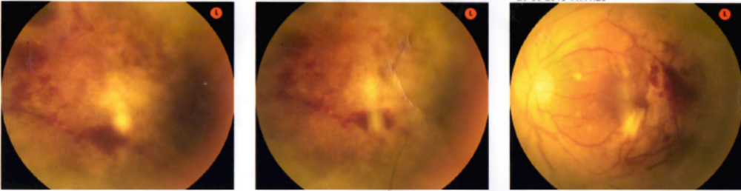

Patient was advised investigations both systemic and ocular. On systemic investigation Complete blood count was within normal limits, ESR was 45mm/hr. LFT and KFT were within normal limits. HIV 1 and 2 was reactive.
Fundus fluorescein angiography was done which showed extensive retinal vasculitis with numerous microaneurysms with marked areas of capillary non perfusion and blocked fluorescence.
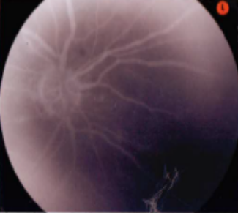
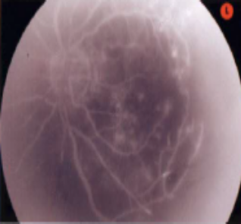
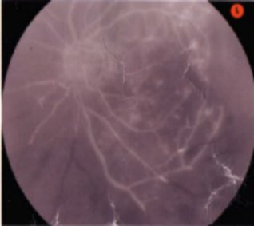

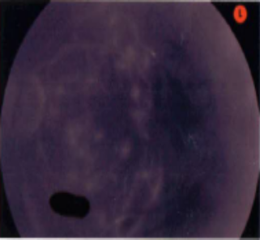
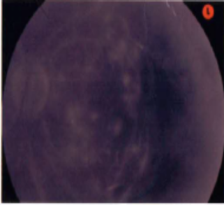
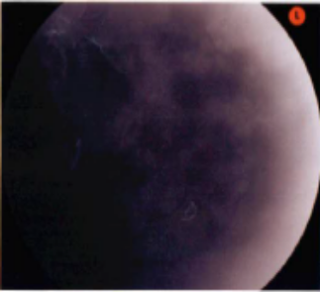

FFA shows extensive vasculitis with marked capillary non perfusion.

Patient was referred to ART Centre where CD 4 count was done which was 114cumm and started on ART therapy. Cytomegalovirus IgG and IgM was done and found to be positive . Patient was also started on oral valgancyclovir 900 mg BD. and intravitreal ganciclovr was given 2.0mg/0.1 ml twice weekly.
On follow up patient’s vision gradually improved in both eyes . And is now continuing on ART Therapy along with oral valganciclovir 900mg OD.

Dr Manik Gupta( MBBS DNB OPHTHAL)
Dept of ophthalmology
TLM SHAHDARA

