TITLE: Tracking cancer lesions on surgical samples of gastric cancer by artificial intelligent algorithms.

Name: Dr.TSHETIZ DAHAL
Affiliation: Lugansk State Medical University

Abstract (up to 300 words)

To quickly locate cancer lesions, especially suspected metastatic lesions after gastrectomy, AI algorithms of object detection and semantic segmentation were established. A total of 509 macroscopic images from 381 patients were collected. The RFB-SSD object detection algorithm and ResNet50-PSPNet semantic segmentation algorithm were used. Another 57 macroscopic images from 48 patients were collected for prospective verification. We used mAP as the metrics of object detection. The best mAP was 95.90% with an average of 89.89% in the test set. The mAP reached 92.60% in validation set. We used mIoU for evaluation of semantic segmentation. The best mIoU was 80.97% with an average of 79.26% in the test set. In addition, 81 out of 92 (88.04%) gastric specimens were accurately predicted for the cancer lesion located at the serosa by ResNet50-PSPNet semantic segmentation model. The positive rate and accuracy of AI prediction were different based on cancer invasive depth. The metastatic lymph nodes were predicted in 24 cases by semantic segmentation model. Among them, 18 cases were confirmed by pathology. The predictive accuracy was 75.00%. Our well-trained AI algorithms effectively identified the subtle features of gastric cancer in resected specimens that may be missed by naked eyes. Taken together, AI algorithms could assist clinical doctors quickly locating cancer lesions and improve their work efficiency.

Biography (up to 150 words)
Myself, Dr.TSHETIZ DAHAL I have completed my MBBS at the age of 24 years from Lugansk State Medical University,Ukraine. I am self employed in Clinical Research and I work through clinical trials in hospital. My current work focuses on advancing new capabilities,methodological strategies and pragmatic approaches to research implementation that advance real world evaluations in populations and individuals. I maintain a strong passion for innovation, rigor and relevance, with a special focus on the promotion, collection and incorporation of patient - centered information into clinical trials and observational studies. I have over 05 publications that have been cited over many times, and my publications H-index is 10 and I have been serving as an board member of few Journals.

Email ID: dahaltshetiz21@gmail.com
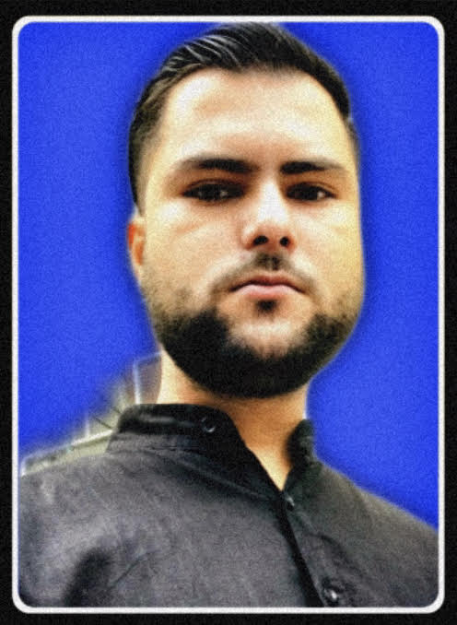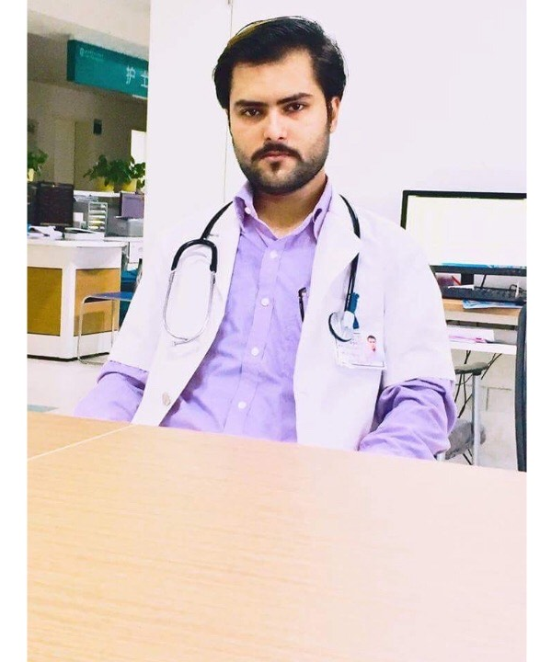
Presenter Name: Dr.Tshetiz Dahal
Type of Presentation: Abstract
Contact Number: +380 506266617

