Title: Genetic Variability of GSTM1 and GSTT1 and Risk of Childhood Acute Lymphoblastic Leukemia (ALL)
Zehra S, Zehra A, Azhar A,
The Karachi Institute of Biotechnology and Genetic Engineering, KIBGE, University of Karachi, Pakistan

Abstract
Glutathione S transferases (GSTs) are the detoxifying enzymes of xenobiotic metabolism. Null polymorphism of glutathione transferase M1 and T1 genes leads to the absence of respective enzymes thus disrupting the normal metabolism of xenobiotics. Therefore, individuals carrying genetic variants of GSTs may influence individual’s susceptibility to ALL. The present study investigated the role of null polymorphisms of GSTM1 and GSTT1 as predisposition factor in ALL development. One hundred and fifty ALL patients younger than 15 years of age and 150 age and gender matched healthy individuals participated in the current case control study. Genomic DNA was extracted from whole blood samples using conventional phenol chloroform method. Multiplex PCR was performed that led to the co-identification of GSTM1 and GSTT1 deletions. The percentage of GSTM1 null was lower in cases (38%) as compared to controls (44%) while the percentage for GSTT1 deletion was same among cases and controls (16%). Chi-square test revealed no association of GSTM1 and GSTT1 deletion with development of ALL in children (p>0.1). The results of the current study may be relevant to cancer biomarker research. However, studies with larger sample size and ethnic backgrounds may further improve understanding of ALL etiology.

Keywords: Acute lymphoblastic leukemia, ALL, genetic susceptibility, polymorphism, GSTM1, GSTT1
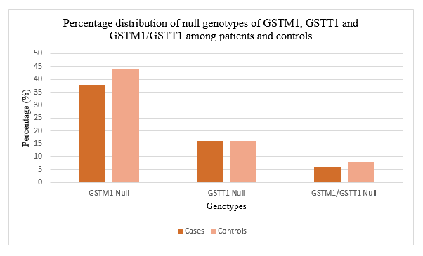

References/Bibliography
- Alves, S., Amorim, A., Ferreira, F., Norton, L., & Prata, M. J. (2002). The GSTM1 and GSTT1 genetic polymorphisms and susceptibility to acute lymphoblastic leukemia in children from north Portugal. Leukemia, 16, 1565–1567.
- Aydin-Sayitoglu, M., Hatirnaz, O., Erensoy, N., & Ozbek, U. (2006). Role of CYP2D6, CYP1A1, CYP2E1, GSTT1, and GSTM1 genes in the susceptibility to acute leukemias. American Journal of Hematology, 81, 162–170.
- Balta, G., Yuksek, N., Ozyurek, E., Ertem, U., Hicsonmez, G., Altay, C., & Gurgey, A. (2003). Characterization of MTHFR, GSTM1, GSTT1, GSTP1, and CYP1A1 genotypes in childhood acute leukemia. American Journal of Hematology, 73, 154–160.
- Canalle, R., Burim, R. V., Tone, L. G., & Takahashi, C. S. (2004). Genetic polymorphisms and susceptibility to childhood acute lymphoblastic leukemia. Environmental and Molecular Mutagenesis, 43, 100–109.
- Dunna, N. R., Vure, S., Sailaja, K., Surekha, D., Raghunadharao, D., Rajappa, S., & Vishnupriya, S. (2013). Deletion of GSTM1 and T1 genes as a risk factor for development of acute leukemia. Asian Pacific Journal of Cancer Prevention, 14, 2221–2224.
- Joseph, T., Kusumakumary, P., Chacko, P., Abraham, A., & Radhakrishna Pillai, M. (2004). Genetic polymorphism of CYP1A1, CYP2D6, GSTM1 and GSTT1 and susceptibility to acute lymphoblastic leukaemia in Indian children. Pediatric Blood & Cancer, 43, 560–567.
- Suneetha, K. J., Nancy, K. N., Rajalekshmy, K. R., Sagar, T. G., & Rajkumar, T. (2008). Role of GSTM1 (Present/Null) and GSTP1 (Ile105Val) polymorphisms in susceptibility to acute lymphoblastic leukemia among the South Indian population. Asian Pacific Journal of Cancer Prevention, 9, 733–736.
- Tang, Z.-H., Zhang, C., Cheng, P., Sun, H.-M., Jin, Y., Chen, Y.-J., & Huang, F. (2014). Glutathione-S-transferase polymorphisms (GSTM1, GSTT1 and GSTP1) and acute leukemia risk in Asians: a meta-analysis. Asian Pacific Journal of Cancer Prevention, 15, 2075–2081.



Assistant Professor, Sectional Head of Biomedical Section, The Karachi Institute of Biotechnology and Genetic Engineering (KIBGE), University of Karachi.
Dr. Sitwat Zehra, Assistant Professor, at “The Karachi Institute of Biotechnology and Genetic Engineering (KIBGE), University of Karachi”. She has spent more than 10 years in teaching and research. Sitwat Zehra, has received Ph.D. in Physiology from University of Karachi. Her research activities encompass Endocrinology, Molecular Biology and Genetic Engineering. She has been involved in teaching Human Molecular Genetics, Cancer Genetics, Biosafety and Bioethics, Current Advances in Biotechnology, Cell Biology, Research Communication and Presentation Skills to M.Phil. and Ph.D. students form last 10 years. Dr. Sitwat is the member of various National and International societies and learning bodies like Pakistan Biological Safety Association (PBSA), Pakistan Physiological Society (PPS), Pakistan Society of Biochemistry and Molecular Biology (PSBMB), International Union of Physiological Sciences (IUPS), Organization for Women in Science for Developing World (OWSD). Number of national and international publications of her research are on her credit, published in journals of high impact.
Email: sitwat.zehra@kibge.edu.pk

- Full Name: Sitwat Zehra
- Personal Email: sitmina2009@yahoo.com
- Mobile Number: 92213342676512
- Linked In: -
- Facebook: phooliftikhar
- Session Name/ number: Hematologic Cancer
- Category: Oral presentation
- Date of Birth: July 4, 1978
- Postal Address: The Karachi Institute of Biotechnology and Genetic Engineering, KIBGE, University of Karachi, Sindh, Karachi, Pakistan. 75270

Notes or Comments:
Kindly use my official email address. Thank you

