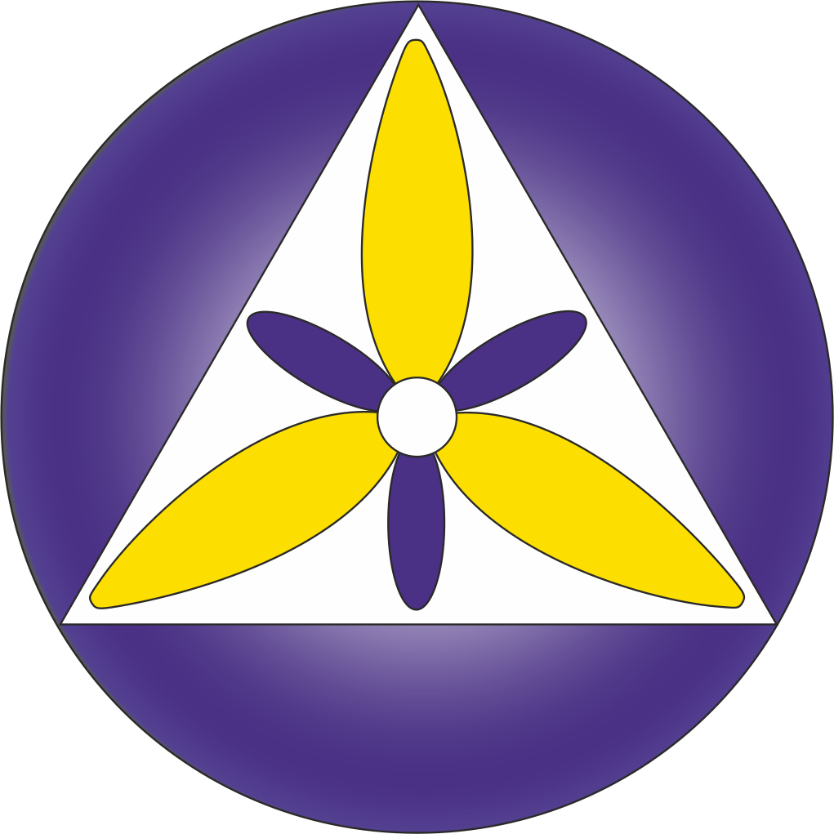
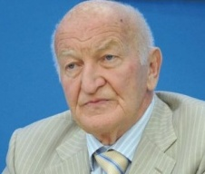

Title: Selective and immunomodulating effect of the anticancer preparation NSC-631570 (Ukrain)

Name: Dr. Wassil Nowicky
“Nowicky Pharma”/ Ukrainian Anti-Cancer Institute,
Margareten Street 7, A-1040, Vienna, Austria

Abstract: (Minimum 250 words Maximum 450 words)
Researchers from Eberhard‐Karls‐University Tubingen, Germany, investigated the effects of NSC‐631570 on cell survival, alteration of the cell cycle and induction of apoptosis without and in combination with ionising radiation (IR) at a dose of 1‐10 Gy. The tests were performed on the exponentially growing human tumor cells MDA‐MB‐231 (breast), PA‐TU‐8902 (pancreas), CCL‐221 (colon cancer), U‐138MG (glioblastoma), and human skin and lung fibroblasts HSF1, HSF2 and CCD32‐LU. Without IR, NSC‐631570 exerted a time‐ and dose‐dependant cytotoxic effect, more pronounced against the cancer cells. Flow cytometry revealed NSC‐631570 to modulate radiation toxicity against human cancer cell lines and to protect normal cells from radiation. The combination of NSC‐631570 plus IR gave enhanced toxicity in CCL‐221 and U‐138MG cells with their accumulation in the G2/M phase of the cell cycle, but not in MDA‐MB‐231 and PA‐TU‐8902 cells. A radio protective effect was found in normal human skin and lung fibroblasts. The authors suggest a reasonable use of NSC‐631570 in combined radiochemotherapy [].
The cytotoxic effects of NSC‐631570 were evaluated in two primary pancreatic cancer cell lines (PPTCC), fibroblasts derived from pancreatic ductal adenocarcinoma specimens (F‐PDAC), and an immortalized epithelial ductal pancreatic cell line (HPNE). Cytotoxicity was assessed by the CellTiter 96 kit based on the cellular metabolism of the tetrazolium compound XTT, which is reduced by living cells to yield a soluble formazan product in the presence of the electron coupling agent phenazine methosulfate, while the modulation of NSC‐631570 uptake in the medium was studied using the fluorescence of NSC‐631570 with the AlphaDigiDoc software by UV light excitation. Cytotoxic effects of NSC‐631570 in PPTCCs were significantly higher than those observed in F‐PDAC and HPNE cells (20% vs. 80% alive cells). Furthermore, the ULA‐DC test Melanoma cells revealed that PPTCCs cells consumed more drug than F‐PDAC and HPNE cells. These data demonstrated the selective effect of Ukrain in PPTCCs, which may be related to a different transport system or higher metabolism of the drug in PDAC, and warrant further investigations in order to support the possible role of Ukrain in PDAC treatment [].

Keywords: oncology, anticancer, NSC-631570, Ukrain, proton

Images/Graphs/Tables:

Recent Publications:
- Larysa M.Skivka, Olexander G. Fedorchuk, Natalia O. Bezdeneznykh, Olexanrda O. Lykhova, Nadija I. Semesiuk, Yuri I. Kudryavets, Oksana M. Malanchuk The effect of antineoplastic drug NSC63150 on immunogenicity of B16 melanoma. J Exp Integr Med. 2014; 4(2): 93- 105.
- Larysa M. Skivka, Olexander G. Fedorchuk, Yaroslav M. Susak, Mychailo Y. Susak, Oksana M. Malanchuk, Mariia P. Rudyk and Yaroslav. W. Nowicky. Physical Activity Interferes with the Immunomodulatory Effect of the Antineoplastic Drug NSC631570. Current Pharmaceutical Biotechnology, 2014, Vol. 15, No. 12.
- Rudyk M., Pozur V., Fedorchuk O., Khranovska M., Senchilo N., Shepelevich V., Svyatetska V., Skivka L. The effect of antineoplastic drug NSC 631570 on the functional polarization of circulating phagocytes in mice with Lewis lung carcinoma. Eurasian journal of oncology. 2015; 1(04): 97-107.
- Mariia Rudyk, Olexander Fedorchuk, Yaroslav Susak, Yaroslav Nowicky, Larysa Skivka Introduction of antineoplastic drug NSC631570 in an inpatient and outpatient setting: Comparative evaluation of biological effects. Asian Journal of Pharmaceutical Sciences. 2016; 11, Issue 2: 308–317.
- Wassil N, Bojan N, Niccola F. The Selective Effect of NSC-631570 (UKRAIN). J Tumor Med Prev. 2017; 1(5): 555575. Ting, F.I., Campos, H.J., Riel, A.(2015). Colo-cutaneous Fistula Complicating Diverticulitis of the Sigmoid Colon after Appendectomy: A Case Report and Review of Literature. Presented to the Philippine College of Physicians Research Conference December 2015.

Biography: (Minimum 150 words Maximum 250 words)
Dr. Wassil Nowicky — Dipl. Ing., Dr. techn., DDDr. h. c., Director of “Nowicky Pharma” and President of the Ukrainian Anti-Cancer Institute (Vienna, Austria). Has finished his study at the Radiotechnical Faculty of the Technical University of Lviv (Ukraine) with the end of 1955 with graduation to “Diplomingeniueur” in 1960 which title was nostrificated in Austria in 1975. Dr. Wassil Nowicky became the very first scientist in the development of the anticancer protonic therapy and is the inventor of the preparation against cancer with a selective effect on basis of celandine alkaloids “NSC-631570”. He used the factor that cancer cells are more negative charged than normal cells and invented the Celandine alkaloid with a positive charge thanks to which it accumulates in cancer cells very fast. Author of over 300 scientific articles dedicated to cancer research. Dr. Wassil Nowicky is a real member of the New York Academy of Sciences, member of the European Union for applied immunology and of the American Association for scientific progress, honorary doctor of the Janka Kupala University in Hrodno, doctor “honoris causa” of the Open international university on complex medicine in Colombo, honorary member of the Austrian Society of a name od Albert Schweizer. He has received the award for merits of National guild of pharmasists of America. the award of Austrian Society of sanitary, hygiene and public health services and others.
Presenting author details
Full name (As per the passport): Wassil Nowicky
University/Industry/Organization name (Present working): “Nowicky Pharma”/ Ukrainian Anti-Cancer Institute
Designation (Director/Prof/Assistant or Associate prof/Researcher/ Scientist /PhD Student): Director, President

Country: Austria
Mobile number (country code – number) : +436644020692
Official Email ID: dr.nowicky@yahoo.de
Presentation type (Oral/Poster): Oral
Category (Invited talk/Young researcher Invited talk/E-poster):
Track number (This is very important to schedule your talk): 13 Anticancer drug
Follow this link – https://oncologists.cancersummit.org/call-for-abstracts.php
Research interest:

Your profile page URL in your department:
Date of birth as per the passport: 15 Oct 1937
Linked In/Facebook/twitter account: www.ukrin.com
Postal address: Margareten Street 7, A-1040, Vienna, Austria

Note: Please fill up the Red mark fields so that it would be easier for us to cite your details in the conference particulars. (Please do not forget to fix your photo and Logo above the title)

Cordes N, Plasswilm L, Bamberg M, Rodemann HP (2002): Ukrain, an alkaloid thiophosphoric acid derivative of Chelidonium majus L. protects human fibroblasts but not human tumour cells in vitro against ionizing radiation. International journal of radiation biology, 78(1):17‐27. http://www.ncbi.nlm.nih.gov/pubmed/11747550
Funel N, Giovannetti E, Nowicky W, Pollina L, Del Chiaro M, Peters G, Nowicky B, Mosca F, Boggi U, Campani D (2010): Different uptake of Ukrain can explain the selective effect against pancreatic adenocarcinoma cell cultures in vitro. In: Proceedings of the 34th National Congress of the Italian Association for the Study of the Pancreas (AISP): Journal of Pancreas.

