
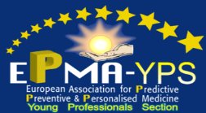
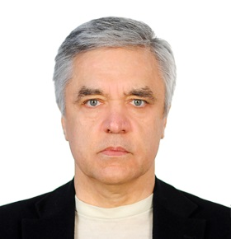

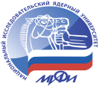
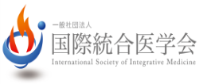
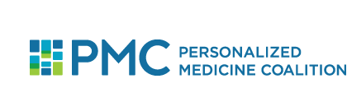

Personalized and Precision Oncology through the View of
Translational Applications and Innovative Tools to Manage
Cancer Progression

Sergey Suchkov¹⁻⁷, Vladimir Lazar⁸, John Mendelsohn^{8.9}

¹Sechenov University; ²Moscow Engineering Physical Institute (MEPhI)
³A.I.Evdokimov Moscow State Medical & Dental University, Russia
⁴ISPM, Tokyo, Japan; ⁵PMC, Washington, USA; ⁶EPMA, Brussels, EU; ⁷AHA, Houston, USA
⁸WIN Consortium, Paris, France
^{8,9}Institute of Personalized Cancer Therapy, University of Texas MD Anderson Cancer Center, Houston, USA

A new systems approach to diseased states and wellness result in a new branch in the healthcare services, namely, personalized and precision medicine (PPM) to stimulate the development in a variety of clinical disciplines including Personalized and Precision Oncology (PPO).
To achieve the implementation of PPO concept into the daily practice, it is necessary to create a fundamentally new strategy based upon the subclinical recognition of cancer-associated bioindicators (biopredictors and biomarkers) of pre-cancer abnormalities long before the disease clinically manifests itself.
Each decision-maker values the impact of their decision to use PPO on their own budget and well-being, which may not necessarily be optimal for society as a whole. It would be extremely useful to integrate data harvesting from different databanks for applications such as prediction and personalization of further treatment to thus provide more tailored measures for the cancer patients and persons-at-risk resulting in improved outcomes whilst securing the healthy state and wellness, reduced adverse events, and more cost effective use of health care resources.
Rapidly improving understanding of PPO, emerging novel therapeutics, and increasingly available and affordable next-generation sequencing have created an opportunity for delivering genomically informed personalized cancer therapy. Alterations that are targetable either directly or indirectly with approved or investigational therapies are potentially "actionable." At this time, evidence linking predictive biomarkers to therapies is strong for only a few genomic markers in the context of specific cancer types.
Deciding what therapy options to pursue can also be daunting, especially when tumors harbor more than one potentially actionable aberration. Further, different mutations/variants in a single gene may have different functional consequences, and response to targeted agents may be context dependent. However, early clinical trials with new molecular entities are increasingly conducted in a biomarker-selected fashion, and even when trials are not biomarker-selected, much effort is placed on enrolling patients onto clinical trials where they have the highest probability of response.
Implementation of PPO requires a lot before the current model “oncologist-cancer patient” could be gradually displaced by a new model “medical advisor-healthy person-at-risk”. This is the reason for developing global scientific, clinical, social, and educational projects in the area of PPO to elicit the content of the new branch. Recognizing the need to define the policies required for sustained innovation in cancer research and care in an era of cost containment, the stakeholder community must engage in an ongoing dialogue and identify areas for collaboration.

Biography
Sergey Suchkov was born in the City of Astrakhan, Russia, in a dynasty of medical doctors, graduated from Astrakhan State Medical University and was awarded with MD. Then maintained his PhD and Doctor’s Degree. And later was working for Helmholtz Eye Research Institute and Moscow Regional Clinical Research Institute (MONIKI). Dr Suchkov was a Secretary-in-Chief of the Editorial Board, Biomedical Science, an international journal published jointly by the USSR Academy of Sciences and the Royal Society of Chemistry, UK. At present, Dr Sergey Suchkov is: (i) a Director, Center for Personalized Medicine, Sechenov University, (ii) Chair, Dept for Translational Medicine, Moscow Engineering Physical University (MAPhI), and (iii) Secretary General, United Cultural Convention (UCC), Cambridge, UK. A Member of the: New York Academy of Sciences, American Chemical Society (ACS), American Heart Association (AHA), AMEE, Dundee, UK; EPMA, Brussels, EU; PMC, Washington, DC, USA and ISPM, Tokyo, Japan.

E-mail: ssuchkov57@gmail.com
Tel: +7 985 761 65 67

