Compliance with Guideline-Based Empiric Antimicrobial Therapy for Febrile Neutropenia in Adult Filipino Patients and their Effect on Outcomes

Frederic Ivan L. Ting, MD, Faith Y. Santos, MD,
Andrew I. Mallen, MD, FPCP, FPSMO, Jeanette J. Umali, MD, FPCP, FPSMID

Abstract

Background: Febrile neutropenia (FN) is a common complication of immunocompromised patients –whether due to infection, cancer, drug-induced, or other bone marrow failure states. With the incidence of patients with immunocompromised states on the rise, this life threatening complication is also increasing. The importance of initiating the appropriate empiric antibiotic therapy can prove to be life-saving, thus we examined how the initial choice of antibiotics influenced patient outcomes.

Objective: This study aimed to determine the effect of adherence to guideline-based antimicrobial therapy for adult febrile neutropenia patients in terms of patient outcomes.

Design: Retrospective Cross-Sectional Analytical Study

Methods: This is a 10-year cross-sectional analytical study which was conducted by doing a retrospective chart review involving adult patients with FN from 2007 to 2016. We determined use of guideline-based antibiotics, examined the factors that influenced adherence, and investigated the effect of initial treatment on patient outcome.

Results: Among the 257 adult patients with FN included in the study, guideline-based antibiotics were administered to 65%. On multivariate analysis, the most powerful predictor of adherence to guideline-based antibiotics was the type of risk (p=0.000), with high risk patients thrice more likely to be given guideline-based antibiotics. Other predictors were physician specialty (p= 0.036) and hematologic malignancy (p=0.045). This study showed that among low risk patients with FN, a trend towards patient discharge was observed (OR 1.18, CI = 0.16 – 8.63). However overall, adherence to guideline-based empiric antibiotic in treating adult FN patients did not correlate to patient discharge (p=0.134, OR 0.557, 95% CI = 0.260-1.205).

Conclusions: In summary, our data suggest that adherence to guideline-based antibiotics in managing adult Filipino patients with febrile neutropenia does not correlate to better outcomes such as patient discharge. Significant factors associated with adherence to guideline-based antibiotics are physician specialty, hematologic malignancy, and type of risk.

Tables

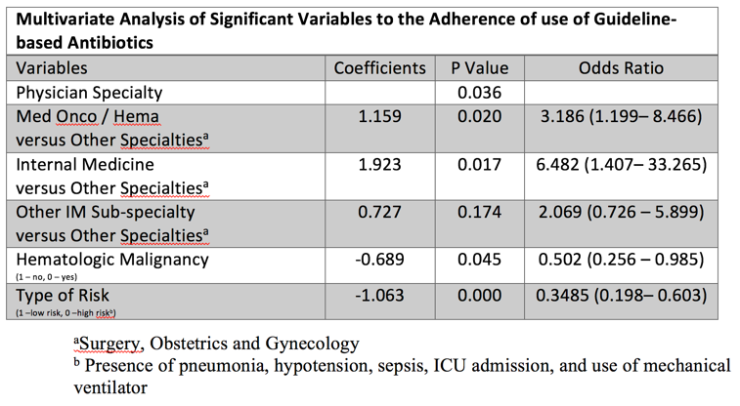

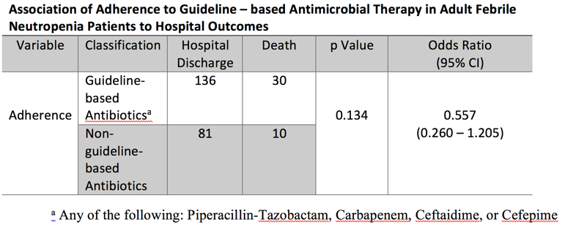

Recent Publications
- Ting, F.I., Campos, H.J., Riel, A.(2015). Colo-cutaneous Fistula Complicating Diverticulitis of the Sigmoid Colon after Appendectomy: A Case Report and Review of Literature. Presented to the Philippine College of Physicians Research Conference December 2015.

- Ting, F.I., Parreñas, C., Palo, K., Seralde, A., Yasa, K., Yu, S. (2012) Perception and Knowledge of University of St. La Salle Students on the University’s Disaster Preparedness.

- Ting, F.I., Calmerin, E., del Rosario, B., Granada, M.E., Seralde, A., Trespeces, A.G. (2011). Water, Dug Wells, and People.

- Ting, F.I., Calmerin, E., del Rosario, B., Granada, M.E., Seralde, A., Trespeces, A.G. (2011). Physical and Chemical Properties of Water from Dug Wells at Purok Kaingin II, Barangay Punta Taytay, Bacolod City, Negros Occidental, Philippines.

- Ting, F.I., Abella, M.K., Corrales, M.C., Centina, M.K., Nonato, R.J., Santos, F. (2010). The Hypocholesterolemic Effect of the Crude Methanolic Extract of Radish Leaves (Raphanus Sativus) on the Total Cholesterol Level of Rabbits with Induced Hypercholesterolemia.


Biography

Frederic Ivan L. Ting, MD is a senior medical resident at the Dr. Pablo O. Torre Memorial Hospital –a tertiary hospital in Bacolod City, Negros Occidental, Philippines. He is currently focusing on the art and science of Oncology, as he is amazed and inspired by the simple complexity of the discipline. He aspires that one day he will fulfill his dream of serving the Filipino people as a medical oncologist, writer, and teacher.
Email: fredtingmd@gmail.com

