Benign leiomyoma metastasizing to multiple organs and literature review
Introduction
Uterine leiomyomas are highly common. Their incidence is generally cited as 20-25%, but has been shown to be as high as 70-80% in studies using histologic or sonographic examination. Disease metastasis is extremely rare and is of unknown etiology. It primarily affects women of reproductive age and might appear years after myomectomy or hysterectomy procedures. Most common theory is of Leiomyoma spread hematogenously. Most common sites are the lungs, heart, lymph nodes, omentum, peritoneum, pelvic cavity, breast, bone, mediastinum and nervous system. In our case the patient presented with abdominal pain with a history of a 9 cm Leiomyoma removal 2 years prior. On CT scan, a heterogenous uterus measuring 19x14x19cm was visualized along with multiple vertebral sclerotic/blastic lesions. Due to increased concern of metastatic disease, additional imaging was performed unmasking multiple nodules in the lungs, pleura, sternum and mediastinum. Pleural biopsy revealed benign leiomyoma pathological structure. There are no randomized studies which were conducted on the best way to manage these cases. 100 cases were described so far in English literature, even though these were milder and did not involve lesion spread to such extent.

Case report
35y/o G0, last menstrual period 07/11/2016, presented to the ER complaining of left upper quadrant pain 9/10 on pain scale starting on the day of presentation. Patient also reported nausea without vomiting episodes. Patient endorsed initial experience of this sort. Patient denied vaginal bleeding or discharge. Patient could not recall any recent changes in weight or appetite. The last time the patient visited an Obstetrics and Gynecology specialist was one and a half years ago. Past medical history included asthma, controlled on albuterol nebulizer and diabetes mellitus controlled on metformin. The patient had one abdominal myomectomy 2 years prior. On admission the patient had a transvaginal Ultrasound (US) and an abdominal and pelvic Cath scan (CT). The impression on the CT was of a large heterogenous lobular uterus measuring 19x14x19cm that occupied most of the pelvic (figure 2). In addition, there was a separate mass measuring 4x3.6cm which was adjacent to the uterus. This could represent a pedunculated fibroid on a stalk or multiple enlarged lymph nodes through the iliac chain. Furthermore, the US detected vertebral body sclerotic lesions on L1,2,3,5,T6,10,11,12. No gross reduction or expansion was seen. The radiologist reported that the radiologic structure seemed unusual for endometrial carcinoma but Leiomyosarcoma could not be excluded. The US indicated that there was a huge heterogenous lobular uterus with a structure typical of fibroid uterus. The adnexa and ovaries were not visualized. CBC, chemistry 7, liver function test were drawn on admission. The only mildly abnormal levels detected were of Hemoglobin and RBC. Tumor markers were drawn as well. HCG, CA 19-9, Alfa-fetoprotein, testosterone total, free, bioavailable and SHBG were all within normal limits. In addition, serum albumin, CA 125 and CEA were all normal. The only nonspecific marker which was found to be elevated was LDH. It was found to be 1592 IU/L. 2 days into admission it was decided to perform a chest CT with no contrast. The impression was of sternal lesions, focal area of pleural thickening at the costophrenic angle, 3 nodules in the right and 8 in the left lung, lytic lesions in the distal end of the left clavicle, mixed lytic and sclerotic lesions in the right fourth rib, sclerotic and destructive changes seen in the anterior aspect of the vertebral body with associated soft tissue mass in the superior mediastinum anterior to the vertebral body. The soft tissue mass measured 4.2 cm. Pain management was attempted while trying to come to a final diagnosis. Interventional radiology was consulted for a possible CT guided biopsy. CT guided biopsy was performed, 2 days into the admission from a pleural lesion (figure 3). The final histologic report including all specific dyes were of smooth muscle cells with 0 mitotic figures, consistent of benign Leiomyoma (figure 1). Thoracic surgery specialist was consulted for a possible surgical managemet. It was decided not to operate at that time due to lesion extent in the thoracic cavity and increased risk of morbidity and mortality. Patient was discharged in good condition and was referred to a gynecology oncology specialist for further treatment options and evaluation. After reviewing the patient’s chart and imaging studies, hormonal treatment was recommended by the oncologist. This was decided due to metastasis distribution, lack of symptoms and the increased risk of morbidity and mortality in a multi organ complex surgical procedure. The only surgical procedure that was recommended was an additional abdominal myomectomy or hysterectomy.

Discussion
Benign metastasizing leiomyomas (BML) is a benign disease affecting primarily women of reproductive age. The disease is of benign pathology but clinically behaves as a malignant metastatic disease. Since Steiner first described the disease in 1939, there were approximately 100 cases described in English literature (1). The etiology is unknown but 3 hypothesis of the pathogenesis have been proposed: A. Hematogenous spread to extrauterine locations due to uterine artery embolization or uterine surgery. B. Malignant behavior of benign looking uterine tumors. C. Systemic leiomyomatosis (2, 3). Most common locations of spread are the lungs, but metastasis to the heart, lymph nodes, bones, omentum, peritoneum, pelvic cavity, breast and nervous system were also observed. The diagnosis is usually incidental and is between 3 months to 20 years after uterine surgical manipulation (4). Even though, English literature describes metastasis to various organs separately, it doesn’t describe metastatic lesions to multiple locations in the same or different organ in the same patient. The disease in usually indolent since as leiomyoma, it usually contains less than 5 mototic figures per 10 HPFs without atypia or necrosis. The presenting patient is usually asymptomatic and the diagnosis is usually incidental. After radiographic imaging of multiple lesions, an imaging guided biopsy is warranted for definite diagnosis. The most important pathology to rule out in the differential diagnosis is Leiomyomasarcoma or other forms of malignancy. Histologically, these tumors contain estrogen and progesterone receptor, hence react to different hormones and regress postmenopausally. There is no treatment protocol; The goal is to reduce morbidity and mortality considering the location of the lesions and their size. Surgical, hormonal and expected management are all possible. Hormonal treatment includes depression of GnRh, Estrogen and Progesterone. The treatment responses which are described in case reports are variable, with no relation to hormonal receptor presence (5). However, progesterone effectiveness depends on the presence of progesterone receptors. Three theories exist about progesterone’s mechanism of action in nodule regression; A. Progesterone inhibits the Hypothalamic-Pituitary-gonadal axis. This results in decreased Estrogen production. B. Progesterone upregulates 17 beta hydroxyl-steroid dehydrogenase, hence converting Estradiol to its less active form, Estrone. C. Progesterone down regulates aromatase activity. On the other hand, Estrogen antagonizing drugs are also a treatment option and were shown to be affective in the treatment of BML (6). Treatment options include anastrozole alone or combined with GnRh agonist for suppression of estrogen production. Both were shown to be very affective in BML treatment (7). Drugs which were designed to alter extracellular matrix production and angiogenesis were also proposed as treatment options. TGF-β in a normal myometrium increases extracellular matrix production and decreases collagenase activity. In leiomyomatous tissue, the TGF-β pathway is dysregulated, hence its inhibition decreases extracellular matrix production and proliferation. Surgical treatment is also of primary consideration. Morbidity and mortality of a surgical procedure is weighed against expectant or hormonal management. Consideration includes; location, size, clinical affect and age. Combination treatment with surgery followed by hormonal treatment is also mentioned in case reports to be highly successful in BML treatment. No randomized controlled trials were conducted on best treatment method. All treatments should be individualized. Our patient presented with abdominal pain, probably resulting from the increased uterine size. The lesions which were discovered were incidental and were not influencing the patients’ everyday life. Since the patient had never procreated, the only surgical option which was surely recommended was a repeat myomectomy. Relating to the lesions which were diagnosed in the lungs, sternum, vertebrae, ribs and lymph nodes, multiple therapeutic options existed. An extensive surgical treatment would require multiple disciplines and would most probably because much harm than any benefit. Limited lesion resection seemed reasonable but since the patient did not have any symptoms, the decision which of the lesions to resect and which not was highly complicated. Hormonal treatment was also very much recommended, either alone or combined with limited surgical treatment. This was in order to reduce lesion size and maybe prevent future symptoms. This report is very unusual, rare and creates an ethical challenge due to the fact that the patient has multiple lesions in various organs and did not procreate yet. More consideration should be given to disease pathogenesis and pathophysiology. A better understanding of the disease will shine light on new and better treatment options and fertility preservation.

References
- Sreiner PE. Metastasizing fibroleiomyoma of the uterus. AM J Patho 1939; 15:89-109 .
- Beck MM, Biswas B, Dsouza A et al. 2012. Benign metastasizing leiomyoma after hysterectomy and bilateral salpingo-oophorectomy. Hong Kong medical journal 18: 153-155 .
- Bowen JM, Cates JM, Kash S et al. 2012. Genomic imbalances in benign metastasizing leiomyoma: characterization by conventional karyotypic, flurescence in situ hybridization, and whole genoma SNP array analis. Cancer Genetics 205: 249-254.
- Abramson S, Glikson RC, Goldstein JD, et. al: benign metastasizing leiomyomas: clinical, imaging and pathological correlation. AJR Am J Roentgenol 2001; 176: pp. 1409-1413.
- Pitts S, Oberstein EM and Glassberg MK: benign metastasizing Leiomyoma and Lymphangiomatosis: Sex-specific disease? Cli Chest Med 2004;25 pp.343-360.
- Wentling GK, Sevin BU, Geiger XJ, et al: Benign metastasizing Leiomyoma responsive to megestrol: case report and review of literature. Int J Gynecol cancer 2005; 15: pp. 1213-1217.
- Nasu K, Tsuno A, Takai N, et al: a case of benign metastasizing Leiomyoma treated by surgical castration, followed by aromatase inhibitor, anastrozole. Arch Gynecol Obstet June 4, 2008.

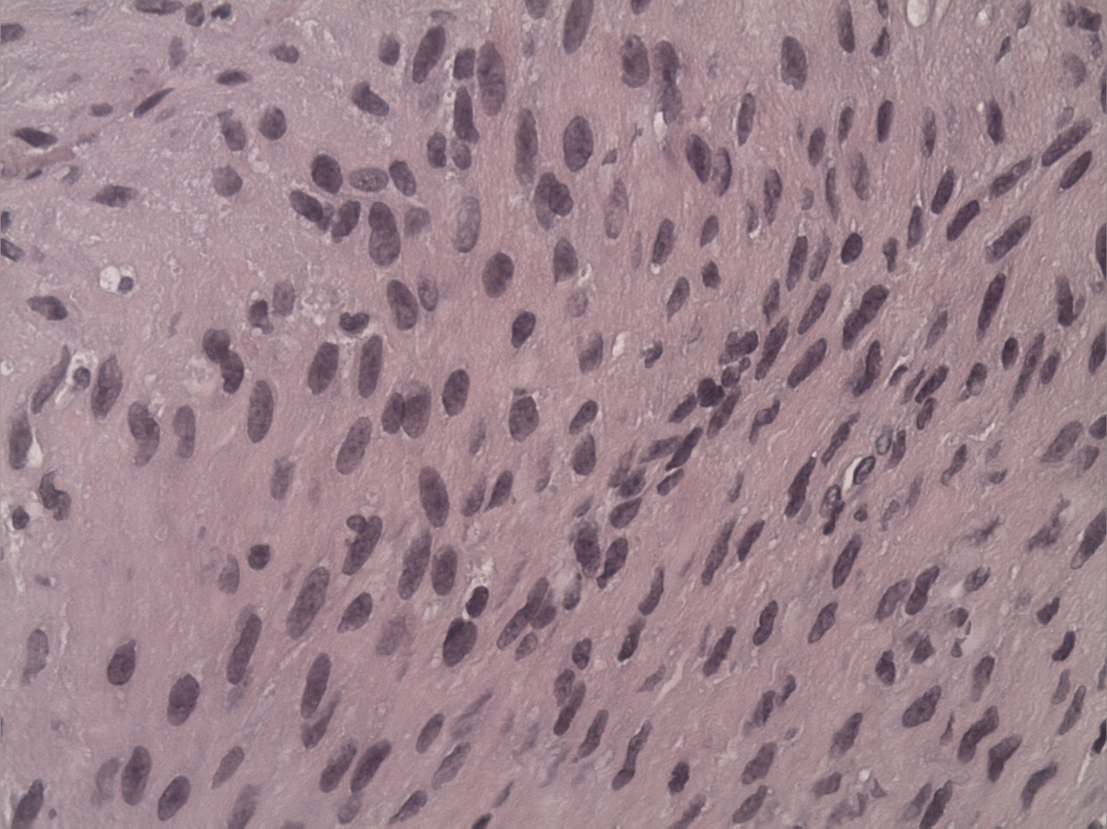
Figure 1- Smooth muscle cells with no mitotic figures, taken from pleural lesion biopsy.

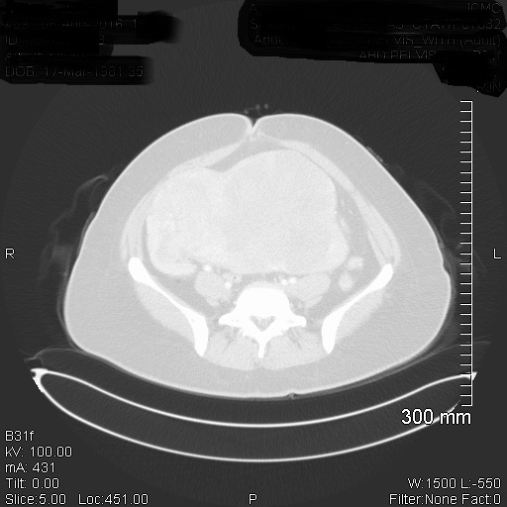
Figure 2- CT scan of an enlarged uterus with a mass of unknown origin

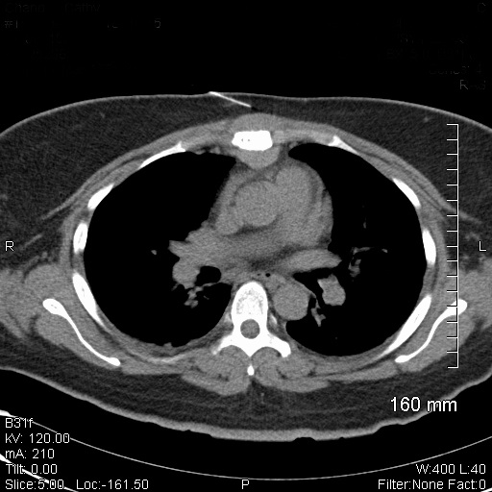
Figure 3- CT guided biopsy of a pleural metastatic lesion

