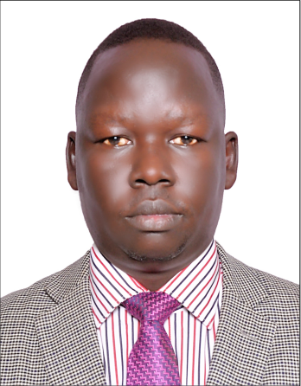

Impact of Malnutrition on Children Less Than Five Years of Age in Juba Payam, Republic of South Sudan

John Leju Celestino Ladu
College of Natural Resources and Environmental Studies, Department of Environmental Studies, University of Juba, P.O Box 82, Juba, Republic of South Sudan

The world’s youngest Nation, the Republic of South Sudan is a fragile state working to recover from decades of conflict and civil war. Children in South Sudan face substantial health risks as a result of malnutrition that has a greater impact on child growth and development such as physiological functions of growth, reproduction, defense, and repairs. Malnutrition among children less than five years of age continues to be one of the South Sudan’s major human development challenges. In spite of tremendous economic crisis made in the last two to three years of conflict, malnutrition among children in both urban and rural areas of South Sudan still claims many lives of children less than five years of age. However, mounting cases of malnutrition has caught the public eye and so health care providers as well as the government are taking the necessary steps to improve the current status of nutrition for children in South Sudan.
In this study, a hospital based cross-sectional study was carried to study the impact of malnutrition on children less than five years of age in Juba payam (district), Republic of South Sudan. Whereas the specific objectives are to examine the causes of malnutrition on children less than five years of age, to investigate the feeding practice of children from their caretakers (especially mothers, fathers and grandparents), to investigate some environmental factors that contributes to malnutrition problems on children less than five years of age and to investigates socio-economic factors that are linked to malnutrition problems from the communities in Juba payam. A cross-sectional descriptive study was designed to collect primary information from households using a scientific questionnaire, observations and interviews to obtain the data for this research study and the data collected were analyzed and interpreted statistically. The results obtained indicated that 56% children were suffering from chronic malnutrition and 24% children were underweighted and 20% children were suffering from acute malnutrition. The study results showed that children with middle and poor economic status were more stunted as compared to children of high economic status. The results showed that children of mothers with no education were significantly more stunted. According to results obtained regarding the associates of child malnutrition status, 22% had never been breastfeed after their birth due to absent of milk from their mothers and maternal death, while 24% were affected by household size. Moreover 30% were faced by lower incomes. Socio-economic and demographic factors, lack of proper feeding practices; internal conflict and environmental health condition are found to be significantly associated with the high prevalence of malnutrition on children less than five years of age in Juba payam, Republic of South Sudan.
However, to reduce the burden of malnutrition among under-five children, a combined effort by the government, non-governmental organizations individuals and the community as well are essential to improve the nutritional status of children at Juba payam. Working at the effective, efficient and equitable program should be designed to reduce child malnutrition. In addition, nutrition surveillance needs to be done continually and special attention should be given to vulnerable groups such as poorest and most undernourished children. A healthy mother can give birth to a healthy children, thus the intervention programs for improving the nutritional status of children must focus not only on children but also on their mothers nutritional status.

Biography
John Leju Celestino Ladu has completed his PhD as well as Postdoctoral (PD) researcher at the age of 34 years from Southeast University school of Energy and Environment. He worked as Assistant Professor in the Department of Environmental Studies, College of Natural Resources and Environmental Studies, University of Juba and as the Deputy Dean of the College of Natural Resources and Environmental Studies, University of Juba. Apart from lecturing in the university, Dr. John Leju Celestino works as an Environmental Consultant in private and government institutions in the Republic of South Sudan. He has participated in several national and international conferences in South Sudan, Sudan, Uganda, Somalia, China, Germany and Norway. He has published more than 40 papers in reputed journals and has been serving as an editor in several journals.

Presenting author details
Full name: JOHN LEJU CELESTINO LADU
Contact number: +211912773265, +211922221326
Twitter account:
Linked In account: John Leju Celestino Ladu
Session name/ number:
Category: (Oral presentation/ Poster presentation)

