Neuronal growth regulator 1 (NEGR1) may be involved in the cholesterol trafficking by interacting with Niemann-Pick diseases, type 2 (NPC2) protein
Hyejin Kim¹, Kyoungho Han¹, Lihua Che, and Soojin Lee*, Chungnam National University, South Korea

Abstract
Human neuronal growth regulator 1 (NEGR1) is a newly-identified obesity-related gene that is localized in the membrane raft through the glycosylphosphatidylinositol (GPI)-anchor. NEGR1 is also identified as a commonly down-regulated gene in various human cancers and NEGR1-overexpressing cells showed increased cell-cell adhesion and reduced tumorigeneity . To discover novel NEGR1-interacting proteins, we performed yeast two-hybrid screening and found NPC2 as a positive clone. NPC2 is a lysosomal protein that is responsible for intracellular cholesterol transport and its defect is linked to a fatal neuronal disease, NPC. The in vivo interaction between NEGR1 and NPC2 was confirmed by co-immunoprecipitation experiment and co-localization of NEGR1 and NPC2 was found in the late endosome/lysosomal fraction. We also observed that abnormal cholesterol accumulation by U18666A was reduced by NEGR1 overexpression . Altogether, NEGR1 may contribute the intracellular cholesterol trafficking by interacting with NPC2.

Image
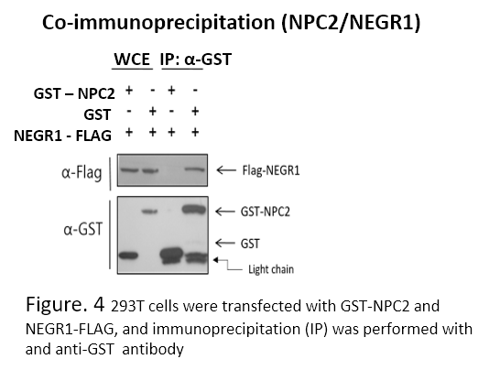

Recent Publications
- Hyejin Kim et al, (2014) Newly Identified Cancer-Associated Role of Human Neuronal Growth regulator 1. Journal of Cancer 5(7):598-608.
- Hyejin kim et al, (2017) The new obesity-associated protein, neuronal growth regulator 1(NEGR1), is implicated in Niemann-pick disease Type C(NPC2)-mediated cholesterol trafficking. Biochemical and Biophysical Research Communiaction 482:1367-1374.

 Biography
Kyoungho Han is attending Molecular Cancer Cell Biology Experiments at Chungnam National University and has a master's degree and his main concern is Cancer and Obesity
Email: kyounghos@naver.com
Phone: +82-10-6256-0901

Notes/Comment

