Leukima inhibitory factor receptor (LIFR) was identified to interact with Neuronal growth regulator 1 (NEGR1)
Jae-hyeon kim^{1,} A ra Yoo^{1,} Lihua che, and Soojin Lee*

Abstract (300 word limit)

Human neuronal growth regulator1 (NEGR1) was identified as a commonly down- regulated gene in various human cancers. NEGR1 is a raft-enriched glycosylphosphatidylinositol (GPI)-anchored protein that showed sequence homology with IgLON family that functions in neurite outgrowth and neural cell adhesion. Recently, NEGR1 was identified as a new locus that is related with human obesity.
To identify yet-unidentified NEGR1-interacting proteins, we performed yeast two-hybrid screening using domain 1-2 region of NEGR1 as a bait. A positive clone was selected and sequence analysis identified it as leukemia inhibitory factor receptor (LIFR), a membrane receptor for LIF, a polyfunctional cytokine that affects the differentiation, survival, and proliferation of a wide variety of cells in the adult and the embryo. In vivo co-immunoprecipitation study confirmed that these two proteins interact in the cells. Taken together, we newly identified LIFR as a binding partner of a new obesity-related membrane protein, NEGR1.


Image
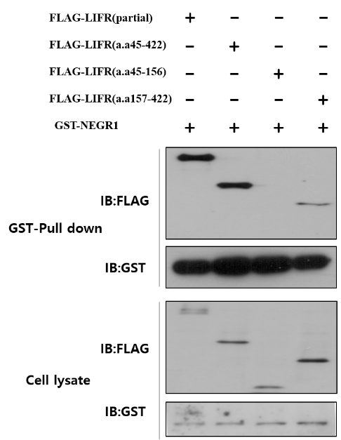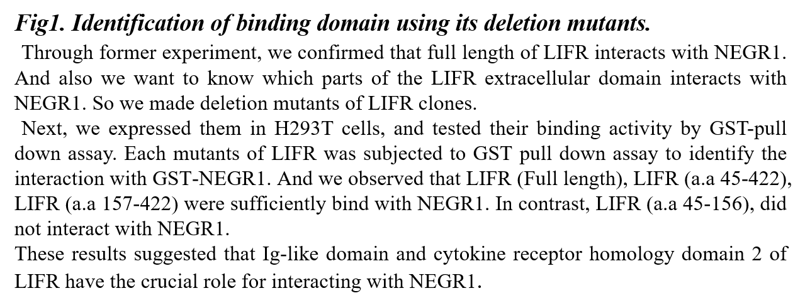
Recent Publications (minimum 5)
[1] Kim, H., et al., Newly Identified Cancer-Associated Role of Human Neuronal Growth Regulator 1 (NEGR1). J Cancer, 2014. 5(7): p. 598-608.
[2] Hyejin Kim et al. The new obesity-associated protein, neuronal growth regulator 1 (NEGR1), is implicated in Niemann-Pick disease Type C (NPC2)-mediated cholesterol trafficking. Biochemical and Biophysical Research Communication.. 2017; 482: 1367-1374.
[3] Luo Q, et al. Carcinogenesis, 2015 Oct. PMID 26249360.
[4] Park, J.H., et al., Signal transduction and activator of transcription-3 (STAT3) in patients with colorectal cancer: associations with the phenotypic features of the tumour and host. Clin Cancer Res, 2016.

Biography
I am studying my master's degree at Chungnam National University. I am conducting research on obesity and health. I am going to carry out more research related to obesity in the future.
Email: dkfk11214@naver.com
Phone: +820-9554-7177

Notes/Comment

