Medicinal plants for the treatment of obesity
Nora MAHFOUF, PhD in Biology, Chadli Ben Jedid University, Algeria
Pr Salima Bennadja, Badji Mokhtar University, Algeria
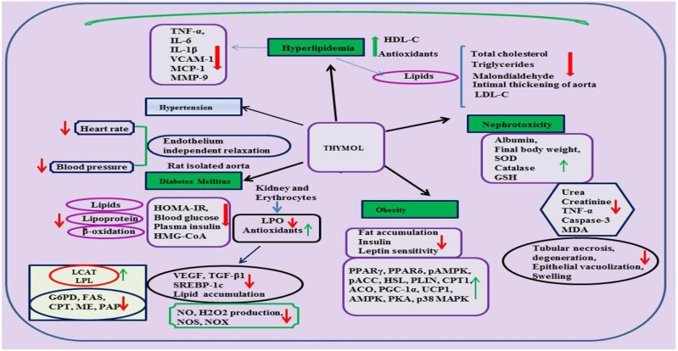
Pr Hichem Nasri, Chadli Ben Jedid University, Algeria

Obesity is a risk factor linked to chronic diseases such as cardiovascular diseases, some types of cancer and type 2 diabetes mellitus [1]. The challenge of reducing overweight and obesity is a global problem. Most of the synthetic anti-obesity drugs have failed to manage the obesity due to either adverse effect. The research of prominent chemical constituents from herbal for the management of obesity has greatly increased. Algeria is a country that produces hundreds of species of aromatic plants that are endemic. Among these plants is the oregano . The genus Origanum (oregano) is one of over 200 genera in the Lamiaceae family and includes annual and perennial herbs growing on stony slopes at a wide range of altitudes [2].

In our research on Origanum vulgare L. from wild grown plants at the East of Algeria, the chemical composition of the essential oil was characterized by gas chromatography-Mass spectroscopy (GC-MS) and revealed the predominance of thymol (32.85%).

Thymol is credited with a series of pharmacological properties, it was demonstrated that thymol can inhibit the accumulation of visceral fats, improve lipid lowering action and enhance insulin and leptin sensitivity [3].

Recently published research study was shown that thymol significantly decreases the apoptotic and inflammatory effects induced by hypercholesterolemia in rat carotid tissue and that this decrease is possibly associated with a direct antioxidant effect of thymol [4].

Based on our results and several published works, we can conclude that hymol may be explored as a potentially promising food additive for prevention of obesity.

Figure 1. Effect of thymol on metabolic and kidney disorders. (Nagoor Meeran et al., 2017)
Recent publications:
1. Abdullah A, Peeters A, de Courten M et al. (2010) The magnitude of association between overweight and obesity and the risk of diabetes: a meta-analysis of prospective cohort studies. Diabetes Res Clin Pract 89(3):309-319
2. Nora MAHFOUF. Alternatives to antibiotics. Research in essential oils: the case of oregano. AMR CONTROL 2017. P.12 http://resistancecontrol.info/2017-contents-preview/
3. Mohammad Rafiul Haque,S. H. Ansari,A. K. Najmi &Mohammed Afroz Ahmad . 2013. Monoterpene phenolic compound thymol prevents high fat diet induced obesity in murine model. Technology mechanisms and methods. 116-123.
4. Bayatmakoo, R., Rashtchizadeh,N., Yaghmaei, P., Farhoudi, M,. Karimi, P. 2017. Thymol decreases apoptosis and carotid inflammation induced by hypercholesterolemia through a discount in oxidative stress. Crescent Journal of Medical and Biological Sciences. 186–193.
5. Nagoor Meeran MF, Javed H, Al Taee H, Azimullah S and Ojha S .2017. Pharmacological Properties and Molecular Mechanisms of Thymol: Prospects for Its Therapeutic Potential and Pharmaceutical Development. Front. Pharmacol. 8:380. doi: 10.3389/fphar.2017.00380


She received her Diploma of Higher Studies in Microbiology, University of Badji Mokhtar, working with Professor Boutefnouchet Nafissa on topic in nosocomial infections and the resistance to antibiotics of the species Pseudomonas aeruginosa. She then moved to Chadli Ben Jedid University where she received a Biology Master’s diploma in Ecotoxicology. She worked on the antibacterial activity of rosemary essential oil on strains of Gram-positive and Gram-negative antibiotic-resistant bacteria. At present, she is preparing a PhD thesis on the study of the Origanum vulgare species. She works with Professor Hichem Nasri and Professor Bennadja Salima on the bactericidal activity of the essential oil of oregano.
Email: noramahfouf99@gmail.com

Speaker Mobile Number: (00213) 06 67 41 44 62

Speaker Facebook Profile URL: https://www.facebook.com/profile.php?id=100015521927060&ref=bookmarks

