SOCIO-DEMOGRAPHICS: IMPACTS ON NUTRITIONAL HEALTH STATUS OF CIRRHOTIC PATIENTS
Tariq Saeed, Sarfraz Hussain, Shahid Mahmood, M Modassar AN Ranjha*, Muhammad Nadeem, Syeda Mahvish Zahra, Shafeeqa Irfan, Muhammad Yousaf Quddoos, Wajiha Saeed, Muhammad Qamrosh Alam, Iqra Ramzan, Abdullah bin Masood and Rida Asif.
Institute of Food Science and Nutrition, University of Sargodha, Sargodha-Pakistan.
*Corresponding and presenting author’s email: ModassarRanjha@thenutritiontimes.com

Abstract
Exploring impacts of socio-demographics on nutritional health status of cirrhotic patients can be a breakthrough to minimize liver cirrhosis. Demographics, socioeconomic status, food intake, BMI, liver size, serum albumin, and hemoglobin were assessed and correlated with physiological status of liver cirrhosis, data was collected for these factors by using questionnaire fill up, and biochemical tests in lab. Association between gender and physiological status of volunteers was non-significant. Majority (69.1 %) of volunteers had B positive and AB positive (68.9 %) blood groups were amongst patients of liver cirrhosis. Study revealed that most of volunteers (72.1 %) had sedentary life style. Most of the liver cirrhosis patients (81.4 %) had reported sleeping time of less than 6 hours. About 67.8 % cirrhotic patients belonged to low income socio-economic status. 71.4 % patients who were suffering from liver cirrhosis had reported to be living in joint family system. Cirrhotic patient profiling indicated a high BMI trend. A significant correlation was found between physiological status with fruit & vegetable, cereals, meat, dairy, water intake, fats and oil as well as junk & snack intake. Small liver size, low serum albumin and low hemoglobin levels and have significant relationship to liver cirrhosis.
Key words: Liver, Cirrhosis, Food intake, Hemoglobin, and Serum Albumin.

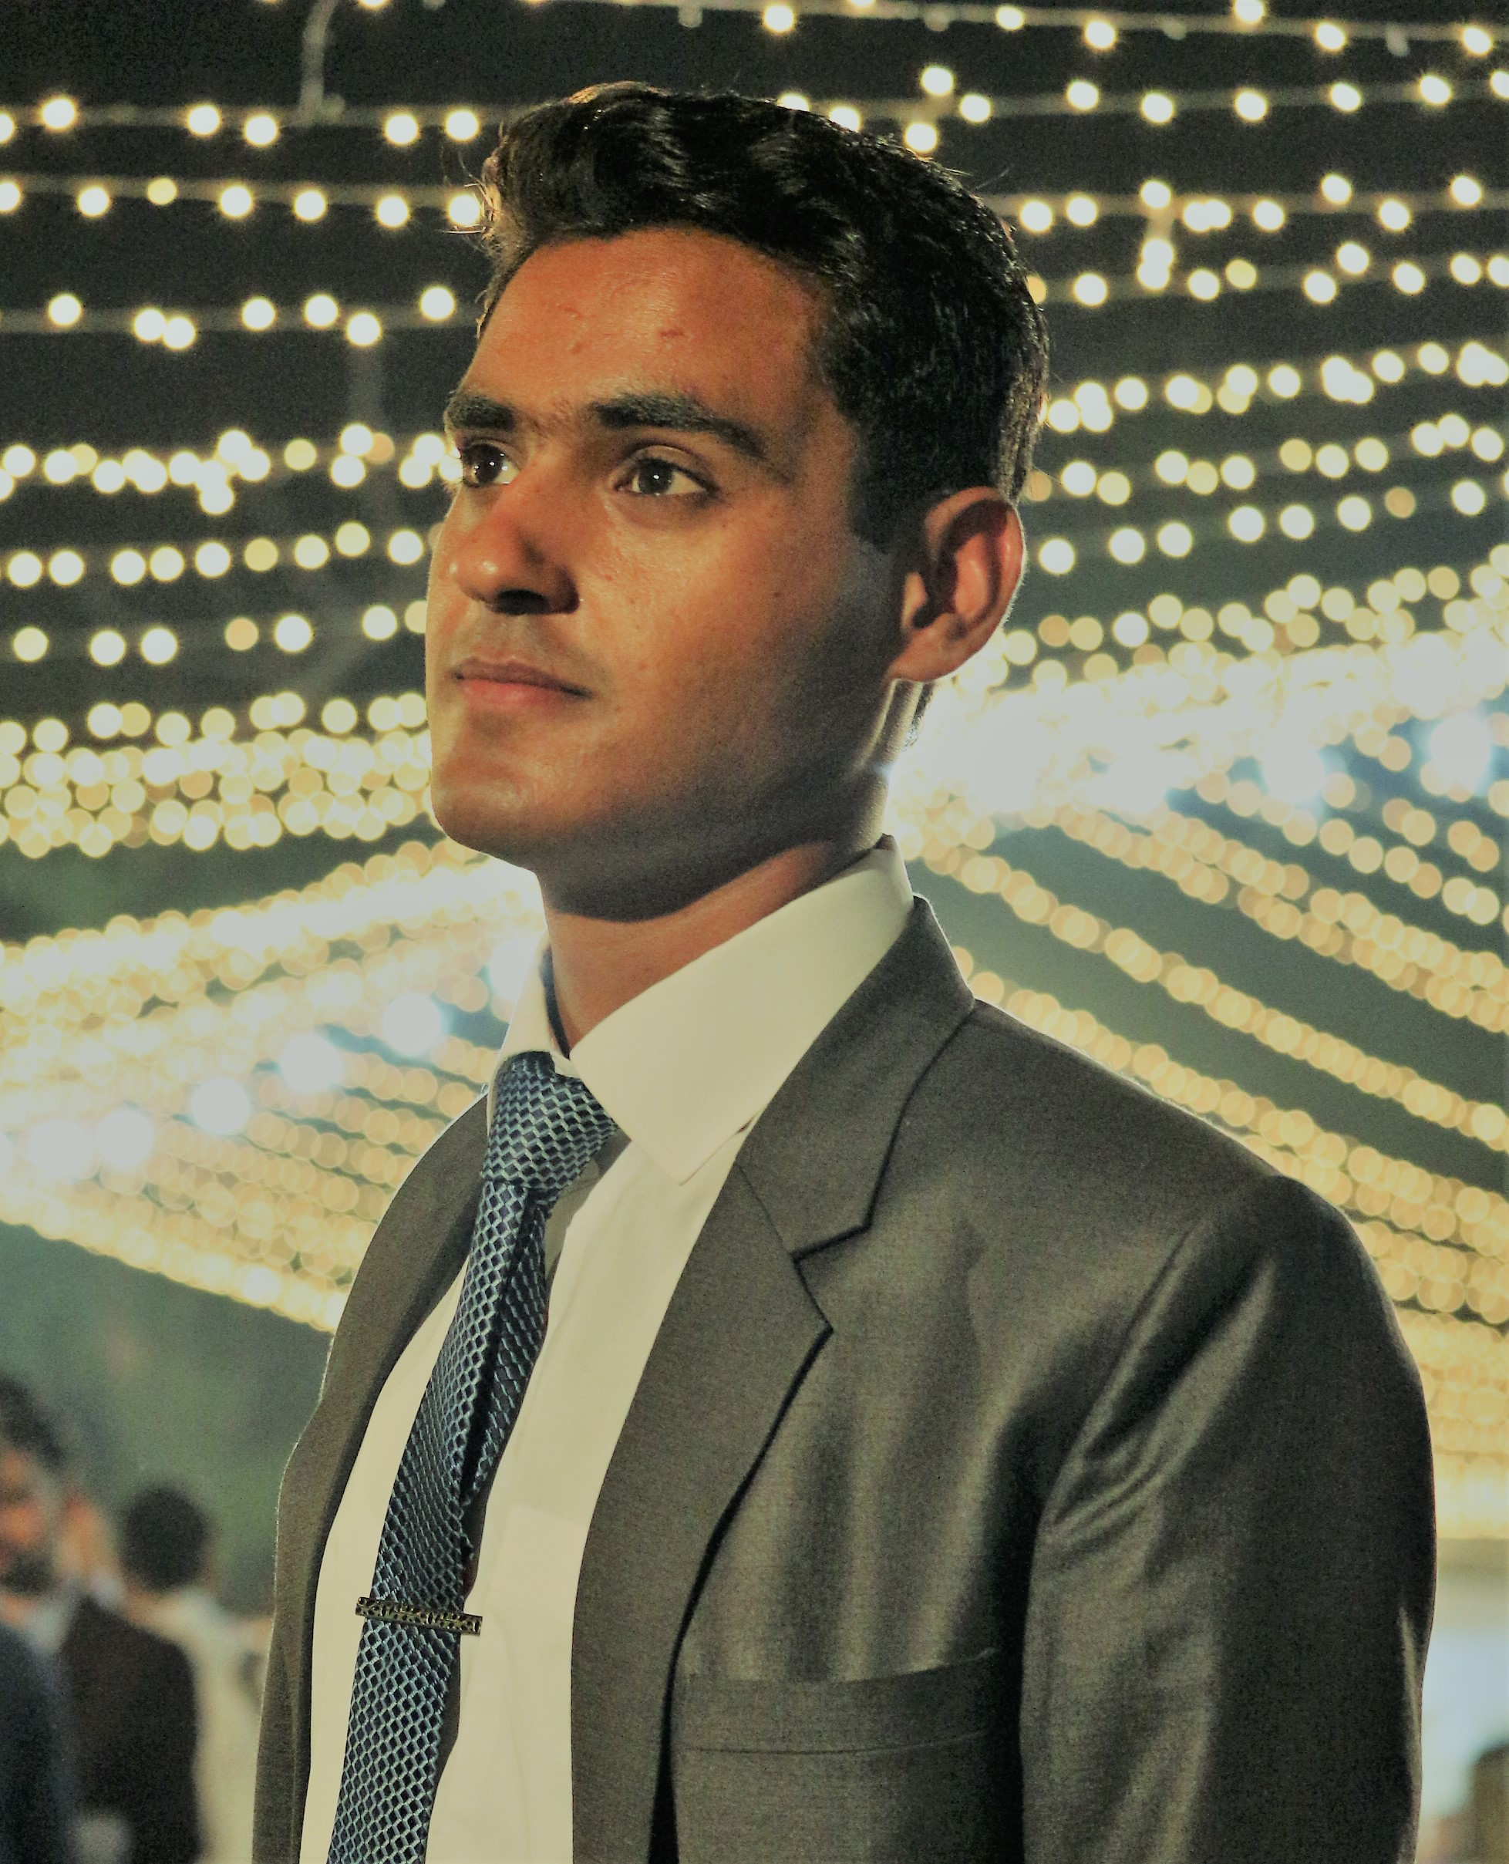
Biography
Muhammad Modassar AN Ranjha an active Nutrition Researcher having a vision to promote the Knowledge of Nutrition among the masses of Underdeveloped and Developing countries. He is highly motivated and optimistic for this goal as he is currently working as a volunteer in Nutrition & Health Research Project Pakistan and running a Blog for spreading the knowledge of Nutrition.
Presenting author details
Full name: Muhammad Modassar Ali Nawaz Ranjha
Contact Number: +923488000158
Email: modassarranjha@thenutritiontimes.com
Web Site: www.thenutritiontimes.com
Linked In Account: Muhammad Modassar Ali Nawaz Ranjha
Category: Clinical Nutrition

