Making a Difference: How Public Health Nurses Understand the Social Processes of Leadership
Karen Stansfield, DBA, MMedSci, BSc (Hons), RHV, RN, University of Salford, UK
Abstract
Statement of the Problem: The need to strengthen leadership in Public Health Nurses (PHNs) has been voiced in health care policy for the past twenty years (Department of Health, 1999 & 2006; National Health Service England, 2016, 2019). Yet there is still a lack of research examining how PHNs understand leadership, with, much of the existing research on leadership focusing on leaders “per se” as opposed to leadership as a social process.

The purpose of this study is to understand how PHNs perceive their leadership role, and how leadership as a social process is demonstrated in the delivery of the PHN service in the context of the NHS.

Methodology & Theoretical Orientation: An interpretive perspective using a constructivist grounded theory methodology approach was used to ascertain the participants’ main concerns in relation to leadership (Charmaz, 2014). Using in depth interviews and focus groups.

Findings: A conceptual model of making a difference: how PHNs understand the social processes of leadership has been constructed. The conceptual model demonstrates how the categories, context of leadership, the purpose of leadership and leadership behavior emerged. These were constructed from the comparative analysis, of the data and encapsulate the participants’ main concerns. This model identifies the need to incorporate education based on the three categories and the core category “making a difference” and there is a need to focus on leadership development as a continuous process.

Conclusion & Significance: This study has provided a model for leadership development that can be used as a structural model in PHN in both academic and clinical practice settings, and as a way of articulating how PHNs understand leadership. This study sheds light on the importance of building not only PHN identity but also leadership identity when delivering PHN education.

Image
Figure 8.1 The conceptual model, making a difference: how PHNs
understand the social processes of leadership
I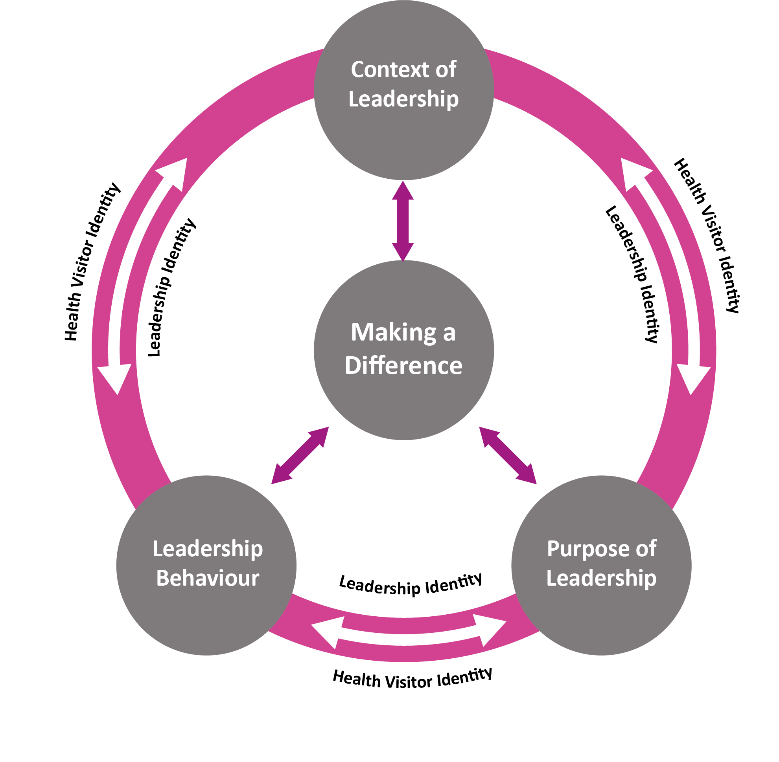
Recent Publications

- Nettleton, R, Stansfield, K, J, & Whittaker, K. (2019) Recommended National Curriculum – Specialist Community Pubic Health Nursing – Health Visiting/School Nursing (0-19 child public health nursing services)- Project Manager. Institute of Health Visiting.
- Stansfield, K, J. (2018) Final Report for the Burdett Nursing Trust- To pilot and implement a targeted leadership development model for Health Visitors/School Nurses to strengthen their collective clinical leadership skills (funded).
- Stansfield, K, J. (2017) Opinion piece: The future of health visiting is at risk. Nursing Standard.
- Stansfield, K, J, Newland, R, & Smith, L. (2013) Searching for a model for public health practice. Fully funded paper for Public Health England/Department of Health.
- Stansfield, K, J, & Clark, M. (2013) Making sense of leadership in the NHS: How Health Visitors engage with the social processes of leadership. Discussion paper accepted by the British Academy of Management Conference Aintree Liverpool.

Biography
Dr Karen Stansfield has extensive senior management, strategic leadership and quality assurance experience in the health and care sector, industry and in education. Karen is a highly skilled educationalist and has extensive experience in undertaking curriculum development in both pre and post-registration nursing and specialist education. Karen completed a doctorate in business administration her thesis was on health visiting and leadership. The leadership development model was created from this research. Karen has subsequently been awarded two grants from the The Burdett Trust for Nursing in conjunction with the Institute of Health Visiting in 2017 to pilot and implement the leadership development model and in 2018 to undertake a feasibility study to implement a leadership programme containing the leadership model and to develop and implement a leadership board game based on the leadership model. This was developed and delivered to a wide range of public health nurses in the UK.
Email: K.Stansfield1@salford.ac.uk

