Effects of a transitional palliative care model for patients with end-stage renal failure – a randomized controlled trial
Tam M.L.B. ¹ and Wong K.Y.F.²
¹School of Nursing, Tung Wah College, HKSAR
²School of Nursing, the Hong Kong Polytechnic University, HKSAR

Abstract (300 word limit)
Background Palliative care was increasing adopted for irreversible chronic disease in the recent decade. A nurse-led transitional palliative care model was adopted in the process of care. Objectives This randomized clinical trial examines the difference of intervention effect between the intervention and control groups. Method Purposeful criterion sampling was adopted. There were 76 ESRF patients (intervention : 38 and control : 38) recruited from a general regional hospital in Hong Kong. Demographic data such as gender, age, education level, accommodation, cohabitants, occupation, and comorbidity illness were collected. Primary outcome variables include non-scheduled readmission rate, length of stay in the hospital and utilization of Accident and Emergency Department. Secondary outcomes variables including health-related quality of life with subscale of symptoms problem list, effects of kidney disease, burden of kidney disease , physical and mental composite score, physical symptom manifestation; palliative performance Scale; Hospital Anxiety and Depression; Satisfaction with care and Zarit carer burden. Data collection was carried out from August 2014 to October 2017 at the baseline, 1, 3, 6 and 12 months after recruitment. Repeated measures of analysis of variance were adopted for comparing the group difference over five time-points of two independent random samples. Results The mean age of the participants was 80.8 + 10.8 years old with comparable demographic characteristic in both groups. There were significant between group differences with intervention group presented better in both primary and secondary outcomes (table 1). Discussion The findings evidenced the positive effects of the nurse-led transitional palliative care model on patient with irreversible chronic renal disease. In addition, caregivers of the intervention group presented less burden in caring the patient that echoed the implications of appropriate and timely supports to the patient and their caregivers
Image
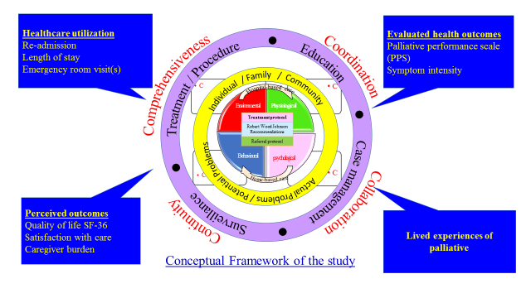

Table 1. Results
Outcome measures | Group differences  (Intervention vs control ) | p-value
Rate of readmission since inception admission (days) | 44.05 vs 30.58 | 0.003
AED visit with PC | 1.32 vs 2.67 | 0.000*
Length of stay (LOS) with PC | 10.34 vs 31.31 | 0.000*
KDQOL-36TM | F (1,74) | p-value
Symptom problem list (SPL) | 3467.9 | 0.000*
Burden of kidney disease (BKD) | 8610.29 | 0.000*
Effects of kidney disease (EKD) | 652.25 | 0.000*
Physical composite score (PCS) | 1603.59 | 0.000*
Mental composite score (MCS) | 5865.58 | 0.000*
Symptoms intensity | 257.229 | 0.000*
Anxiety | 51.304 | 0.000*
Depression | 129.541 | 0.000*
Palliative performance score (PPS) | 3730.491 | 0.000*
Satisfaction with care | 15892.552 | 0.000*
Zarit burden Index | 337.129 | 0.000*

Biography (150 word limit)
Tam B acted as an ex-nurse consultant in Renal Nursing in Hong Kong. She was appointed as senior lecturer at the Tung Wah College. Likewise, she serves as the Adjunct Assistant Professor of the Chinese University, Hong Kong, Honorable consultant of Lingnan Hospital, Sun Yat-sen University, China, and the Professional Consultant of Lock Tao Nursing Home-Renal Centre. Being one of the founder of the Hong Kong Renal Nurses Association, She is very much concern the continuous nursing education and quality patient services. Her research interests are renal nursing, palliative care and patient education.
Email: bonnietam@twc.edu.hk

