Leaning Forward, Stepping up for Queensland Communities: Nursing and Midwifery Lead Improvement
- Jan Phillips, Executive Director, Centre for Leadership Excellence, Clinical Excellence Queensland
- Shelley Nolan, Chief Nursing and Midwifery Officer. Office of the Chief Nursing and Midwifery Officer. Clinical Excellence Queensland, Department of Health

Abstract (300 word limit)
Healthcare services worldwide need to transition to address current and future challenges relating to new technologies, changing demographics, increased chronic disease and funding pressures. These challenges impact nurses and midwives in a system where there is increasing dissonance between reality and providing quality patient care based on a client first philosophy. World leaders recognise nurses and midwives are critical to address these challenges.
A compelling case exists for nurses and midwives, being the largest most accessible healthcare workforce, to lead change making the greatest positive impact on health care delivery. These professions understand the complexity of delivering best practice and are committed to keeping the focus on patient care at the forefront of improvement efforts.
The Centre for Leadership Excellence (CLE) designed a range of development programs delivered to enhance the leadership and management capabilities of Queensland Health clinicians. The Manage4Improvement Program (M4I) provides practical leadership, management and service improvement skills.
The Office of the Chief Nursing and Midwifery Officer (OCNMO) recognised that nursing and midwifery leaders in regional and rural sites have less opportunities to be supported in developing clinical leadership skills along with the most opportunity to address health inequities. In collaboration with CLE, a targeted M4I program was offered to current and potential nursing and midwifery leaders. Participants learnt complex management strategies and effective leadership behavior to successfully implement clinical improvement to enhance patient safety and the quality of care.
Since 2018, the program has been very well

received from across all Queensland Hospital and Health services, with 90% of program participants rating the program as excellent or good.
This presentation will provide an overview of the OCNMO M4I program, including how organisations can assist clinician managers within a complex health system showcasing a range of innovative nursing and midwifery improvement projects undertaken by participants.
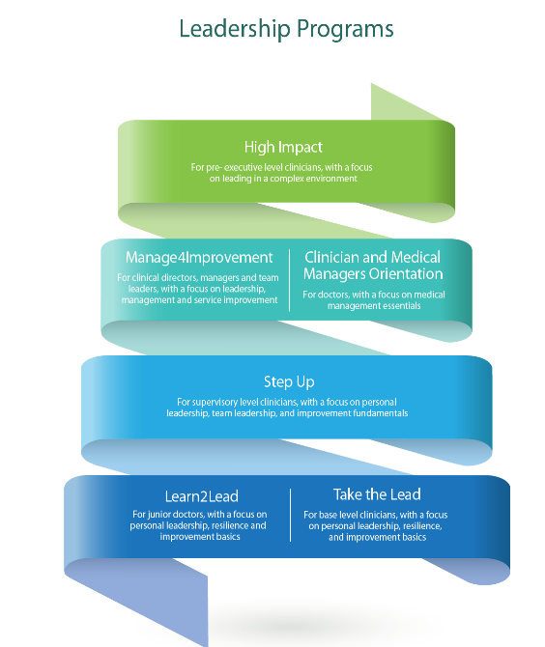
Recent Publications (minimum 5) Supporting Abstract.

- Beech M. (2002) Leaders or managers: the drive for effective leadership. Nursing Standard 16 (30), 35–36.
- Davidson PM. (2006) Clinical leadership in contemporary clinical practice: implications for nursing in Australia Journal of Nursing Management, Wiley Online Lib.1111/j.1365-2934.2006. 00555.x
- Swanwick T. (2011) What is clinical leadership… and why is it important? Wiley Online Lib.10.1111/j.1743 498X.2010. 00423.x
- Browne-Ferrigno, T. (2004). Leadership Mentoring in Clinical Practice: Role Socialization, Professional Development, and Capacity Building. Educational Administration Quarterly, 40(4), 468–494. https://doi.org/10.1177/0013161X04267113
- Olsen S, Neale G. (2005) Clinical leadership in the provision of hospital care.
BMJ. 2005;330(7502):1219–220

Ms. Jan Phillips

Executive Director, Centre for Leadership Excellence
Jan has previously held executive and general management positions in a number of large public sector organisations, including central public-sector management agencies and housing, local government, planning and public works departments.
She brings significant expertise in public service and healthcare improvement, including leadership and management development, workplace culture improvement, workforce redesign, strategic planning, quality improvement, innovation, human resource management and organisational change.


A/Professor Shelley Nowlan

Chief Nursing and Midwifery Officer. Office of the Chief Nursing and Midwifery Officer.

Shelley has over 30 years’ experience in a range of health settings and experiences.

Shelley is a people orientated nurse leader who is experienced in clinical innovation, leading strategic planning and significant nursing workforce commissioning.

Her strong advocacy for nursing and midwifery informs policy development at state and National level, clinical practice innovation, research and workforce development.

Notes/Comments:

