Improvement the Sexual Functions among Menopause Women after delivery of ‘Mentari’ Health Education in the South Sumatera Indonesia
Lisda Maria*, Setyowati**
*Magister of Nursing Study program, Faculty of Nursing Universitas Indonesia
** Faculty of Nursing Universitas Indonesia

Abstract
The number of Indonesian divorce cases in 2014 reached 382,231, up about 131,023 cases compared to 2010 as many as 251,208 cases. One of the causes of couples are due to women who have entered the menopause phase that influence the decreasing sexual activity among 52% of elderly couple and lack of knowledge. This research is generally aimed to find out the effect of health education "Mentari" to sexual function in menopausal women. This research design is a quasi experimental pre-post test with control group design. The sample counted 64 people, 32 people in each group. Data collection were using Female Sexual Functioning Index (FSFI) questionnaire. The results showed there was a significant increase in sexual function in the domain of desire, stimulation, the lubrication, orgasm, the satisfaction, and pain during intercourse. The results concluded that there was a significant increase of sexual function in all domains after being given Mentari health education with (ρ <0,05).
This study recommended for nurses to use the health education ‘Mentari’ in doing intervention to the elderly women.

Keywords: Health education "Mentari", sexual function, menopause

Image
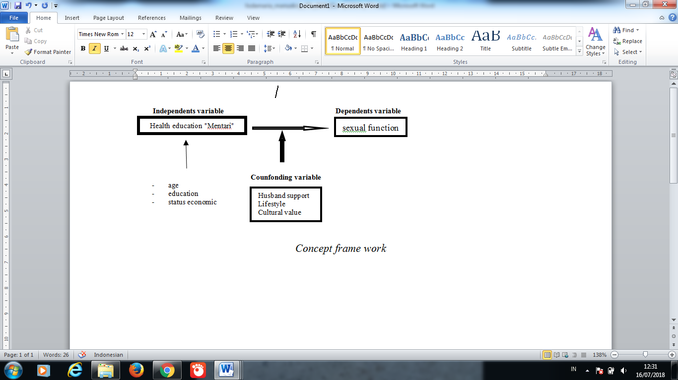
Recent Publications
- Setyowati (2016), The Health Providers’ Empowerment by Involving Families in the Prevention Program of HIV-AIDS Among Housewives in Indonesia, Proceeding: 4th Annual Worldwide Nursing International Conference (WNC 2016) by GSTF www.globals tf.org, Singapore
- Setyowati (2016), Empowerment the health providers by involving families in the prevention program of HI?V-AIDS among housewives in Indonesia, Proceeding international conference : Optimizing healthcare Quality : Teamwork in Education, Research and practice, Chiang Mai
- Seyowati (2015), The Effectiveness Of ‘Pain Digital Acupressure (Pda)’ To Reduce The Labor Pain And The Length Of Second Stage During Labor, Proceeding International conference Manipal College of Nursing Manipal, INDIA
- Setyowati (2017), The Experience of Girls Living in a Localization Area in Maintaining Their Reproductive Health, Jurnal: Comprehensive Child & Adolescent Nursing, Vol.40.No.S1, 137-144
- Setyowati (2017), “SETIA” Health Education Set Enhances Knowledge, Attitude, and Parenting Self-Efficacy Score in Postpartum Adolescent Mothers, Jurnal: Comprehensive Child & Adolescent Nursing, 2017, Vol.40.No.S1, 114-127
- Setyowati (2017), The development of an interactive health education model based on Djuwita application for adolescent girls, Jurnal: Comprehensive Child & Adolescent Nursing, Vol.40.No.S1, 169-182.

 Biography
The research team that will be the presentation
Name : Lisda Maria
Place / Date of Birth : Palembang/ 15 Jan 1982
Work : Lecturer of Stikes Pembina Palembang
Student : FIK UI magister program

Name : Prof.Dra. Setyowati, M.App.Sc., Ph.D
Place / Date of Birth : Salatiga, 27 Nopember 1954
Work : Lecturer of the Faculty of Nursing-UI
Function : Professor of the Faculty of Nursing-UI

Email: watib4150@gmail.com

Notes/Comments:

