Not only a family, we are a team to fight together: A protocol study for self-efficiency of type 2 diabetes with family group-based peer support.
Ma Lin, postgraduate student of Lanzhou University, China
Han Lin, PhD, dean of nursing school in Lanzhou University, China

Abstract
Introduction: Self-efficiency is deemed to be vital to improve self-management and self-care ability. The support from family group-based is considered to have potential significance to improve the self-efficacy of type 2 diabetes (T2DM) patients. This study intended to use the family group-based health management model to improve diabetes patients’ self-efficiency.
Methods: This study was conducted from January 2014 to December 2017. And it consists of two phases: (1) Formation of the family group-based health management model; (2) Application of the internet platform and the health management model in the patients and their first-level relatives. Finally 43 diabetes family groups were involved. Each family group consists of a diabetes patient and a first-level family member. This study mainly concentrated on the self-efficacy of the type 2 diabetes (T2DM) patients under intervention from the family group-based health management model. Data was collected by Diabetes Self-Efficiency Scale (T2-CSO) which was compiled by Jingxuan Wang in Taiwan. And they were recorded in the baseline and at the third, the sixth, the ninth, the twelfth and the eighteenth month.
Results: The study concluded 43 diabetic patients, and the outcomes showed the family group-based health management model significantly improved each dimension of diabetes patients’ self-efficiency with the scores of total self-efficiency increased from 86.417.7 to 99.522.4 after eighteen months’ intervention. What's more, we took the physical examination including BMI , waist-hip ratio and the biochemical tests with fasting blood glucose and hemoglobin (HbA1c). All of these consequences except the waist-hip ratio did not get obvious change after eighteen months' interventions (P>0.05). But all of these outcomes tended to keep steady in the normal states.
Conclusion: A family group-based health management model aimed at involving relatives, creating trust, and practicing together to improve the management of diabetes. The involvement of patients or relatives was significant on self-efficiency, and later made an influence on the self-management of diabetes. These positive results will direct our community and family to do a better work on helping the patients enhance their health.

Image
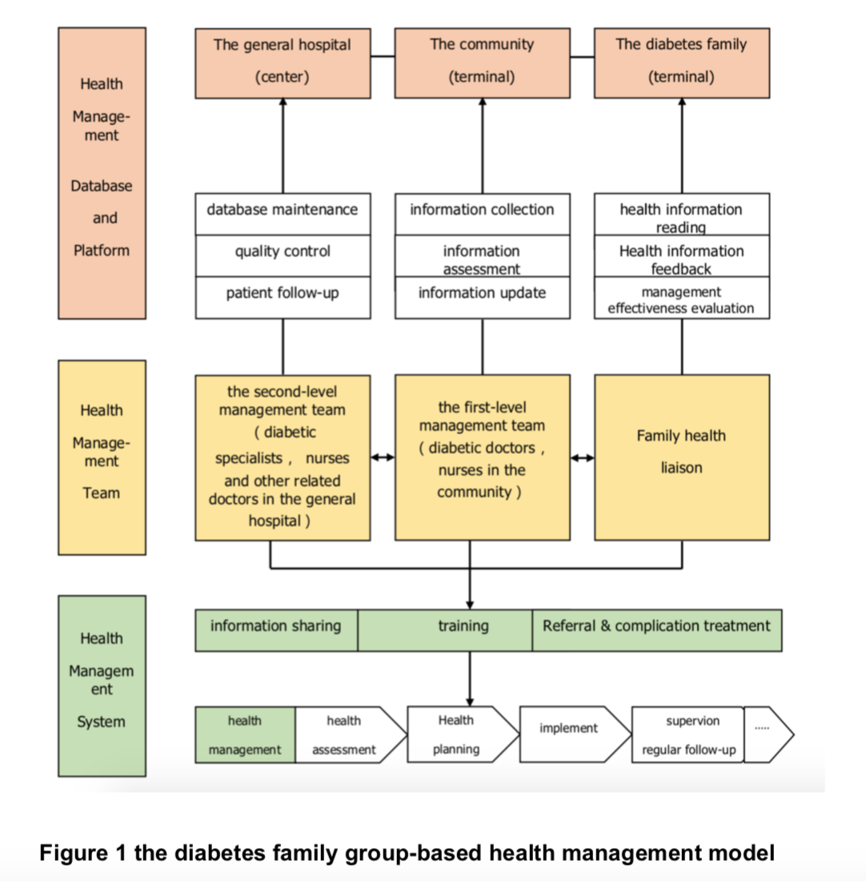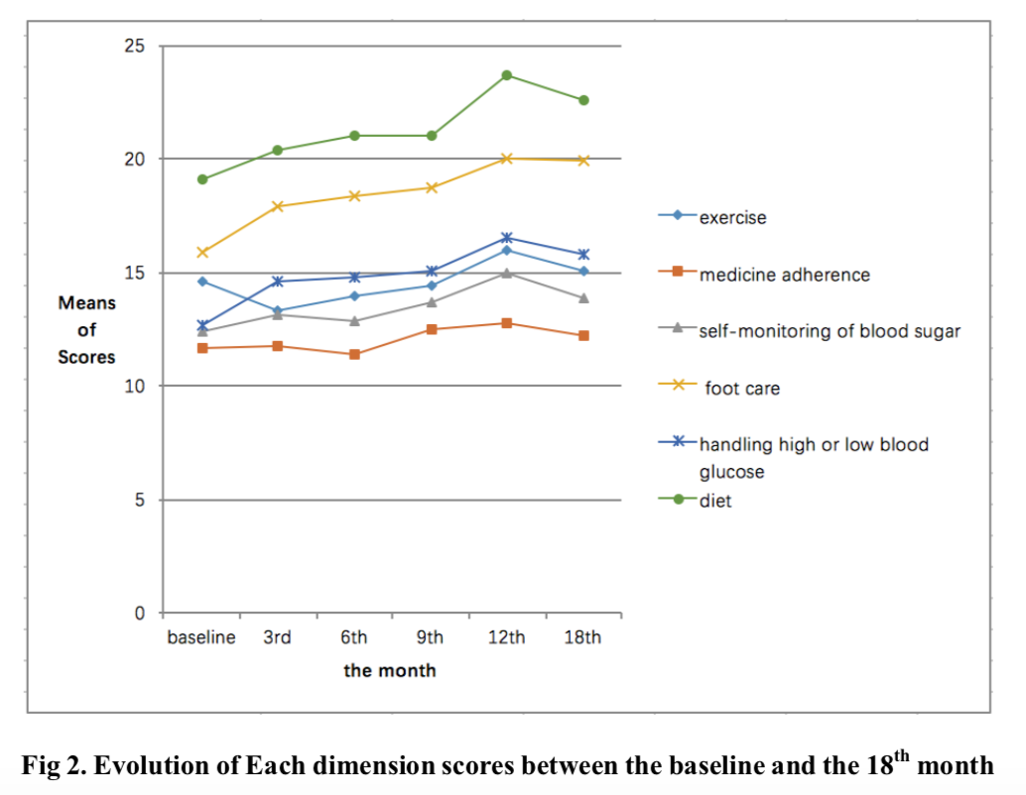
Recent Publications
- Abdul-Razak, A., Rosanna, C., Cecil, T., Dushyant, S., & Naderali, E. K. (2015). Sociodemographic and Clinical Predictors of Self-Management among People with Poorly Controlled Type 1 and Type 2 Diabetes: The Role of Illness Perceptions and Self-Efficacy. Journal of Diabetes Research,2016,(2015-12-1), 2016(3), 1–12.
- D'Souza, M. S., Karkada, S. N., Parahoo, K., Venkatesaperumal, R., Achora, S., & Arr, C. (2017). Self-efficacy and self-care behaviours among adults with type 2 diabetes. Applied Nursing Research Anr, 36, 25.
- Guariguata, L., Whiting, D. R., Hambleton, I., Beagley, J., Linnenkamp, U., & Shaw, J. E. (2014). Global estimates of diabetes prevalence for 2013 and projections for 2035. Diabetes Research & Clinical Practice, 103(2), 137.
- Karlsen, B., Oftedal, B., Stangeland Lie, S., Rokne, B., Peyrot, M., Zoffmann, V., & Graue, M. (2016). Assessment of a web-based Guided Self-Determination intervention for adults with type 2 diabetes in general practice: a study protocol. BMJ Open, 6(12), e013026–9. http://doi.org/10.1136/bmjopen-2016-013026
5. Walker, R. J., Gebregziabher, M., Martinharris, B., & Egede, L. E. (2015). Quantifying Direct Effects of Social Determinants of Health on Glycemic Control in Adults with Type 2 Diabetes. Diabetes Technol Ther, 17(2).

Biography
Ma Lin has finished her bachelor’s degree at 2013, and then she worked in Gansu Provincal Maternity and Child-Care Hospital for nearly three years. After that, she leave the hospital and started her further education for master’s degree in 2016 until now as a postgraduate in Lanzhou University.
Email: malintulip@163.com
Contact number: +86 18293109235
Notes/Comments: This research was supported by National Nature Science Foundation of China (grant 71363004，grant71704071，grant71663002), the Fundamental Research Funds for the Central Universities (lzujbky-2016-ct14) and the Fundamental Research Funds for the Central Universities (grant 31920150046).

